





NSE PROJECT PARIVARTAN DIGITAL ARCHITECTURE ARCHITECTUREARCHITECTURE

Reference Document – V 2.2

**Table of Contents**

August 2020

[1 NSE Parivartan Digital Platform Architecture 4](#_Toc48121341)

[1.1 Introduction 4](#_Toc48121342)

[1.2 Document Scope 4](#_Toc48121343)

[1.3 Current State Challenges 4](#_Toc48121344)

[1.4 Parivartan Program Objective 6](#_Toc48121345)

[1.5 Project Parivartan Program Scope 6](#_Toc48121346)

[1.6 Program Benefits 7](#_Toc48121347)

[2 Functional Architecture 9](#_Toc48121348)

[2.1 Current State Pain Points Identified by Application 9](#_Toc48121349)

[2.2 Current State Clearing and Exchange Applications 11](#_Toc48121350)

[2.3 Target State Capability Model 12](#_Toc48121351)

[2.4 Future State Conceptual Model 14](#_Toc48121352)

[3 Operational Design 15](#_Toc48121353)

[3.1 Target Operational Model 15](#_Toc48121354)

[3.2 Clearing Non-Functional Requirements 15](#_Toc48121355)

[3.3 Exchange Non-Functional Requirements 16](#_Toc48121356)

[4 Technical Architecture 18](#_Toc48121357)

[4.1 Architecture Vision 18](#_Toc48121358)

[4.2 Target State High Level Architecture 19](#_Toc48121359)

[4.3 Microservices Architecture Components 21](#_Toc48121360)

[4.4 Architecture Guiding Principles 22](#_Toc48121361)

[4.5 Parivartan Components and Products 22](#_Toc48121362)

[4.6 Common Framework Build components 24](#_Toc48121363)

[4.7 Parivartan Architecture Constraints 25](#_Toc48121364)

[4.8 Assumptions 25](#_Toc48121365)

[5 Parivartan Architecture Patterns 26](#_Toc48121366)

[5.1 Parivartan API patterns 26](#_Toc48121367)

[5.2 End to End Request Flow Pattern 27](#_Toc48121368)

[5.3 Load-balancing Container Instances - Spring Cloud Gateway Routing Proxy 27](#_Toc48121369)

[5.4 Flow for User Registration 28](#_Toc48121370)

[5.5 Fintech Integration Scenario – PAN Validation Service Provided By Two Fintechs 28](#_Toc48121371)

[5.6 Async Third Party Services Invocation 29](#_Toc48121372)

[5.7 OTP based 2FA Scenario 30](#_Toc48121373)

[5.8 Inter Microservice communication – Netflix Eureka, Feign Client, Ribbon, Hystrix & Kafka 30](#_Toc48121374)

[5.9 Configurable Cross-cutting concerns – AOP & Config Server 31](#_Toc48121375)

[5.10 Auto-scaling strategy 36](#_Toc48121376)

[5.11 Circuit Breaker 36](#_Toc48121377)

[5.12 Log Archival 36](#_Toc48121378)

[5.13 Clearing and Settlement use case realization 37](#_Toc48121379)

[6 Front End Architecture 42](#_Toc48121380)

[6.1 Parivartan UI/UX Best Practices 42](#_Toc48121381)

[6.2 UI Component Types 46](#_Toc48121382)

[6.3 A Component Centric Work Flow 46](#_Toc48121383)

[6.4 Web Frontend Architecture diagram 47](#_Toc48121384)

[6.5 Lazy loading for Modules 48](#_Toc48121385)

[6.6 Web Login 49](#_Toc48121386)

[6.7 Code review and quality checks 49](#_Toc48121387)

[6.8 Accessibility 49](#_Toc48121388)

[6.9 Web Content Delivery Through Akamai CDN Network 50](#_Toc48121389)

[6.10 Mobile React Native Framework 52](#_Toc48121390)

[6.11 React Native UI Core Components 52](#_Toc48121391)

[6.12 Basic Components 52](#_Toc48121392)

[7 Integration Architecture 55](#_Toc48121393)

[7.1 Considerations: 55](#_Toc48121394)

[7.2 Overall Integration Architecture Approach 55](#_Toc48121395)

[7.3 Integration Design Principles and Guidelines 57](#_Toc48121396)

[7.4 Parivartan Clearing & Settlement and Collateral To-Be Interface List: 58](#_Toc48121397)

[7.5 Integration Scenarios 59](#_Toc48121398)

[7.6 Integration Architecture (Detailed): 61](#_Toc48121399)

[7.7 Integration Patterns to Various Backend Systems 62](#_Toc48121400)

[7.8 Apache Camel Adapters 63](#_Toc48121401)

[8 Parivartan Security Architecture 64](#_Toc48121402)

[8.1 Parivartan Apigee API Gateway Security 64](#_Toc48121403)

[8.2 Channel Request Authorization Flow Via Apigee 65](#_Toc48121404)

[8.3 Microservices Authorization 66](#_Toc48121405)

[8.4 Access Control for UI 66](#_Toc48121406)

[8.5 Web and Mobile App oAuth Pattern - Grant Type: Password Grant 67](#_Toc48121407)

[8.6 oAuth Flow from Partner API Clients 68](#_Toc48121408)

[8.7 Addressing Vulnerabilities using Spring Security 68](#_Toc48121409)

[8.8 SSO Process Flow 69](#_Toc48121410)

[8.9 2FA 70](#_Toc48121411)

[8.10 Password Rules: 70](#_Toc48121412)

[8.11 Data Encryption: 71](#_Toc48121413)

[8.12 Application Security Best Practice: 71](#_Toc48121414)

[8.13 Parivartan Data Security 73](#_Toc48121415)

[9 Data Architecture Considerations 74](#_Toc48121416)

[9.1 Data Governance 76](#_Toc48121417)

[9.2 Benefits of Data Governance 76](#_Toc48121418)

[9.3 Data Governance Roles 76](#_Toc48121419)

[9.4 Data Governance Implementation 76](#_Toc48121420)

[9.5 Data Governance Best Practices 77](#_Toc48121421)

[9.6 Parivartan History and Differential Data Import 78](#_Toc48121422)

[9.7 Oracle Database Partitioning 78](#_Toc48121423)

[9.8 Redis As Cache 78](#_Toc48121424)

[9.9 Parivartan ETL Jobs strategy 79](#_Toc48121425)

[9.10 Data Backup and Archival Architectural Guidelines 79](#_Toc48121426)

[9.11 Data Processing Strategy. 80](#_Toc48121427)

[9.12 Migration of Data from Existing Database to Parivartan Database 80](#_Toc48121428)

[9.13 Overall Data Processing Diagram 80](#_Toc48121429)

[9.14 Data Processing Definition 80](#_Toc48121430)

[9.15 Batch Jobs Scheduling and Maintenance 81](#_Toc48121431)

[9.16 Database and Data Storage Backup and Disaster Recovery 81](#_Toc48121432)

[9.17 Kafka Disaster Recovery 84](#_Toc48121433)

[10 Infrastructure Architecture Considerations 87](#_Toc48121434)

[10.1 Deployment Architecture 88](#_Toc48121435)

[10.2 Production Site - BKC – Mumbai 91](#_Toc48121436)

[10.3 Near DR Site - Kohinoor – Mumbai 92](#_Toc48121437)

[10.4 DR Site – Chennai 93](#_Toc48121438)

[10.5 Cloud – Native AWS ( APAC – Mumbai Region – Temporary environment) 93](#_Toc48121439)

[10.6 Cloud – VMC on AWS 94](#_Toc48121440)

[10.7 TAS for VMs Architecture 94](#_Toc48121441)

[10.8 Routing Architecture 100](#_Toc48121442)

# NSE Parivartan Digital Platform Architecture

## Introduction

NSE has 25 years of heritage and is recognised as one of the most progressive stock exchanges. NSE has a strong Digital vision aiming at enhancing stakeholder experience and building process efficiencies. NSE aims to become a “hub (marketplace)” that encircles people, products and experiences. This hub will help in connecting regulators, corporates, investors, wealth managers, institutions, trading members and other stakeholders on an open, collaborative and secure platform.

This opportunity is aimed at the digital transformation of NSE by implementing agile solutions using state of the art technology. This also covers the re- imagination of the customer journeys, data monetization and security.

NSE is currently handling of the order of 2 crores trades per day. The transactions are currently managed through 25 plus IT systems built around the following broad functional areas:

Clearing and Operations – NCMS, NMAS, CIM,NCIS

Listing – NEAPS, NSE Corporate Website

Compliance – ENIT, NEAPS, Surveillance, NICE Plus

Audit – Inspection System, Investigation System

Member Maintenance – ENIT

Member Services – ENIT,NICE Plus

Member Helpdesk – SAP CRM, CISCO Ticketing System, NICE Plus

MIS and Reports – NOTIS, Extranet/Datawarehouse

## Document Scope

This document covers the end to end high level platform architecture of Parivartan program including product stack, design patterns and certain use case scenario elaboration using architecture components. Detailed design will evolve through the solution design phase for the individual journeys for which detailed solution design documents will be prepared specific to the journeys. This will be a live document which can be kept updated for any further decisions on product additions, changes, patterns etc. through the course of the program.

## Current State Challenges

There are various functional and technical challenges managing increasing trade volumes and projected growth through the existing application estate.

**Customer Engagement Layer**

There are multiple customer engagement applications. Members need to access different applications for different functionality. Applications are built around older technologies that are not available on multiple devices and form factors in an omni-channel way.

**Integration Layer**

Integrations are point to point and primarily at the database level (FTP and DB Link). Some applications like NOTIS have exposed REST APIS but the API management tool does not exist. There is a proliferation of interfaces due to point-to-point integration and maintaining them is complex, involves huge effort and cost. Also due to P2P nature of integration, changes to any interface has ripple effect to multiple systems.

**Application Layer**

Application landscape is highly fragmented with applications by asset class and by functional area. Some applications like NCMS are doing functionalities which they are not intended to do. Some applications like CIM are not structured well and lack logical grouping of functionalities.

**Data Layer**

Data is replicated in multiple databases. Master data is stored separately in all the databases and synced up either through batch processes or through manual file upload (NCMS front end).

**Security Layer**

All applications are not accessed through a SSO. Authentication and role based access is managed through a database of users and access levels in the application.

**Infrastructure Layer**

Databases of all applications are on-prem with limited cloud-readiness. Multiple applications like NOTIS & NCMS are sharing infrastructure leading to multiple failure points and components impacting each other. Also, Fail-over and recovery in terms of DR & BCT is not modular and a highly time consuming process.

**Additional Current State Challenges**

|  |  |
| --- | --- |
| Concern area | Details |
| Repetitive functions getting implemented across applications. Common component integration is not easy and not sustainable due to legacy systems | * Authentication and authorization – Each application has its own mechanism of authentication and authorization * Logging – No standard logging often creates problems like sufficiency of logging and log monitoring * API integration – Every application creates its own API with its ow protocol * Data integration across multiple systems is done through FTP, db link etc. |
| Tight coupling across systems results into high TAT | * Various systems exchanging data with point to point interface * Any new data requirements from interfacing systems creates further dependency |
| End to end quality assurance is becoming challenge in both functional and performance areas due interdependencies | * All interfacing systems have to be tested due to the interdependencies * Performance testing is limited to a system although there is dependency on other systems |
| Complex and manual release procedures result into many mistakes causing disruptions in production | * Release must be big bang. Staggered release not possible * Revert in case of any issue in not possible without downtime |
| Patch management is huge concern and endless exercise leading to security/compliance concerns | * Over the years systems are running on different OS and platforms leading to delays in applying patches since the systems must be tested before deploying patches   + Any issue arising due to patching in production leads to disruption in service |
| Increased regulatory pressure, ever increasing business complexities and competitive environment demands zero tolerance to failure | * Earlier higher restoration was acceptable for some of the systems in case failures. However, over period regulatory pressure is mounting for zero downtime across all the services provided by Exchange/Clearing house |

## Parivartan Program Objective

The objective of project Parivartan is to build a highly scalable, responsive, nimble, adaptive digital platform that can deliver anytime anywhere omnichannel experience to users of its applications with reimagined customer journeys, built on a foundation of API/microservices that provide scale, fast response times, resiliency and innovation. The goal of the program is to lay a strategic foundation with Digital technology and architecture that will make existing operations more real time and embrace more straight through processing by harnessing technologies like OCR, API and event driven architecture and support innovation to keep up with emerging technologies in the areas of AI/ML, Cloud, Open Source and the values they bring in.

The key target state functional goals are summarised here:

* **Enhanced Stakeholder Experience**
* **Enhanced Operational Efficiency**
* To become a **marketplace for interactions** between members, regulators, participating institutions, listing corporates, institutional and retail investors and data vendors
* Enable **“anytime, anywhere”** transaction and instant gratification
* Enable provide **straight-through, scalable, secure** customer-facing service
* **Adaptability and Cultural Change** across business and technology organisations
* **New ways of working** in **Digital and Agile** frameworks, supported by engineering practices like **DevOps** that enable automation of software build, test and deploy activities and improve faster time to market of business needs
* **Enable FinTechs to develop value added solutions** using the data made available by NSE

## Project Parivartan Program Scope

The following key 9 journeys have been identified for project Parivartan Digital Transformation to be delivered in 3 waves:

|  |  |  |
| --- | --- | --- |
| Category | Journey Name | Processes |
| Member Services | Member Maintenance | Onboarding |
| Offloading |
| Billing/Invoicing/Payments |
| Member Provisioning | Colo Services |
| Enablement |
| Access Management |
| Compensation for Claims |
| Member Helpdesk | Enquiries, Complaints |
| Regulatory Helpdesk |
| Defaulters and Expelled |
| Clearing Operations | Operations | Order Modification |
| Confirmation Services |
| CP Code Modification |
| Trade Enquiry |
| Trade Confirmation |
| Risk Management | CM Limits Management |
| Real Time Margin |
| Custom Rule Based Clearing |
| Collateral and Open Positions |
| MIS | Publishing |
| Distribution |
| Regulatory Operations | Listing Maintenance | Listing/Delisting |
| IPOS |
| Exchange Compliance | Member Compliance |
| Listing Compliance |
| Member Surveillance |
| Surveillance Actions |
| Alerts to Members |
| Investor Services Cell & Arbitration of Defaulters claim processing |
| Inspection and Audit | Plan & Execution |
| Enforcement |
| Investigation |

The program is envisaged to be delivered in a 12 month timeframe starting from June 2020 using **Agile methodologies**. The various milestones and program timelines are depicted in the following diagram.

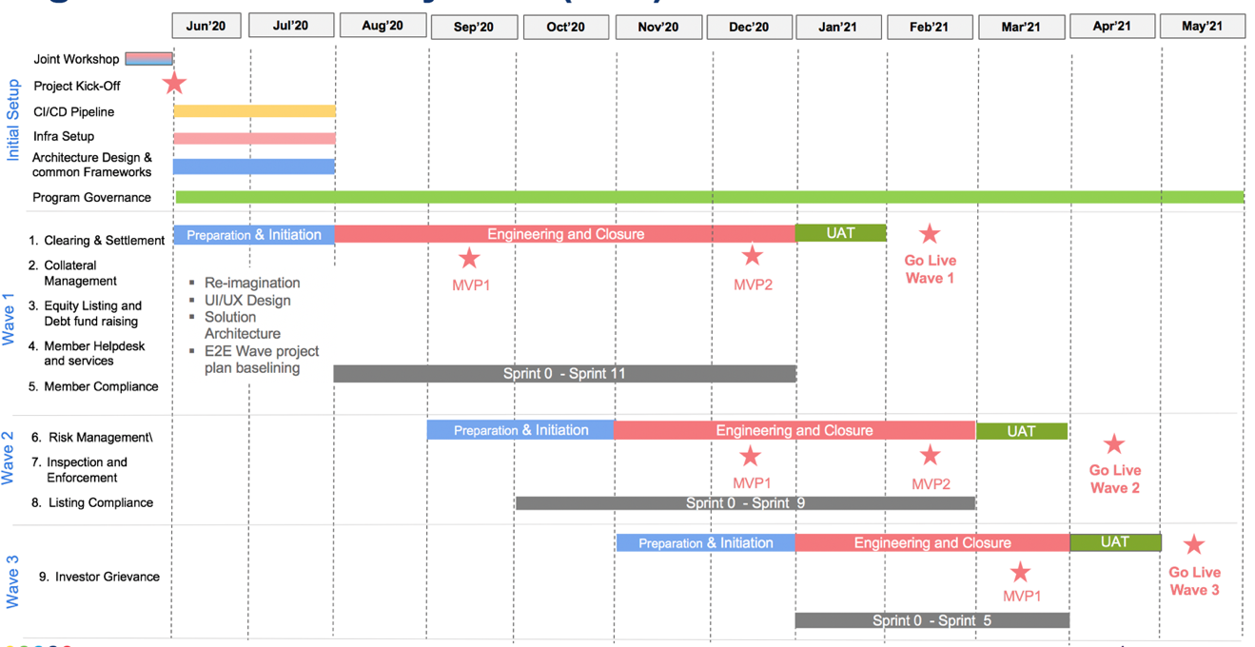

## Program Benefits

The following key benefits will be realized by the Parivartan project:

* World-class trading and clearing front office applications on cloud ready platform for NSE at par with the best exchanges in the world
* Cutting edge technology platform that is robust, resilient, scalable and designed for high performance as future technologies platform NSE Group Applications
* Based on adoption of cloud, microservices, open source and AI/ML innovation delivering best-in-class technology capability for rapid innovation and business functionality roll out in future
* Move away from existing monolithic application estate that is difficult and costly to scale and maintain

# Functional Architecture

## Current State Pain Points Identified by Application

Some of the current application specific pain areas are summarized in the table below:

|  |  |  |  |
| --- | --- | --- | --- |
| Actor | System | Functions | Pain Areas |
| **Corporates | Functional activities and enabling systems** | **NEAPS** | Listing Maintenance • Registration – first time listing • Submit initial application for listing • Receive in-principal approval letter • Submit final listing application day-on-  day • Receive final approval letter  • Submit security deposit  Exchange Compliance   * Submit compliance documents * Update announcements | * Still a lot manual entry needs to be done while filling the form in spite of data available with NSE * No integration with Payment Gateway delaying the process at multiple steps * Lack of clarity on the status of application * No provision for a quick upload of the Board * meeting's MoM * Unable to save draft application so that can * come back later and complete it |
| **Investor | Functional activities and enabling systems** | **NICE Plus** | Investor Grievance   * Registering complaints against TMs and CMs * Following up on the complaint | * Lack of access of updates / announcements on mobile phone, limiting accessibility on the go * NICE Plus is very bulky and cumbersome to use - a user-friendly mobile solution to log complaints and track them is missing * Lack of better self-help options like intuitive FAQs to resolve queries, currently call is the most opted solution |
| **Call Support | Functional activities and enabling systems** | **CISCO Dialer, SAP CRM** | Member Helpdesk   * Receiving Calls * Register and Categorize grievances * Allocating tickets * Viewing Reports | * Lack of workflow management for internal coordination and follow-ups * Allocation logic for assigning a particular ticket to the right stakeholder in NSE is * missing * Lack of dashboard and clear reporting for internal stakeholders on their pending * tickets * Historical data points and member history is also not visible * Not empowered with accurate and relevant information, which can be further * passed on to the external stakeholders |
| **Investor | Functional activities and enabling systems** | **NICE Plus** | Investor Grievance   * Registering complaints against TMs and CMs * Following up on the complaint | * Lack of access of updates / announcements on mobile phone, limiting accessibility on the go * NICE Plus is very bulky and cumbersome to use - a user-friendly mobile solution to log complaints and track them is missing * Lack of better self-help options like intuitive FAQs to resolve queries, currently call is the most opted solution |
| **NSE Inspection Officers | Functional activities and enabling systems** | **Inspection, DW, ENIT** | * Create inspection case in database * Schedule inspection cases * Dispatch letter of intimation to the client * Generate system preliminary observation sheet * Prepare draft report in the system, inspection * checklist, POS * Send action letter (non-critical) * Upload documents to the repository * Send letter of observation to TM * Prepare reply analysis & observation summary * Collate data records available with exchange * Output of queries is stored in Data Warehouse in the form of reports * Receive reply from TM | * Lot of the data points from pre-inspection to final report are filled manually * Lot of the communication (sending additional documents, replying to * queries, etc.) between member and NSE happens offline through emails * Platform issues around slow speed, document generation, doc. uploads, etc. * Lack of high power analytical capabilities to tighten forensics |
| **NSE Listing Officers | Functional activities and enabling systems** | **NEAPS** | * Listing Maintenance * Downloading documents   submitted by corporate   * Updating status of the listing   application   * Raising queries for customers   and changing status to Rework   * Approving the listing   application | * Systems (ex. Compliance and Listing, Equity and Debt, etc.) do not interact to leverage existing data * Lot of verification which can be automated are still manual & time consuming |
| **NSE Compliance Officers | Functional activities and enabling systems** | **Connect2NSE.com, ENIT, Inspection** | Exchange Compliance   * Downloading all the documents * Some parts of communication to the members * Updating status of various submissions   Member Compliance   * Uploading penalty charges for automated deduction | * Lack of workflow management for internal coordination, obtaining NOCs and follow-ups |
| **NSE Member Services Officers | Functional activities and enabling systems** | **Connect2NSE.com, ENIT, Service Now** | Member Services   * Uploading of various documents * Updating status of various requests and submissions * Member enablement   Member Services • Raising a request to Trade Ops for User ID Management  • Raising an adhoc request | * Lack of workflow management for internal coordination, obtaining NOCs and follow-ups * Lot of activities which can be automated with timely triggers are still manual |
| **NSE Clearing Officers | Functional activities and enabling systems** | **Connect2NSE.com, Extranet, NCMS** | Clearing Operations   * Upload obligation and   other files for client   * Upload master data   (contract notes, securities, etc.) for client   * Member enablement and disablement * Obligation reports for members are uploaded on NCMS | * Lack of automation in performing tasks * Lack of visibility on step-by-step statuses of different processes * No clear summarized dashboard/view for tracking activities * Gaps in translating feature enhancement to actual IT req. to final output |

## Current State Clearing and Exchange Applications

There are several functions that are common across Clearing and Exchange operations. The following table highlights the common areas in the two processing units.

|  |  |  |  |
| --- | --- | --- | --- |
| Function | Sub-Function | Realized by Application Type | Mobile Enabled |
| Member Services | Enable/Disable members | External App, Case Management Tool | No |
| Request connectivity | External App, Case Management Tool | Yes |
| On-boarding & Off-boarding | External App | No |
| Colo services | External App, Case Management Tool | No |
| Register for MFD | External App, Case Management Tool | No |
| NNF Approvals | External App, Case Management Tool | No |
| User Management | Add/Delete Users | External App | Yes |
| Provide user access | External App | Yes |
| Update user details | External App | Yes |
| Enable Maker-Checker | External App | Yes |
| Compliance | Role-wise allocation of docs. for verification | Internal App, Case Management Tool | No |
| Verify documents | Internal App | No |
| Update announcements | External App | No |
| Submit regulatory docs. | External App | Yes |
| Submit compliance docs. | External App | No |
| Submit de/merger docs. | External App | No |
| Download member certificate | External App | Yes |
| Helpdesk | Access FAQs | External App | Yes |
| Register queries | External App, Internal App, Case Management Tool | Yes |
| Solve queries | Internal App, Case Management Tool | No |
| Internal allocation | Internal App, Case Management Tool | No |
| Chat with Chatbots/Support | External App, Internal App | Yes |
| MIS | View/download trade reports | External App | No |
| View/download collateral util. | External App | No |
| View/download margin reports | External App | No |
| View/download risk volatility | External App | No |
| View summarized dashboards | External App | Yes |
| View/download Bhav copies | External App | No |

The distinct functionalities between clearing and exchange functions are highlighted below.

|  |  |  |  |
| --- | --- | --- | --- |
| Function | Sub-Function | Realized by Application Type | Mobile Enabled |
| **Clearing** | Approve/Confirm trades | External App | No |
| Pay-in Funds & Securities | External App | No |
| Check statuses of pay-in & out | External App | Yes |
| Set auto-approval limits | External App | No |
| Transfer Obligation | Internal App | No |
| Enforce penalties | Internal App | No |
| Modify Orders | External App | No |
| Modify CP Codes | External App | No |
| Allocate OTRs | External App | No |
| **Risk Management** | Check real-time margins | External App | Yes |
| Set TM-wise limits | External App | No |
| Set customized triggers | External App | No |
| Monitor volatility & other risks | External App | Yes |
| **Collateral Management** | Add/Delete collateral | Internal App, External App | No |
| Allocate collateral | External App | No |
| Early Pay-in | External App | No |
| Monitor collateral levels | External App | No |
| **Listing** | Registration & submit documents | External App | No |
| Submit & track application | External App | Yes |
| Pay various charges and fees | External App | No |
| Verify documents & application | Internal App | No |
| Approve application | Internal App, Case Management Tool | No |
| **Inspection** | Submit Inspection Docs | External App | No |
| Create, schedule and fill cases | Internal App | No |
| Generate Documents | Internal App | No |
| Send reports and findings to SEBI | Internal App | No |
| **Investor Grievance** | Access FAQs | External App | Yes |
| Register queries | Internal App, Case Management Tool | Yes |
| Resolution | Internal App, Case Management Tool | No |
| SEBI reporting | Internal App | No |
| Chat with Chatbots/Support | External App, Internal App | Yes |
| Claims settlement | External App, Internal App, Case Management Tool | Yes |

## Target State Capability Model

The following diagram depicts the target state overall capability model that will be realized by technology architecture around cloud, microservice, AI/ML, RPA and other digital themes.

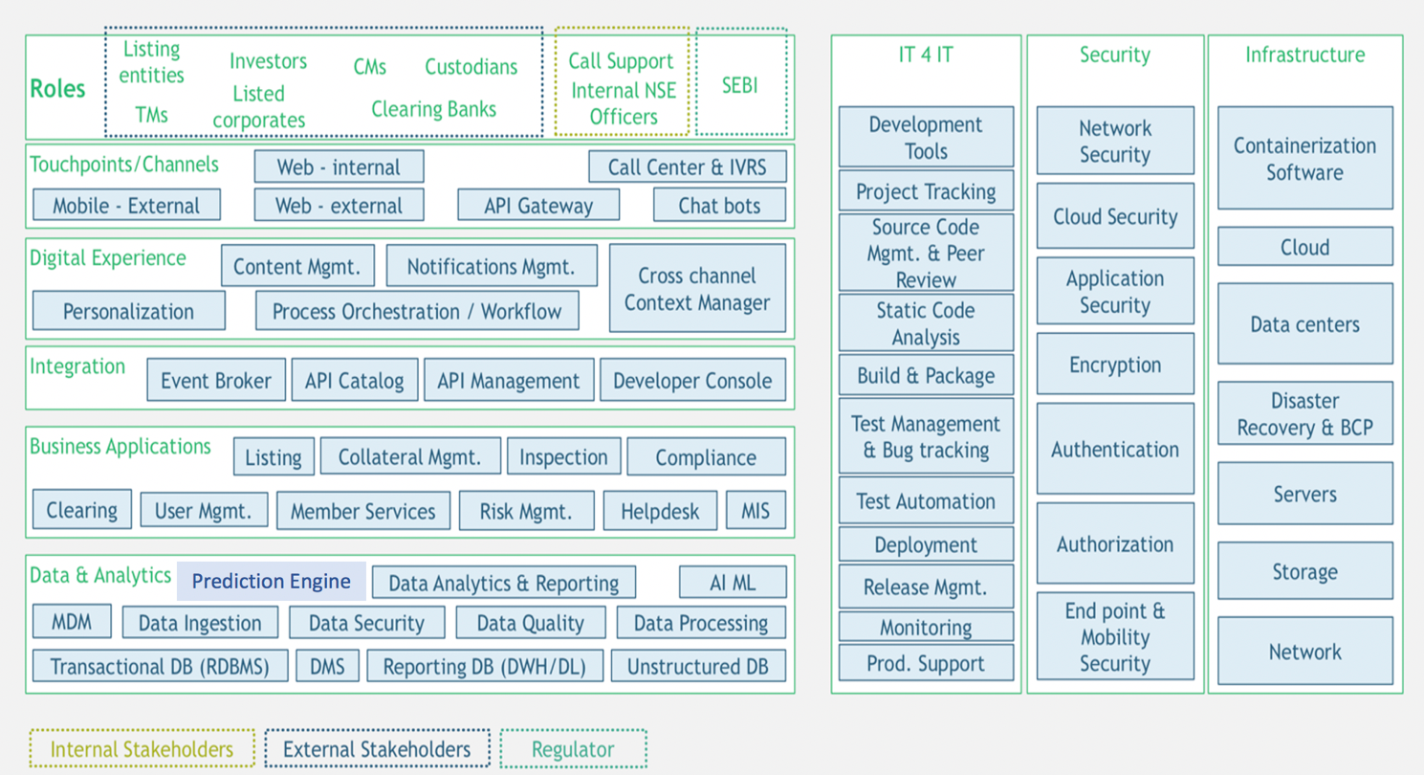

## Future State Conceptual Model

The clearing and non-clearing platforms have been separated as independent functional and deployment units. The following diagrams depict the key clearing capabilities.

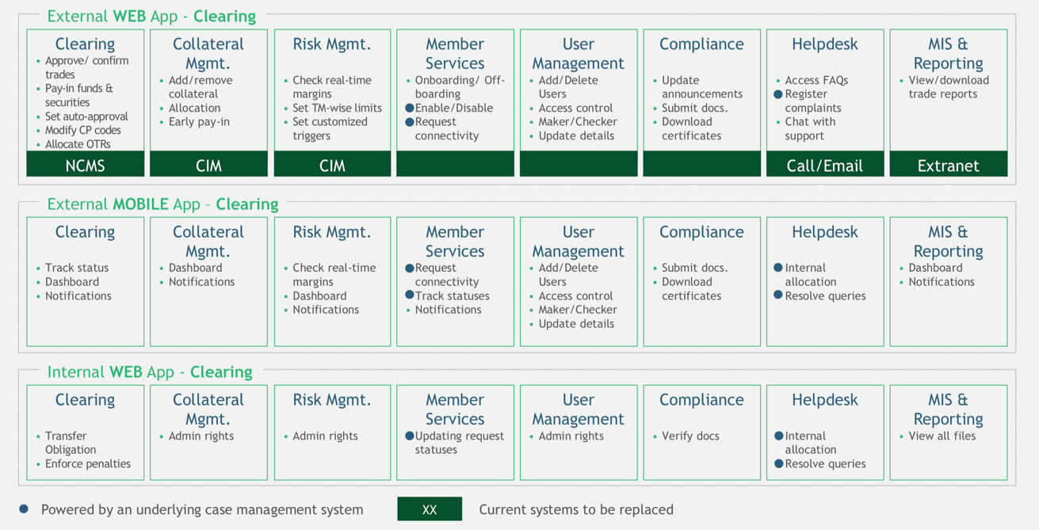

The following diagrams depict the key non-clearing capabilities.

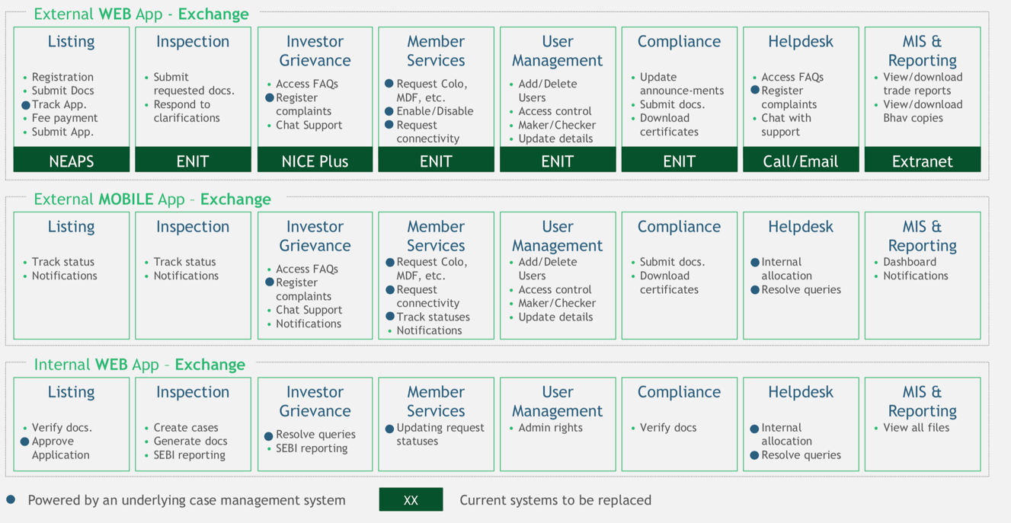

# Operational Design

## Target Operational Model

The program will be delivered on hybrid cloud platform using VMWare Tanzu Application Services (TAS) cloud native platform. TAS will be deployed as private cloud in initial release. Product deployment is on-prem with microservices deployed on TAS private cloud and supporting on-prem infrastructure. The production deployment will be on NSE’s BKC data center with DR on Chennai DC. Two dev environments are created – one on KOH DC and other on AWS public cloud with application deployment on VMC VMs including CI/CD components.

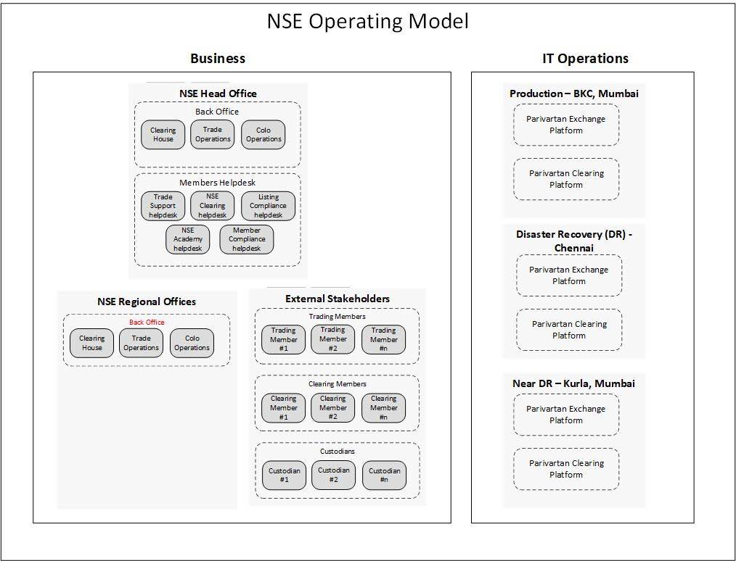

## Clearing Non-Functional Requirements

|  |  |  |
| --- | --- | --- |
| Journey | Sub Process | Volumes/day |
| Clearing Risk Management | Collateral and Open position details at granular level to members | 20000 |
| **C** Clearing Operations | CM Limits Management | 5000 |
| Order Modification | 100000 |
| Confirmation Service | 20L-60L |
| CP Code Modification | 5L |
| Trade Enquiry | 2cr |
| Trade Confirmation | 20L-60L |

**Clearing Projections**

|  |  |  |  |  |  |
| --- | --- | --- | --- | --- | --- |
| Peak Throughput | Txns/day | YoY Growth | Y1 Users | Y2 Users | Y3 Users |
| 5000/sec | 20cr | 50% | 25k | 50k | 75k |

## Exchange Non-Functional Requirements

|  |  |  |
| --- | --- | --- |
| Journey | Sub Process | Volumes/day |
| Exchange Compliance | Member Compliance | 500 |
| Listing compliance | 900 |
| Investor Grievance | 1000 |
| Inspection & Audit | Plan & Execution | 1000 |
| Member Maintenance | Onboarding, Offboarding, Billing, Payments | 1000 |
| Listing maintenance | Listing, Delisting, IPOs | 100/yr |

**Exchange Projections**

|  |  |  |  |  |  |
| --- | --- | --- | --- | --- | --- |
| Peak Throughput | Txns/day | YoY Growth | Y1 Users | Y2 Users | Y3 Users |
| 1000/sec | 20000 | 50% | 25k | 50k | 75k |

**Non-Clearing Platform NFRs**

**Other Key NFRs**

* 24x7 uptime, 99.99% availability
* RPO - 0, RTO - 15min
* Data retention - 7 years

**Detailed NFRs**

|  |  |  |
| --- | --- | --- |
| Area | NFR | Specifications |
| **Security** | **Login** - Access levels/roles | Login to provide 2 Factor Authentication for both Web and Mobile Application  Usage of OTP needs to be  limited whereas to use Mobile Alert/Notification Feature instead of OTP where possible |
| Roles with Read Only, Write/Update Permissions if applicable | Use Write Permission appropriately and frequent review/approval of Write Permission of ACL for both user and system level access control  Appropriate Read or Write Permission to be given for documents stored in document store |
| Password requirements | Member Password needs to be 12 characters of length, must include alphabet and at least one number  Expiry 1 month  NSE Users passwords to be authenticated via AD will follow existing policies. |
| Inactivity timeouts – durations, actions, traceability | Need to determine session time out – 30mins |
| System data back-up (e.g. every *x* hours and copies stored in a secure off-site location) | ?? |
| Encryption (data in flight and at rest) | AES 256 with TLS 1.3 |
| Data Classification- System Accreditation: All Data must be protectively marked and stored / protected. | Clear Document classification like public, private, protected needs to be set for all documents stored |
| Transport Layer Security | All application URL should use HTTPS (TLS 1.3) enabled |
| Regulatory Compliance | Data Privacy like PCI, SEBI Compliance and others where applicable |
| **Audit** | System must maintain full **traceability** of transactions User and transactional time stamps, etc | Login Process needs to be Audit Trailed mandatorily. This needs to be stored in database or Log. Audit trail to include logged in user, application/system user and time stamp mandatorily  Audit data should include business user name, transaction timestamp, regulatory requirements  Soft deletes only - no hard deletes on DB  Event logging - common base event logging |
| **Capacity** | Throughput – how many transactions at peak time does the system need to be able to handle | Should handle average of peak volume of 5000/sec  Should handle average of maximum volume of 20,00,000 – 60,00,000 transaction per Day |
| Storage – (memory/disk) –volume of data the system will page /persist at run time to disk | Application to store 2 years of live/current dat.  5 years of Archival Data  Individual application to override  for any change in above limit. |
| Year-on-year growth requirements(users, processing & storage); e-channel growth projections | Estimated 50% of growth on average for all application |
| Processing times – functions, calculations, imports, exports | All application pages should respond less than a second within LAN |
| Query and Reporting times – initial loads and subsequent loads, ETL times | End of day jobs - should not be more than 15-30min |
| **Availability** | Uptime requirements of new system | 99.99% availability |
| **Reliability** | The ability of a system to perform its required functions under stated conditions for a specific period of time. | Application Design should consider maximum of resilient features like Auto Scaling when failure of instance, Circuit breaker etc.. |
| **Recovery** | Recovery Point Objectives (RPO) | 0 min |
| Recovery Time Objectives (RTO) | 15 min |
| Backup frequencies – how often is the transaction data, config data, code backed-up | Data – 15 min, config, code – 30min |
| **Maintainability** | Conformance to Enterprise Architecture standards | Architects to validate Architecture standards being adapted |
| Conformance to Technical design standards | Architects to validate Architecture standards being adapted |
| Conformance to coding standards | Application to use Code Quality Tools to validate code quality standards to include coding standards rules, security rules etc.  Code quality should be above 95% |
| Conformance to best practices. | Application Technical Leads to verify and validate all best practice being followed with peer and external review check list. |
| **Usability** | Internationalization / localization requirements – languages, spellings, keyboards, etc | English language support only for now. No Internationalization and Localization support requirement |

# Technical Architecture

## Architecture Vision

The following table highlights the vision statements forming the foundation of the target state architecture.

|  |  |
| --- | --- |
| Vision | Description |
| **Omni Channel** Experience Driven Design | Design for an **omni-channel stakeholder experience** and **interoperability** by balancing business functions shared **across different channels** |
| **Modular, Loosely Coupled System** | Design modular, **loosely coupled micro-service-based architecture** enabling a “Lego” approach in order to quickly adapt & differentiate the stakeholder experience. A domain driven approach for building microservices that makes them truly autonomous, fit-for-purpose and reusable. |
| **Reusable** services | Promote optimum, fit-for-purpose re-use of viable **common services across NSE** to deliver required business capabilities |
| **Differentiation** at Edge, **standardization** of core | Drive differentiation & diversification “at the edge” driving **experience differentiation** and aim for optimal **standardization of core components** delivering operational effectiveness |
| **Partner Ecosystem** through **APIs** | Design technology **capabilities as-a-service** enabling easier wider **ecosystem integration** - including 3rd party / partner products & services including **AI/ML, Analytics** |
| **Single representation of data entities** | Design for **single representation of customer, service , employee and transaction across the exchange** |
| Adoption of **Open Source** and **Open Standards** | Promote flexible adoption of smart technologies including **open source without introducing vulnerability** and exposure risks. Use of open standards which enables easy wider eco system integration. |
| **Cloud and Mobile first** approach | Design new technology capabilities with **cloud and mobile first approach,** where appropriate, allow **co-existence with legacy systems using intelligent portfolio integration** |
| **Software defined scalable infrastructure** | Embrace **software defined infrastructure** for higher flexibility and agility through use of cloud, PaaS and containerisation |

## Target State High Level Architecture

The following diagram depicts a high level view of the target state architecture.

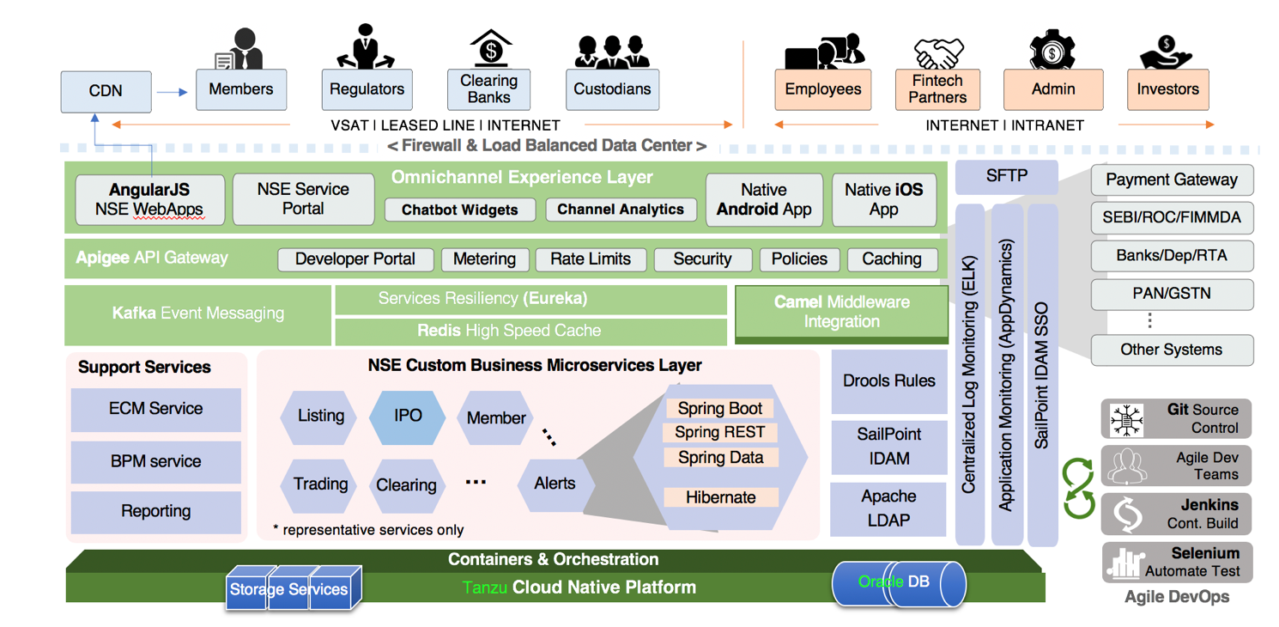

**Layer Description**

***UI/UX layer***

The UI/UX layer represent systems of interaction available to Parivartan system users through various channels like Web, mobile, chatbot. The Web application is built with Responsive Web Design principles using Angular 8 framework. It enables web pages to be rendered adjusted automatically for various form factors and devices on which they are viewed. ReactNative is the framework used for mobile app development as it provides more native experience to users.

***Apigee API Gateway***

The API Gateway implemented using Apigee abstracts all microservices invocation by providing REST endpoints for channel apps to invoke. The Gateway layer implements security, throttling, Quota, Caching and other policies and routes the authorized. The Gateway implements oAuth2 token generation for different grant types and integrates to Parivartan authentication microservice which acts as the auth server. The tokens generated are passed to client application who pass them in HTTP headers for validation by Apigee before requests are forwarded to microservices.

**Key Capabilities of API Management Platform**

|  |  |  |
| --- | --- | --- |
| Feature | Apigee | Benefits |
| Simplified application development | Can create APIs quickly from existing data and services. It provides zero downtime to use those APIs, so the APIs are ready to use. Using following methods, can create API proxies in Apigee environment like importing swagger file, using Java maven plugin or create an API Proxy using Apigee UI | It speed up the API creation and deployment and provides segregation of concerns and modularity |
| Secure and scale | Manage access to APIs with security features that protect - with configurable policies like OAuth, Spike Arrest, XML/JSON threat protection, Regular Expression, Verify access token, access control, Extraction Variable, Assign message, and SAML assertions. | Apigee build trust and engagement with secure assets in your API program. It provides the protection against the hackers, bots, and other suspicious attacks |
| Reporting and monitoring | Apigee Analytics, it’s an inbuilt feature. It provides us the API performance, traffic consumption, developer engagement, API error details etc. and able to generate a custom report | Using this feature, can monitor all microservices closely |
| Improve developer productivity | Deliver an enhanced developer and community experience that accelerates API adoption, simplifies learning, and improves the business value of APIs | It speed up development cycles, improve partner onboarding, and expand ecosystem growth. |

Since Parivartan will have separate deployments for Trading and Clearing, when it comes to API Gateway single multitenant Apigee Gateway is sufficient to handle both Trading and Clearing. It will be identified by the base path and both are bundled in different Apigee products.

Example: -

For Trading -- https://ncl.apigee.com/v1/trade/{api-path}

For Clearing -- https://ncl.apigee.com/v1/clear/{api-path}

Using the Target Server load balancing in Apigee we can route the traffic to DR system. Please find the example below,

**Example**: -

<LoadBalancer>

            <Algorithm>RoundRobin</Algorithm>

            <Server name="target1" />

            <Server name="target2" />

            <Server name="target3">

                     <IsFallback>true</IsFallback>

             </Server>

</LoadBalancer>

The configuration above results in round-robin load balancing between targets 1 and 2 until both targets 1 and 2 are unavailable. When targets 1 and 2 are unavailable, all traffic is routed to target 3.

***Microservices Layer***

The microservices are implemented using Java Springboot framework that provides all the plumbing needed for containerized deployment and runtime lookup using Eureka registry and routing of requests to containers. The microservices are designed specific to domain models and are deployed in containers managed by TAS. The containers are scaled elastically based on load. Developers would need to define manifests for each microservice deployment specifying memory, initial number of container instances and peak number of instances. Microservices runtime are supported by several Spring Cloud services like Hystrix providing circuit breaker functions, Spring Cloud Gateway which acts are load balancer between container instances and routing proxy.

**Microservices Granularity** rules are depicted in the following table

|  |  |  |
| --- | --- | --- |
| Type | Description | Examples |
| Process Microservices | Coarse Grained top-level microservices that are meant to orchestrate across multiple fine grained system microservices calls, aggregate and transform data and respond to client | A user registration microservice is an example that wraps calls to user microservice to store data in DB and notification microservice to send email confirmation |
| System Microservices | These are fine grained microservices that implement a specific discreet function. System microservices being fine grained have higher reusability than process microservices | A PAN validation microservice is an example that integrates to PAN Validation Service Provider through Camel and returns the validation status. |
| Experience Microservices | These are coarse grained microservices that leverages system and process microservices specifically for front end view specific data needs | An experience microservice example is a Personalisation microservice where user preferences and views can be stored and retrieved via calls to user services, preference store, contextual services from analytics engine, alerts microservice etc. |

***Backend Systems and Datastores***

Oracle will be the database used for Parivartan. Microservices will be implementing CRUD operations on their respective domain model on Oracle tables. For integration to NSE core systems, Apache Camel ESB would be used with protocol adapters like sftp, socket, DB etc depending on nature of the integration. Microservices will also need to integrate to various third party services e.g. fintechs like Billdesk, Kaarza and others. For 3rd party services exposing REST APIs, Parivartan microservices will invoke them through a proxy gateway outbound to 3rd party APIs. If a 3rd party service needs to call a Parivartan API (e.g. scenarios like async communication with callback needs), they will come through the Apigee gateway.

## Microservices Architecture Components

|  |  |
| --- | --- |
| Component | Description |
| Containers | Containers are a run time component encapsulating discreet components of application logic with minimal resource footprint as compared to monolithic deployments, containers provide independent deployment and scaling of services, elastic scaling advantages so resource utilization is optimized and application can scale massively and release resources when load reduces |
| Distributed Cache (Redis) | Redis Cache provides caching of data that can be retrieved using a key. Caching provides performance improvement for use cases where static data is retrieved from APIs. This type of data can be stored and loaded from cache for faster turnaround and avoiding roundtrips. Depending on the use case cache timeout need to be set. |
| Spring Boot Web | For building RESTful Web Services for enterprise applications. |
| Spring Boot AOP | For implementing cross-cutting concerns such as logging across the multiple layers of a Java application |
| Spring Boot Validation | For custom validators that allows to apply and combine different validation rules |
| Spring Boot Actuator | Provides endpoints for monitoring and managing Spring Boot application such as health and metrics. It also enables the refresh of externalized Config on a microservice. |
| Spring Cloud Config | Config server that manages all the application related configuration properties. And client applications can load the configuration properties from the Config server without app restart and downtime |
| Spring Cloud Netflix Eureka | A discovery Server that holds the information about all client microservice applications, as a result of microservices registering into the Eureka Server. |
| Spring Cloud OpenFeign | Is a REST client that makes it easy to invoke microservices. |
| Spring Cloud Netflix Ribbon | That provides client-side load balancing algorithms, and used by Feign. It internally resolves the service name with a lookup on the Eureka server. |
| Spring Cloud Netflix Hystrix | Stops cascading failures and enables resilience in a distributed system where failure is inevitable |
| Spring Cloud Zipkin / Sleuth | For distributed tracing including where trace data are reported to |
| Spring Cloud Netflix Spring Cloud Gateway | As a proxy server and service router that handles the requests and does the dynamic routing to microservice applications with a lookup on Discovery server |
| Spring Boot Security | For securing an application, for example to prevent XSS, DDOS. |
| Spring Data JPA | Java Persistence API that improves the implementation of data access layer for Oracle DB |
| Spring Data Redis | To integrate with Redis Cache. |
| Spring Kafka | To publish and subscribe the messages based on the fault-tolerant messaging system, which is fast, scalable and distributed by design. |
| SLF4J | The Simple Logging Façade for Java that serves as a façade or abstraction for the various logging frameworks. E.g. log4j2 or logback |

## Architecture Guiding Principles

|  |  |  |
| --- | --- | --- |
| Principle | Rationale | Implications |
| Data and IT systems should be **secured** at all times, in rest or transit | Financial institution's data is highly sensitive and should be protected against tampering and unauthorized access. | Security principles specific to NSE should be laid down and implemented using suitable standard protocols |
| Seamless access to data & processes **through all channels**, agnostic of device | Inherent need to provide a seamless omni-channel experience to the stakeholders | Services and systems need to be available across channels using a suitable digital experience layer |
| Ease of **integration** across applications & services, internally & externally | Integration issues or integration inability with multiple parties lead to inefficiencies and delayed processes | NSE's to-be architecture should support secure, API-led integration for real time & batch processing |
| Microservices should be resilient and robust | Services need to be always available and fault tolerant | NSEs API should have high availability and responsiveness and system should ensure intelligent routing for errors as they happen |
| Processes should have minimal manual intervention & leverage **automation** | Back-&-forth on email and processes heavy on manual & multiple data entry lead to productivity loss | At NSE, processes should be simplified, digitized and automated across stakeholders and applications |
| Systems should be **scalable** (horizontally & vertically) to manage rapid increases seamlessly | With the rapid increase in trade volumes and data, need the right kind of systems to manage the influx | NSE's architecture should be scalable without impacting performance during peak times (e.g. expiry dates, etc.) |
| Data Domain models should be of **optimal granularity** | Microservices domain models granularity should be optimized based on business domains | Optimized domain models will enhance performance and prevent proliferations of microservice datastores |
| Systems should exhibit **flexibility** to tackle ever-changing environment | Highly regulated areas need flexibility to tackle frequent policy changes and stakeholder requirements | NSE's to-be architecture needs to be microservices-enabled with sufficient granularity |
| Systems should always be **ready for future technologies** to stay relevant | With the current pace of tech. advancements, imperative for architecture to support AI, ML, Blockchain, etc. | NSE's to-be architecture should be analytics ready and readily support multi-format / standard integration |
| Organization's mindset and technology function to drive **Agility** | Delivery and Org. processes need to be efficient to stand out in an ever-changing highly-regulated market | NSE needs to adopt "Agile" software delivery and "Devops" tooling to manage software lifecycle better |
| Design choices and systems should facilitate **minimal architecture maintenance** | In a frequently changing environment, arch. should follow lean principles to allow for ease of change | Wherever possible, NSE's arch. should allow standardized codebases and modularity to localize impact |
| **Data governance** is foundation to seamless & secure operations across the organization | Duplicated data, dispersed data and not-so-standard data lifecycle management leads to process disruption | NSE should follow best practices - MDM, data quality, data lifecycle management processes and tools, etc. |
| Adopt a **cloud-first** approach to increase data accessibility & scalability | In today's fast changing environment, new ways of working like remote collaboration become very critical | NSE should move away from on-prem & move towards secure access to IT apps. and services on cloud |
| **Data centralization** is pivotal in leveraging the true power of data | Critical to establish single source of truth for all data across the organization – Data Masters | NSE's to-be architecture should have consolidated databases and masters instead of different sources |

## Parivartan Components and Products

#### DevOps Components

|  |  |  |  |
| --- | --- | --- | --- |
| Area | Options Discussed | Decision | Rationale |
| CI/CD - ALM |  | **Jira 8.10.0** | Jira is widely used as a project management tool for Agile projects and it integrates well with other CI / CD tools |
| Collaboration tool | Confluence and Sharepoint | **Confluence 7.4** | Confluence selected as it integrates well with Jira and supports the user collaboration in an agile program better. |
| Source Code Control System | GitHub and Bitbucket | **Bitbucket 7.1** | Bitbucket is from Atlassian and integrates better with Jira. Intuitive UI. Has more security features and the code can be split between team members by branches. |
| Static Code Analysis | SonarQube | **SonarQube** **7.9** | SonarQube is good for static code analysis and integrates well with Jenkins as the CI tool. |
| CI/CD pipeline | Jenkins | **Jenkins** **2.2.35.1** | Jenkins integrates well with a host of CI/CD ecosystem components |
| Build tools | Maven and NPM | **Maven 3.6.3** and **NPM 6.14.6** | Maven will be used for java code build. NPM will be used for node.js build. |
| Binaries repository | Artifactory | **Artifactory** 7.6 | Artifactory is widely used and integrates well with other CI / CD components. |
| Unit Testing | Junit | **Junit** 5.6.0 | Junit will be used for unite testing of Java components |
| DB Monitoring | Oracle Enterprise Manager | **Oracle Enterprise Manager** 13.4.0 | This will be used for Oracle component testing and monitoring. |
| API testing | REST Assured | **REST Assured** 4.3 | Intuitive tool for REST API automated testing |
| Application Performance Management | AppDynamics | **AppDynamics 4.5** | Application Performance Monitoring |
| Performance Testing | JMeter | **JMeter 5.3** | JMeter will be used as performance testing tool with specific focus on web applications. |
| Software security and source code scanning | Checkmarx and Veracode | **Checkmarx** **8.9.0** and **Veracode** | Checkmarx is already used by NSE and can be used for static code security assessment. Veracode will be used for Dynamic Analysis Security Testing. It integrates well with the other components. |
| Multi cloud continuous delivery | Spinnaker | **Spinnaker** **1.17** | Spinnaker for multicloud deployment pipelines. |
| Logging | ELK, Datadog, Loggly | **ELK 6.2** | ELK will used logging framework provides dashboarding features and collects logs from streams. Easy for debugging on cloud environments. |
| Delivery pipeline Dashboard | Hygeia | **Hygeia** **3.1.0** | Hygeiea for dashboard view of pipeline components |
| DB version control | Liquibase | **Liquibase 3.6.0** | Will be used to manage the versions of the database schema as part of the overall code version management. |

#### Application Stack Components and Products

|  |  |  |  |
| --- | --- | --- | --- |
| Area | Options Discussed | Decision | Rationale |
| Front end - web | Angular, React | **Angular 8.0** | MVC framework, better maintainability, less code, better user experience |
| Front end -mobile | Ionic, ReactNative | **Reactnative** 0.62 | Performance and user experience of React Native for mobile app development is better. |
| IDE for Web | Visual Studio Code, Eclipse | **Visual Studio Code 1.47** | Visual Studio Code is a rich editor for Angular development with developer friendly debugger, auto code completion, git integration and many other features |
| Web server | Nginx, express | **Nginx 1.19.1** | Nginx is very fast and reliable as a load balancer and web server. |
| API Gateway | Apigee, IBM API connect | **Apigee 20.04.06** | Apigee is the leader in most analysts ratings and provides out of the box easy to implement policy configurations and custom policy implementation options |
| Microservice Development | Springboot | **Springboot 2.2.1** | Springboot will be the microservices development framework |
| Containerization | TAS and Openshift | **TAS 2.9** | TAS abstracts lot of the container management complexities for developers and operations compared Openshift. Containers have huge benefits over monolithic deployments in terms of scaling as they can be deployed and scaled independently and elastically. This improves the overall scalability, availability and resiliency of the services and in turn end user experience. |
| IDE for Java | STS, Eclipse, IntelliJ | **STS** 2.2.1 | Spring Tool Suite is Eclipse based IDE that is meant for Springboot development using annotations for various Spring Cloud framework components |
| Event Broker | Rabbit MQ, Kafka, Apache Pulsar, Solace | **Kafka 2.4.0, Solace 9.6.0.27** | Kafka has many industry use cases of high throughput event processing implementation and has high availability clusters, persistence and guaranteed delivery features |
| Cache | Redis, MemcacheD, EHCache | **Redis 2.9** | Redis has high availability clusters and open source |
| Selenium | Selenium | **V4** | one of the best tools for automated UI testing |
| Database | Oracle | **Oracle 19c** | Oracle will be used as the Database |
| Data Ingestion, processing | Informatica | **Informatica 9.6** | Existing tool in NSE that can be reused |
| Data Security | Vormetric | **Vormetric** | Existing tool in NSE that can be reused |
| Datawarehouse | Greenplum | **Greenplum 6.9** | Existing tool in NSE that can be reused |
| BPM | jBPM, ServiceNow | **jBPM 7.40.0** | Open Source BPM engine. Parivartan does not have many workflow use cases. Open source jBPM comes with Eclipse based editor and visual workflow designer |
| Rules | Drools, JRules | **Drools 7.40.0** | Lightweight Open Source Rule Engine with fast response |
| Document Management System | OmniDocs, ServoDocs | **Newgen Omnidocs 10.0** | Advanced features and capabilities like OCR |
| File Transfer Gateway | Axway, IBM Sterling | **IBM Sterling File Gateway v6.0** | Better adherence to regulatory compliance, better change management |
| Reporting | Jasper Reports, Eclipse BIRT, Tableau | **Tableau 2020.1** | Tableau is currently used by NSE and integrates to various data sources |

\*\* Java 11 will be java version used for code and all product dependencies.

#### Third Party Services

|  |  |  |  |
| --- | --- | --- | --- |
| Area | Options Discussed | Decision | Rationale |
| SMS | Infobip | **Infobip** | Infobip SMS API is currently used in NSE |
| Email | Infobip | **Infobip** | Infobip EMail API is currently used in NSE |
| Push Notification | Infobip | **Infobip** | Infobip provides Push Notification service |
| Payment | Billdesk, RazorPay | **Billdesk** | Billdesk already implemented for one listing journey in NSE; contract in place |
| OCR | Jocata, CapitalQuant | **Automation anywhere / CapitalQuant** |  |
| PAN Validation | Karzaa | **Karzaa** | Provides DoB based PAN validation |
| Aadhar Validation | Aadhar |  | Aadhar validation |
| Member Screening | Karzaa, Corpository, Jocata, CrediWatch, Trackwizz | **Jocata & Trackwizz** | Jocata: Fully owned subsidiary of BillDesk, hence contract already in place  Trackwizz for one specific implementation (IOSCO screening) which is not available elsewhere |
| E-Sign | Jocata, Trackwizz, Leegality | **Jocata** | Jocata has tie-up with e-sign vendors (Leegality, Digio), contract already in place with parent company (BillDesk) as above |

## Common Framework Build components

The below table list the framework and common components including the various concerns that affects the entire application

|  |  |  |  |
| --- | --- | --- | --- |
| Component | Component Type | Description | Implementation |
| Authentication | Cross-Cutting Concerns | Process of verifying user credentials | Microservice with CRUD operations for credentials stored in DB |
| Authorization | Cross-Cutting Concerns | Process of verifying what access privileges belong to user role | Microservice with CRUD operations for ACLs in DB mapping role to privileges |
| Auditing | Cross-Cutting Concerns | Tracking of resource utilization and authority, specifically, the monitoring and recording of user actions. | Non-blocking (event based) Microservice |
| Application Logging | Cross-Cutting Concerns | Produce structured log messages due to the mutable state of microservice containers | Spring AOP based library.  To be included as dependency in individual microservices. |
| Validation | Cross-Cutting Concerns | Server-side validations of common data attributes | Library.  To be included as dependency in individual microservices. |
| Exception Handling | Cross-Cutting Concerns | Handling of runtime errors for normal flow of application | Library.  To be included as dependency in individual microservices. |
| Configuration Server | Framework | Externalization of application configuration | Microservice |
| Service Discovery | Framework |  | Microservice |
| Business Rules Engine | Common | Business rules execution in a runtime production environment with Drools | Setup / Configuration |
| Notification services | Common | Notification service via SMS, Email and Push Notification | Microservice |
| User Preferences | Common | Capture the user’s (customer) preferences attributes of the portal/mobile app | Microservice |
| Payment Processing | Common | Payment processing with Billdesk | Microservice |
| PAN Card Validation | Common | PAN Card Validation with Karzaa | Microservice |
| Aadhar validation | Common |  | Microservice |
| OCR | Common |  | Microservice |
| Member/Person/Entity Data Screening | Common | Data Screening with Jocata and Trackwizz | Microservice |
| Core system Integration | Common | Core system integration via TCP, FTP and DBLINK | Adapter |
| Workflow integration | Common | Workflow integration with jBPM | Microservice |
| DMS | Common | Integration with Newgen for document management | Microservice |
| Case Management | Common | Case Management with jBPM | Microservice |
| E-Sign | Common | E-sign integration with Jocata | Microservice |

## Parivartan Architecture Constraints

* NSE Core systems will not be modified as far as possible

## Assumptions

* Reimagination will strive for straight through processing and real time APIs and interfaces wherever possible
* Hybrid frameworks will be used for mobile and web clients for omni-channel experience
* Mobile and Web app functionality will not be exactly identical, hence separate mobile app will be created

# Parivartan Architecture Patterns

## Parivartan API patterns

|  |  |
| --- | --- |
| Pattern | Description |
| Stateless | APIs are to be designed as stateless exposing REST interfaces to clients. Any state management will be carried out on client layer as necessary e.g. maintaining login sessions. |
| Negotiation of API endpoints (Content & Context) | HTTP has provisions for several mechanisms for content negotiation — the process of selecting the best representation for a given response when there are multiple representations available. REST API implementations rely on agent driven content negotiations using HTTP request headers or resource URI patterns. Implementing Accept header based content negotiation is most used and recommended way. e.g. “Accept: application/json”. When data is sent in the payload of a HTTP message within a request or a response, the corresponding format is specified using a Content-Type header. Usable values correspond to media types (initially called MIME types). |
| Intent vs domain model | API implementations would be atomic and fine grained confined to specific domain model within the context of the API. Intent Verbs will be used to make it explicit the nature of the operation that is being performed by the API. E.g. APIs performing Create operations will receive a POST HTTP request, while ones doing read or select operations will receive an HTTP GET request. |
| Versioning and Request Structure | All endpoints must be prefixed with version e.g. /v1/. Pattern: /v1/...  Collections of resources are referenced by their resource name (plural) Pattern: /v1/:resource name Example: /v1/accounts  Individual resources are referenced their resource name (plural) followed by the an id. Pattern: /v1/:resource name/:guid Example: /v1/accounts/25fe21b8-8de2-40d0-93b0-c819101d1a11 |
| Security | An API gateway establishes a single entry point for all requests coming from all clients. It uses Client credentials (client-id and client-secret ) to validate a request and generate Authorization tokens for oAuth authentication using enterprise security framework (e.g. Microsoft Active Directory). Options for integrating with enterprise identity and access providers include JWT tokens from identity provider, API call to identity provider using 2-way TLS, custom libraries from identity provider |
| Asynchronous | API Endpoints are responsible for behaving either asynchronously (return HTTP 202) or synchronously (don't return HTTP 202). Asynchronous implementations may return an identifier to the async. task and a status like “in progress” etc. E.g.  202 Accepted Location: /v1/jobs/123 { "message": "Task queued" } . The identifier can later be used to query the status of the task e.g. GET /v1/jobs/123 |
| Event driven | Various use cases of Parivartan will leverage Apache Kafka Event bus for event based interactions including publish subscribe and fire and forget patterns. Publish Subscribe will be used for trade download use cases in Clearing. For many common services like auditing, async hand-off will be done from microservices for needs like auditing using events instead of blocking synchronous calls. |
| Errors | The HTTP status code returned for errors MUST be included in the documented status codes for APIs. This code would be an internal unique identifier of a class of error. The method for maintaining a list of these codes and their meanings would need to be determined. |
| CQRS | Command Query Responsibility Segregation (CQRS) is implemented by building APIs of two types: command-side APIs and query-side APIs. The command-side handles create, update, and delete requests and emits events when data changes. The query-side handles queries by executing them against one or more materialized views that are kept up to date by subscribing to the stream of events emitted when data changes. |
| Circuit Breaker | circuit breaker pattern isolates points of access between the services, stopping cascading failures across them, and providing fallback options, all of which improve the system’s overall resiliency. |
| Failures and Retries | Auto retry failed requests with random retry intervals and use short timeouts. When a service fails fast, it makes sense to automatically retry a request before breaking the circuit. The clients of a service shouldn’t be kept waiting for a timeout to occur. Use Custom fallback implementations – using stubbed data, cached data, or queue a write request to generate a fallback response instead of “fail silent” or HTTP 5xx response. |
| Throttling | API Gateways can apply policies to handle request spikes during a very busy period. It throttles the number of requests processed by an API proxy and sent to a backend, protecting against performance lags and downtime. Application level throttling and sending appropriate message at service level if an API call is throttled will be designed. |
| Caching | Policies can be configured on API Gateway for caching certain responses for faster response. E.g. an API that geocodes an address will always return the same response for the same address and makes sense to cache it. |
| Mediation | API Gateways can be used for lightweight custom mediation and also provides policies for implicit translation of JSON to XML or SOAP and XML/SOAP to JSON formats. |
| JSON Threat Protection | Minimizes the risk posed by content-level attacks by specifying limits on various JSON structures, such as arrays and strings. Application level json threat sanitization will also be designed using specific java libraries. |

## End to End Request Flow Pattern

The following diagram depicts the end-to-end pattern of the architecture components used for handling requests originating in the front end channel applications.

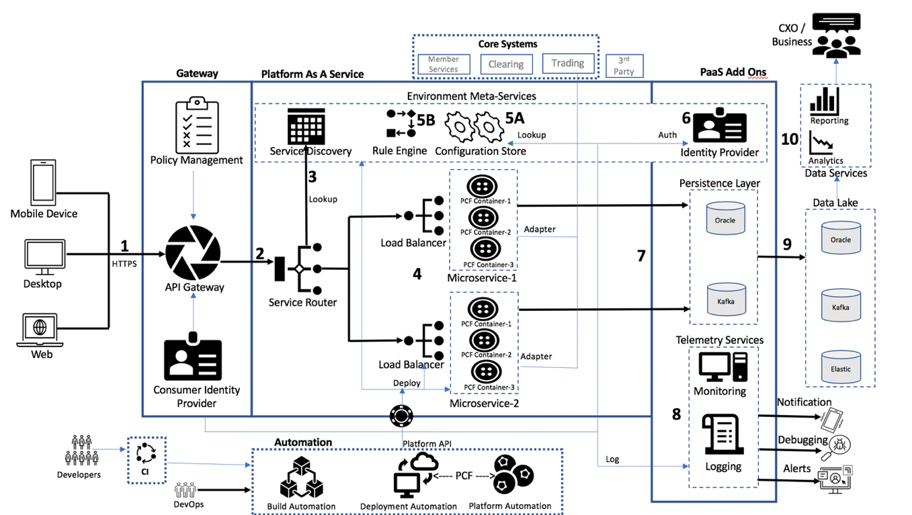

## Load-balancing Container Instances - Spring Cloud Gateway Routing Proxy

The following diagram illustrates the request flow from client via Apigee Gateway to microservices layer. Spring Cloud Gateway acts as a routing proxy and load balancer.

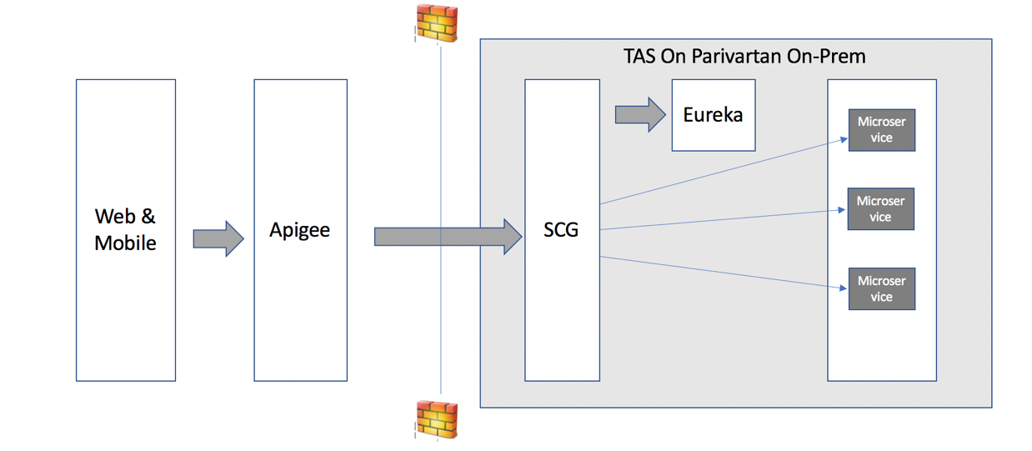

Spring Cloud Gateway exposes endpoint URLs for microservices. It talks to Eureka server to get live container instances of a microservices invoked by clients (via Apigee in this case). Eureka keeps track of all running container instances and returns the list of instances to Spring Cloud Gateway. Spring Cloud Gateway load balances across the container instances in round robin fashion.

## Flow for User Registration

The following diagram depicts the components involved and sequence of events for user registration from web and mobile channels

**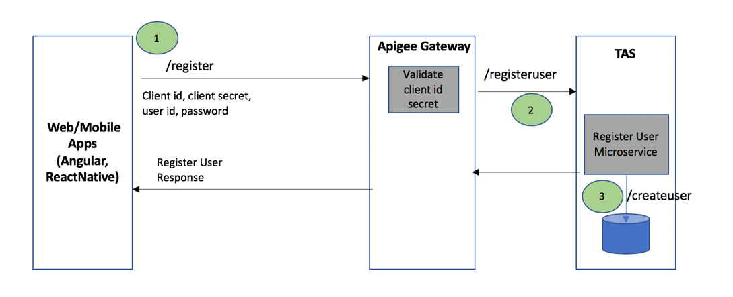**

**Pre-Requisite -** Parivartan API Product registered on Apigee and client id/secret generated for front end apps

**Sequence**

1. User receives registration page and submits credentials and details

2. App invokes Apigee /register endpoint with client credentials grant, passing client id, client secret, user id and password

3. Apigee forwards request to RegisterUser microservice which invokes which stores the user credentials and details in Parivartan DB. On successful storage in DB response is returned to UI.

## Fintech Integration Scenario – PAN Validation Service Provided By Two Fintechs

**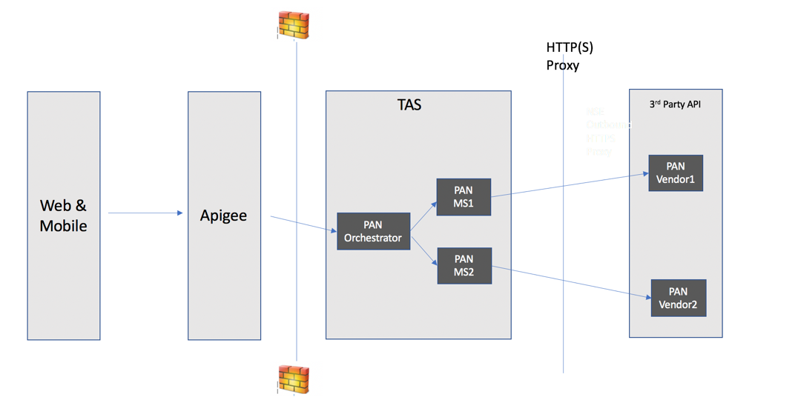**

This is a Parivartan requirement for certain use cases where two fintechs providing same service is sometimes used when the service is critical to fulfil an use case (e.g. real time PAN validation) and service outage with one vendor would still let the processing complete. The Fintech APIs may be invoked in round robin fashion by the orchestrator API.

|  |  |
| --- | --- |
| **Step** | **Description** |
| 1 | Client invokes Apigee endpoint for PAN Validation |
| 2 | API Gateway validates client id and secret and invokes PAN Validation top level microservice (orchestrator) |
| 3 | Orchestrator routes the request in round robin fashion to vendor specific microservices |
| 4 | An HTTP(S) proxy routes outbound internet traffic from NSE network to 3rd party API |

## Async Third Party Services Invocation

**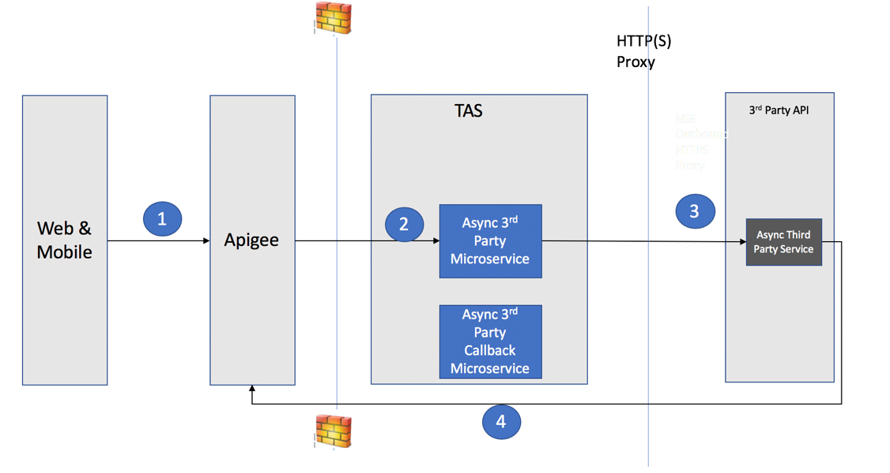**

This is a Parivartan requirement for certain use cases where a fintech is exposing an asynchronous API. This type of API will receive a client request with a correlation id that it can use later to return the response asynchronously. Such APIs would typically require a callback API to be implemented on Parivartan side which the third party invokes to return the response to the original call using the correlation id. The callback API endpoint is exposed via Apigee

|  |  |
| --- | --- |
| **Step** | **Description** |
| 1 | Client invokes Apigee endpoint for an Async Fintech API |
| 2 | API Gateway validates client id and secret and invokes microservice implementing the vendor integration |
| 3 | Microservice invokes the vendor async API and does not wait for a response (fire and forget) |
| 4 | Once request processing is complete on vendor side, the vendor service invokes the callback API endpoint on Apigee to communicate the response back to the calling microservice which uses the correlation id to tie it back to the original request. |

## OTP based 2FA Scenario

**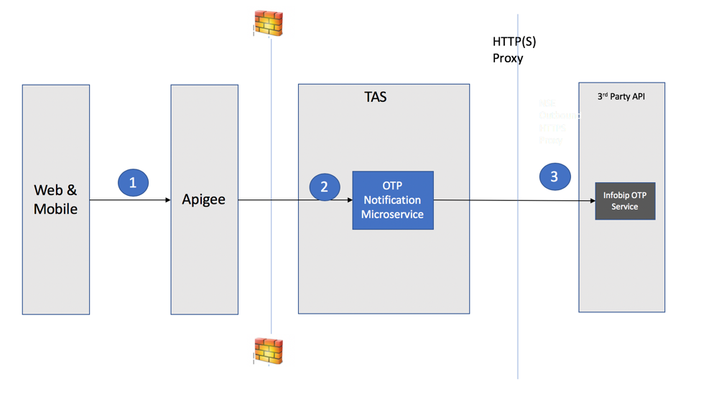**

The users logging in to Parivartan Portal will be authenticated via 2FA. This scenario depicts the 2nd factor based on OTP

|  |  |
| --- | --- |
| **Step** | **Description** |
| 1 | Angular or React app generated random number and sends it to user device by invoking the OTP API |
| 2 | API Gateway validates client id and secret and invokes microservice implementing the OTP integration |
| 3 | OTP service sends SMS to user device. User enters the code received in SMS and it is validated by client app that originally initiated the OTP API |

## Inter Microservice communication – Netflix Eureka, Feign Client, Ribbon, Hystrix & Kafka

The following diagram illustrates the microservice to microservice communication, which involves Feign Client, Ribbon Load Balancer, Hystrix Circuit Breaker, and Kafka Message Broker. request flow from client via Apigee Gateway to microservices layer. Spring Cloud Gateway acts as a routing proxy and load balancer.

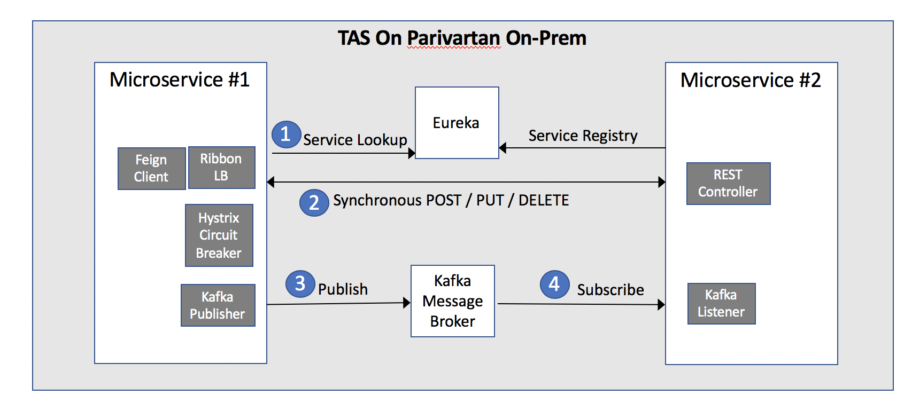

**Pre-Requisite** – All TAS deployed microservices are registered on Netflix Eureka Service Registry

**Sequence**:

Microservice #1 has to execute a synchronous call to Microservice #2.

1.       Microservice #1 makes use of Feign Client component, which internally uses Ribbon client-side load balancing. The microservice invokes the method implemented by Feign Client, which internally uses Ribbon that performs a lookup on Netflix Eureka component to resolve the service instance.

2.       Microservice #2 is then invoked for the Http method – GET / POST / PUT / DELETE.

3.       If the invocation of microservice #2 fails, the Hystrix Circuit Break component can be implemented with a fallback mechanism. In the case of a POST / PUT / DELETE method, a message can be published to a Kafka Topic.

In case of GET failure, we could return default data or partial data or an appropriate message based on the user story.

4.       The message can then be subscribed by Microservice #2 for further processing

## Configurable Cross-cutting concerns – AOP & Config Server

The cross-cutting concern of Application Logging is to be implemented with Spring AOP. Spring AOP implementation is also being considered for Auditing.

The Config server is to be used for fetching flag(s) required to control switching-on & off the capabilities (E.g. Logging and Auditing) for the microservice in execution.

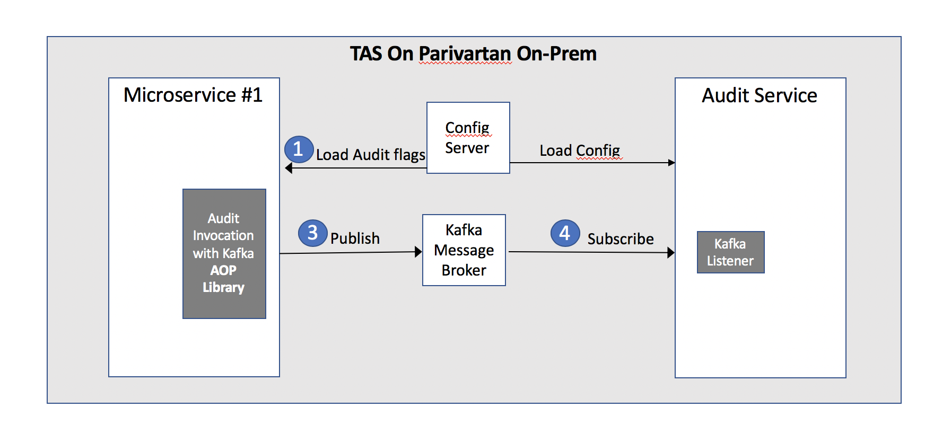

**Sequence:**

Auditing is being used as an example to illustrate, though Application Logging would also follow a similar pattern.

1. The config of the microservice will be loaded during container start-up. It will contain flags that will help control the switch on-off the audit requirement of the microservice.

Config of a started microservice can also be refreshed with a POST API call.

1. Spring AOP aspect to be developed, with a Pointcut to intercept the call during entry and exit to the controller layer and exception processing. The Advice will check if the audit flag is enabled and accordingly prepare an auditEvent.
2. The Advice will then publish the auditEvent on to the Kafka broker. In the case of Application logging, a log message will be written.

The Spring AOP aspect will be developed as a library and included as a dependency in all microservice, thereby providing a consistent behaviour across all microservices.

1. The Audit microservice will subscribe to the topic and update the Audit table.

#### Auditing

Auditing requirement is applicable on the microservice layer only. Auditing to be developed as a microservice, which can be invoked from other microservice either via:

* the standard synchronous Request-Response design pattern
* a non-blocking asynchronous event via Kafka

A Spring AOP based implementation is being considered for invoking the Audit component during entry and exit to the controller layer of the microservices and during exception processing.

For every invocation of a microservice, there will be a record (row) inserted in the Audit database, with the table partitioned on CreatedDate. The need for Oracle table sharding needs to be evaluated.

**Sequence:**

1. The config of a microservice will be loaded during container start-up. It will contain flags that will help control the switch on-off the audit requirement of the microservice.
2. Spring AOP aspect to be developed, with a Pointcut to intercept the call during entry and exit to the controller layer and exception processing. The Advice will check if the audit flag is enabled, and accordingly prepare an auditEvent and publish the auditEvent on to the Kafka broker.

The Spring AOP aspect will be developed as a library and included as a dependency in the microservice, thereby providing a consistent behaviour across all microservices.

1. The Audit microservice will subscribe to the topic and insert the Audit table record.

The API endpoints are as follows

|  |  |
| --- | --- |
| **API endpoints** | **Descriptions** |
| POST /v1/audit | Create an entry in the Audit table on start of microservice processing |
| PUT /v1/audit | Update the entry in the audit table on exit of microservice processing including in the case of an error |
| GET /v1/audit/{id} | Retrieve audit record based on Audit table primary key |
| GET /v1/audit/user/{user}/timewindow | Retrieve audit record by user performing the transaction based on a time window |
| GET /v1/audit/traceId/{traceId} | Retrieve audit record by trace id (generated by Zipkin) |
| GET /v1/audit/serviceId/{serviceId}/timewindow | Retrieve audit record based on Audit table primary key |

#### Application logging on the microservice layer.

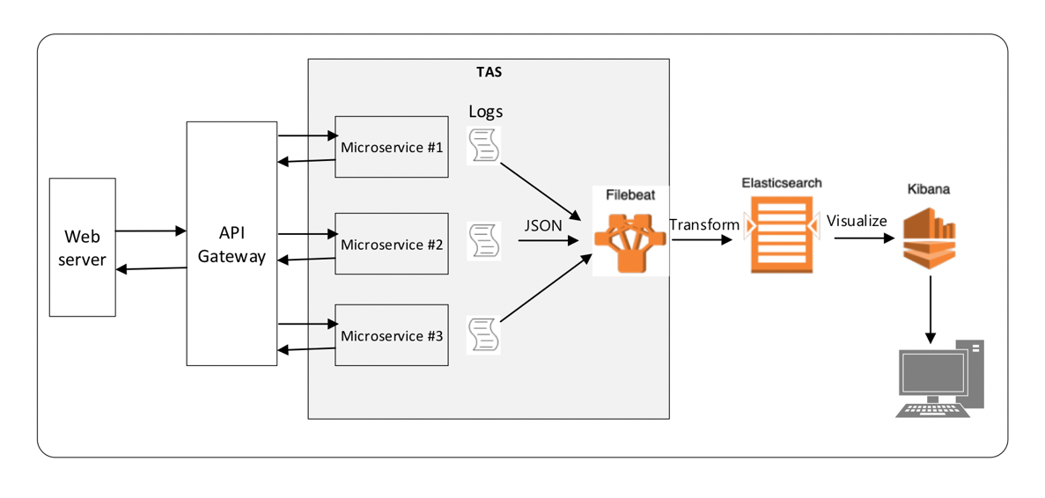

Logging is critical in a microservice architecture due to the mutable state of the microservice containers.

* Each individual microservice should produce structured log messages
* A Filebeat service running on TAS can subsequently ship the log messages to ELK
* ELK can help with aggregation based on Tracing IDs, and to assemble full pictures of events in the system for analysis and action.

A common Spring AOP based logging library is to be developed.

* This library will control what and when to log. For e.g. to log at the beginning and exit of method execution in specific layer.
* Custom logging annotation is to be developed and can be used in individual microservices as required. For e.g. @CalculateTime to calculate method execution time
* This library is to be included as a dependency in individual microservices, thereby enforcing and control of logging by framework

**Sequence:**

1. The config of a microservice will be loaded during container start-up. It will contain flags that will help control the switch on-off the Log requirement of the microservice.
2. Spring AOP aspect to be developed, with customized annotation and different Pointcuts to intercept the call during entry and exit to the specific layers and exception processing.
3. The Advice will check if the Logging flag is enabled, and accordingly write out logs

#### Server-side Common Data Validations

The validation of input data is a common requirement in most applications, and the de-facto standard for performing validation is Hibernate Validator, the Bean Validation framework’s reference implementation. It ensures that the properties of a domain object meet specific criteria using:

* Built-in constraint annotations such as @NotNull, @Min, @Max and many, many more.
* Custom validation annotation, where in constraint annotation are applied on a new annotation
* Custom constraint validator for handling advanced logic, for example, to restrict a field to a specific list

Implementation details:

* A common Validation library containing custom validation annotations is to be developed. For e.g. validation of IP address, siteVisit
* The Validation library is to be included as a dependency in individual microservices. The spring validation library doesn’t have to be added in to the microservice project as it has been included in the Validation library
* Use the custom validation annotation in microservice build

#### Exception Handling

Exception Handling Exception Handling is a front-end and server-side concern.

**From a front-end perspective**, the errors are categorized as:

* Data validation errors, which is handled by Angular forms itself
* Client-side errors related to coding errors and network problems, handled with RxJS operators catchError and throwError
* Server-side errors returned by API calls, which is to be handled with RxJS operators catchError and throwError on the HttpClient service

**For server-side microservices:**

Exception Handling is handled with the global @ExceptionHandler used with the @ControllerAdvice annotation to throw exceptions. The @ControllerAdvice annotation allows to consolidate multiple @ExceptionHandlers into a single, global error handling component. The mechanism is simple flexible, and provides:

* Full control over the body of the response as well as the status code
* Mapping of several exceptions to the same method, to be handled together, and
* It makes good use of the newer RESTful ResposeEntity response

The below exception handling has been developed as a common library and is to be included in individual microservices as a dependency.

1. Common thrown exceptions are handled in a @ControllerAdvice class
   1. BadRequestException, when mandatory fields are missing, data validation failures.
   2. NotFoundException when the entity is not found during an update
   3. InternalErrorException during an internal server exception
   4. MethodArgumentNotValidException
   5. Etc…
2. A standard exception message is defined and constructed as a response to the client.

{

"errorCode": "NOT\_FOUND",

"errorMsg": "Invalid regional office id",

"status": 404,

"timestamp": "2020-07-30 04:24:56"

}

1. Logging of the exception
2. The exception is updated into the Audit table via the Audit microservice

## Auto-scaling strategy

Automatically scale individual microservices based on rules that are set via a configuration defined in a manifest file.

TAS platform provides an auto-scaling service with no additional licensing required.

Auto-scaling to be set based on the following rules:

* Set the minimum number of instances to 1 and max to 5
* Scale up the number of instances by one when the memory utilization crosses 50% and scale down otherwise
* Scale up the number of instances by one when the CPU utilization crosses 40% and scale down otherwise

When the HTTP throughput crosses 20, the number of instances scale up by one, and if it goes below 20, the number of instances scale down by one.

## Circuit Breaker

As services collaborate when handling requests, the failure of one service, either unavailable or exhibiting high latency (and unusable), can potentially cascade to other services throughout the application. This also causes resource exhaustion, an example is threads being consumed while waiting for called services to respond, which makes the calling service unable to handle other requests.

To enable fault tolerance in the application, it is recommended to apply the circuit breaker design pattern whereby the execution falls back to a different path automatically in case of any failure. In this manner, the services handle the failure of the services that they invoke.

* If GET fails, Return default data or partial filled data or an empty list
* If a synchronous POST or PUT fails during microservice to microservice communication, publish an Event via Kafka to the other microservice
* If a specific 3rd party API is not available, route the request to a backup service provider

## Log Archival

**ELK Stack Log**

Elastic Cloud Enterprise automatically curates the logging and metrics indices it collects. By default, metrics indices are kept for one day and logging indices are kept for seven days. This retention period can be adjusted.

**NGNIX Log**

The following script can be run as a VM cron job for daily rotation of NGNIX logs.

$ mv access.log access.log.0

$ kill -USR1 `cat master.nginx.pid`

$ sleep 1

$ gzip access.log.0

## Clearing and Settlement use case realization

The earlier sections covered architecture usage patterns that is applicable for many use cases in Parivartan. This section demonstrates the application of the concepts in some of the key Clearing and Settlement use cases.

**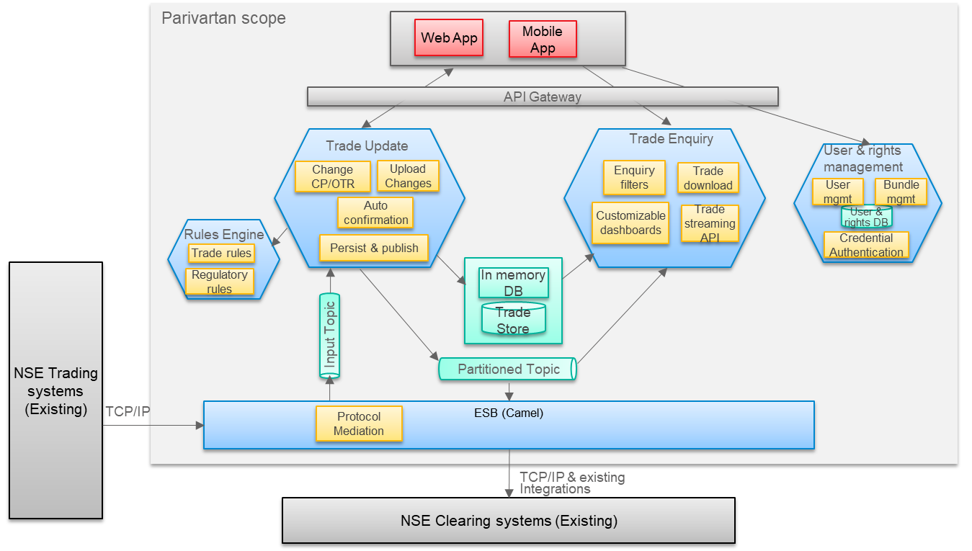**

The above diagram depicts some of the key Microservices and other Parivartan Solution components for the reimagined Clearing and Settlement user journey to demonstrate the architecture realization. It is not intended to be comprehensive solution design for Clearing and Settlement.

The clearing and Settlement will be built on the foundation of API/Microservices as well as Event Driven architecture that provide high scalability, resilience and performance. Trade Enquiry and update are modelled as coarse grained Microservices with single responsibility within Clearing and Settlement. The write and the read functionality are separated as per the CQRS pattern, so that they can be scaled separately based on the different workloads. The User & rights management Microservice is common to many use cases beyond Clearing and Settlement. The Rules Engine is modular service dedicated to executing business rules and can be shared across use cases where business rules are required.

The Microservices will expose clearly defined APIs and can be accessed by Front-end application used by Members via API Gateway. The Trade Update and Enquiry services will be Event Driven and support streaming using Kafka in order to handle high throughput of Trades. Integration with existing NSE core Trading and Clearing systems will be decoupled through the Enterprise Service Bus implemented using Camel.

Wherever applicable, the Microservice will own its data and share access with other services through APIs like the User & right management Microservice which encapsulates its user management data. But in cases where the Microservices are closely related and performance is critical, the database will be shared. Trade Update and Enquiry Microservices share database. A combination of mature Transactional database technology with high data integrity using Oracle, will be used along with newer in-memory database using Redis for high performance.

#### Scenario 1 - Receiving Trade from NSE Trading system and making it ready for Enquiry

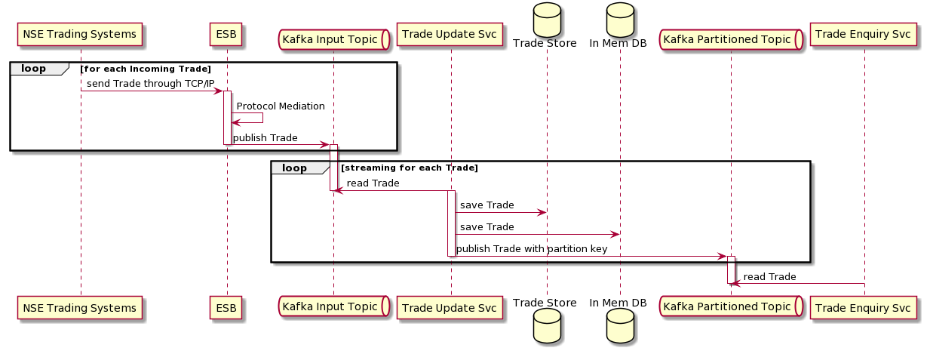

There will be minimal changes to the existing NSE systems and their interfaces. NSE Trading system will continue to send Trade using TCP/IP. Enterprise Service Bus (ESB) implemented using Camel will perform protocol mediation converting Trade messages from TCP/IP to Kafka messages. The Trade Update Service will read the Kafka Messages and persist in the Trade Store in Oracle database to ensure high durability and integrity. The Trade will be stored in the query friendly form in Redis, In-memory Database for supporting use cases that require fast access to specific trade(s) based on search criteria. The Trades will also be stored in Kafka Partitioned Topic for the Trade Enquiry Service to perform Stream processing on a continuous basis to support high throughput.

#### Scenario 2 – Trading or Clearing Member viewing the Dashboard

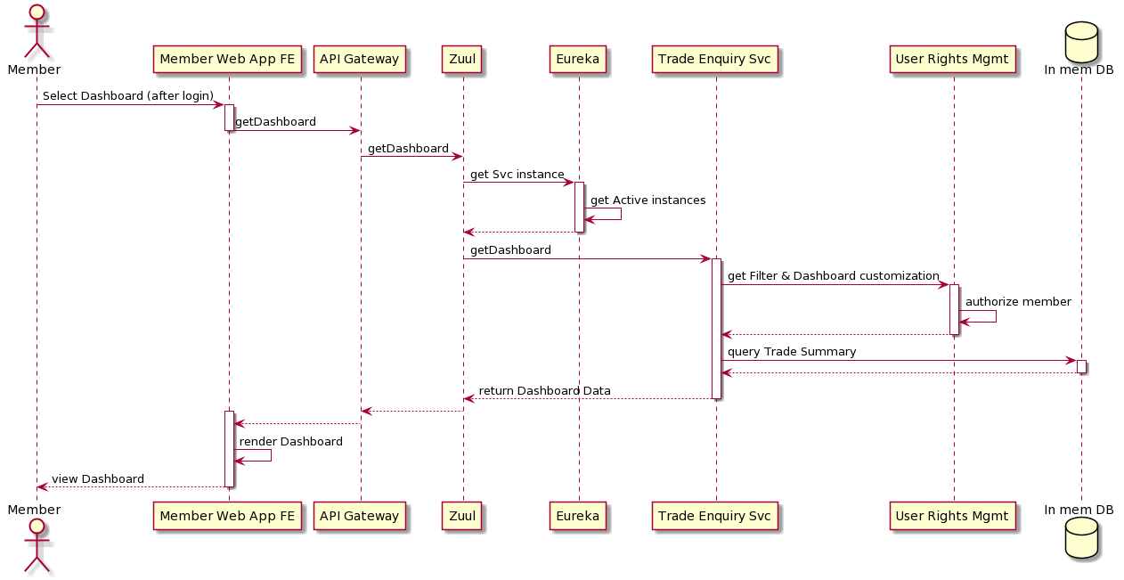

The Trading or Clearing Member will use the new Front end Web Application to access the Dashboard displaying the summary of the trades, securities, value, quantity etc. The member should be logged-in before accessing the Dashboard. The steps for login in and the technology that enables it are covered in the earlier section. The Front End application will initiate the request for Dashboard, which will traverse through the API Gateway and Spring Cloud Gateway routing proxy. The Spring Cloud Gateway routing proxy will get the active instance of the Trade Enquiry service from Eureka and invoke Trade Enquiry service. The Trade Enquiry Service will invoke the User rights management service for authorization check and to get the member’s filter and customized dashboard. The Trade Enquiry Service will query Redis, In-memory Data store for the summary data to be displayed in the Dashboard. The Dashboard will be rendered in the Front End using the Angular Java script framework.

#### Scenario 3 – Trading or Clearing Member downloading Trades

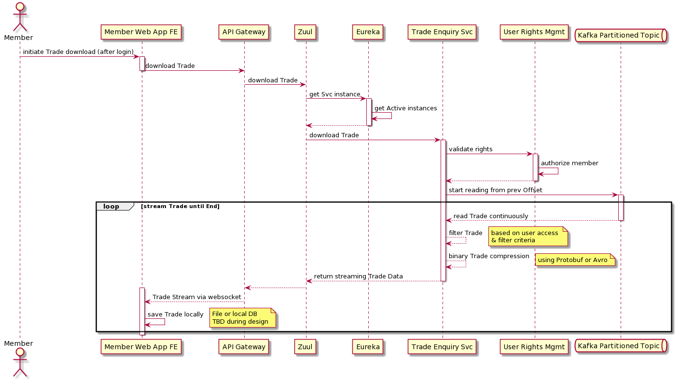

The Trading or Clearing Member can use the new Front end Web Application to download the trades that are related to them, for local processing. The member should be logged-in before initiating the download. The Front End application will initiate the request for download, which will traverse through the API Gateway and Spring Cloud Gateway routing proxy to Trade Enquiry Service. The Trade Enquiry Service will invoke the User rights management service for authorization check. The Trade Enquiry Service will read the Trades from the Kafka Topic starting from the previous offset until which the member has already downloaded. The Trade record read from the Kafka Topic will be further filtered based on the filter criteria and member access rights. The Trade will be compressed using binary serialization format such as Protobuf/Avro which are more compact and efficient for transmission. They will be sent to Front End using appropriate protocol such as Websocket, SSE or Kafka topics which will be finalized after further analysis. The Trades will be read in high velocity using Kafka’s streaming capability and sent as continuous Stream to the Front End, until stopped or end is reached. The last received Trade offset will be saved, for future download.

#### Scenario 4 – Trading Member updating Client/CP Code

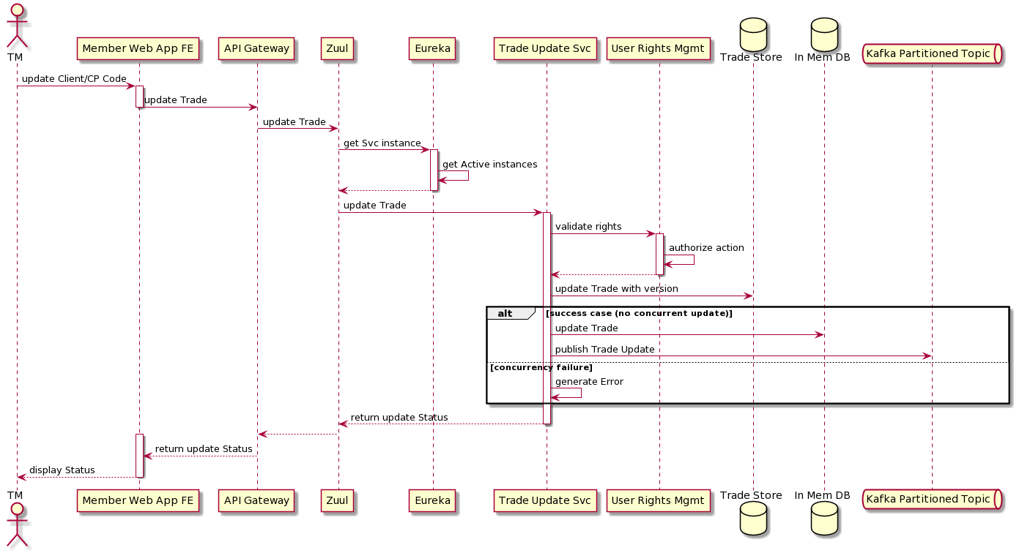

The Trading Member can use the new Front end Web Application to update the Client/CP Code for a particular Trade or set of Trades. The member should be logged-in first to perform the action. In order to perform update, the Trade should first be queried using the Trade Enquiry Service to get the latest snapshot. Once the selected Trade(s) is displayed in the Web application, the Trading Member can make change to the Client or Custodial Participant code and submit. The Java Script framework will post the update to the Trade Update Service via the API Gateway and Spring Cloud Gateway routing proxy similar to the earlier scenarios. The Trade Update Service will invoke the User rights management service for authorization check. The Trade Update Service will save the update in the Trade Store in Oracle database using the last version number for the concurrency check (using optimistic concurrency strategy). If the update is successful, then confirmation will be sent to the Trading member on the success. If there is concurrency version mismatch or any other error then the Trading member will be notified immediately on the issue with appropriate error message. In case of successful update in Trade Store, the Trade will be also be updated in the Redis, In-memory Database and update event will be inserted to Kafka Topic so that subsequent query and download will fetch the latest snapshot.

# Front End Architecture

**Context**

* Developing the mobile application using cross platform mobile framework
* Common UI/UX for both Android & iOS Mobile Platforms.
* A single code base for both mobile platforms.
* Seamless mobile application experience to the user.

**What is UI?**

User Interface is all about the visual appearance of the app that includes various elements such as button, tags, text, images, videos, drop-down list, graphic design, and user’s click.

While User Interface refers to a process that ensures how things will work, therefore, UI designer needs to layout a mobile app design that helps in attracting the eye of the user and provide a seamless product experience.

**What is UX?**

The landscape of User Experience design is to achieve the highest level of satisfaction of the users. It majorly includes how users will feel while interacting with an application.

To create an excellent UX Design, a mobile app developer has to understand the user’s perspective and seek out feedback from the tester to fix the issues and provide a perfect solution to the users.

## Parivartan UI/UX Best Practices

|  |  |
| --- | --- |
| Area | Description |
| Research before design | Conduct a competitive analysis. Find apps that are similar to the one being designed. Pay attention to which parts of the apps you like and which parts you don’t like, and why.  Identify your users. Build user personas to understand better how users will interact with your app (which activities they perform and what content they expect). |
| Prioritize features | **Focus on refining the experience around your core objectives.**Know what the core purpose of your app is — analyse which features of your app are used the most and put the most effort into making that experience intuitive. |
| Cut out the clutter | **Strive for minimalism.**Focus on the content that is valuable for your users and remove unnecessary elements that do not support user tasks. Minimal use of decorative elements such as gradients and drop shadows will help you keep the interface light and airy.  **Prioritize one primary action per screen.**Try to design each screen for one thing and one thing only, with no more than one call-to-action. This makes it both easier to learn and easier to use. A few clear screens are preferable to a single cluttered screen. |
| Make navigation self-evident | **Make sure that navigation feels familiar to users.**People are happy when an app meets their expectations. To make this happen, use navigation patterns that are familiar to your target audience so that the navigation doesn’t require any explanation.  **Design good information architecture.** Organization of information in a clear and logical way. Organize your information in a way that requires a minimum number of actions to reach the destination.  **Navigation shouldn’t draw focus away from the content.**It should be implemented in a way that supports the structure of an app without calling attention to itself.  **Communicate current location.**People should always know where they are in your app so they can navigate successfully.  **Strive for consistency.**Don’t move navigation controls to a new location or hide them on different pages. This will confuse and disorient your users.  **Provide a clear path.**Users should be guided to the content they’re looking for, quickly. The path through content should be logical (from the user point of view). |
| Design finger-friendly tap-targets | **Provide ample touch targets for interactive elements.**Create controls that measure at least 7–10 mm so they can be accurately tapped with a finger.  Ensure that there is a right amount of spacing between tap targets. |
| Make text legible | **Choose a typeface that works well in multiple sizes and weights to maintain readability and usability in every size**. A safe bet is to rely on the platform’s default font. Apple uses the [San Francisco family of typefaces](https://developer.apple.com/fonts/) to provide consistent reading experiences across all platforms. [Roboto](https://fonts.google.com/specimen/Roboto) and [Noto](https://www.google.com/get/noto/) are the standard typefaces on Google Android.  **Use legible font size**. Text should be at least 11 points so users can read it at a typical viewing distance without zooming.  **Use sufficient colour contrast for text**. Insufficient contrast makes text blend in with the background. Strive for a minimum contrast ratio of 4.5:1 for body text and image text. |
| Provide feedback on interactions | Based on the type of UI element or current state of the app, designers can use different forms of feedback. For example, interactive elements can be highlighted briefly when tapped, progress indicators can be used to communicate the status of long-running operations, and animated effects can help clarify the results of operations. |
| Minimize the need for typing | **Ask only what you really need to know**. Keep forms as short and simple as possible by removing any unnecessary fields.  Make **data entry as efficient as possible**. When possible, present choices instead of input fields because it’s easier to choose from a list of predefined options than to type a response. Try to prefill fields with the most likely default values (providing good defaults minimizes decision making and speeds up the process). |
| Create a seamless experience | **Synchronize a user’s current progress**. For example, when users browse items in an e-commerce app on mobile they might want to switch to the desktop version to complete a purchase. Users expect to continue the journey from where they stopped on mobile. |
| Always test design | **Ask real users to complete regular tasks in your app**. Based on results of testing you’ll be able to see how well the design really performs.  **Constantly measure your app**. Treat your app as a continuously evolving entity, using data from analytics and user feedback to improve the experience |

**What to Avoid**

|  |  |
| --- | --- |
| Type | Comment |
| Don’t try to design the perfect experience from the first attempt | Focus on prototyping and testing. Powerful prototyping techniques such as [rapid prototyping](https://theblog.adobe.com/rapid-prototyping-efficient-way-communicate-ideas/) can help designers to iterate fast. Based on insights gathered from testing sessions it’s possible to design better experiences for the users in each new iteration. |
| Don’t design in isolation | Start by validating your hypothesis based on the user’s needs. Use the Design Sprints technique to help you move from idea to learning, with following steps.  Understand, Sketch, Decide, Prototype, Validate |
| Don’t ask for permissions right at the start | Ask only what your app clearly needs. Don’t ask for all possible types of permissions. It would be suspicious if an app requests permissions with no obvious need for them (e.g. an alarm clock app asking permissions for access to your list of contacts). |
| Don’t make users wait for content | Use skeletons (Temporary containers) to create a feeling of fast loading. Show the screen immediately and use placeholders to identify where content isn’t available yet. Replace these placeholders with actual content as soon as it loads. |
| Don’t use jargon in the user interface | Avoid acronyms, brand-specific terms, cultural-specific axioms, and technical terminology that people might not understand. In general, it’s better to use simple and direct language to maximize clarity. |
| Don’t use custom gestures as a primary way of interacting with an app | Use standard gestures for shortcuts. People are familiar with the standard gestures, so no extra effort is needed to discover or remember them.  Avoid using standard gestures to perform non-standard actions. Unless your app is a game, redefining the meaning of standard gestures leads to confusion and complexity. |
| Don’t replicate the web experience on apps | Avoid using underlined links in mobile apps. [Underlined links](https://www.smashingmagazine.com/2017/12/underlined-text-improve-ux/) are a natural part of the browser-page model, but they can’t be applied to mobile experiences because apps use buttons, not links. |
| Don’t create dead end pages | Nothing in your app should be a dead-end. Error and [empty states](https://www.smashingmagazine.com/2017/02/user-onboarding-empty-states-mobile-apps/) should provide instructions and actions to move forward. |
| Don’t take users to a browser | Use an in-app browser. If your app lacks a specific feature or piece of content, try to use an in-app browser. Do not invoke the smartphone browser. |
| Don’t ask a user to rate your app during their first experience | Don’t ask a user to rate an app when they perform a task. Don’t interrupt the user, especially when they’re performing a time-sensitive or stressful task. Look for logical pauses when a rating request makes the most sense.  Allow ample time to form an opinion. Wait until users prove to be repeat users, and they’ll be more likely to rate your app and provide better informed feedback. You can trigger the rating request after a specific number of app openings or goals have been completed. Choose the perfect moment (e.g. after a positive interaction with an app, like after the completion of a significant task). |

## UI Component Types

|  |  |
| --- | --- |
| Type | Comment |
| Foundation Components | The primary expression of the design language of the system. They’re the defining parts of the experience, and very targeted in scope. They ensure a consistent underlying interface. UI Developers on the design team will build them. |
| Application Components | Specific to one of the applications being built, and not seen as a defining, foundational part of the UI. They’re usually larger in scope, and almost always composed of one or many Foundation Components. Some Application Components may eventually transition into Foundation Components. The application teams will build them. |

## A Component Centric Work Flow

The design teams guiding principle was to use real, working components as the primary means of sharing the UI with application developers. Over time, converged on the following workflow. It is a circular flow marked by tight feedback loops between designers, UI developers, and application developers.

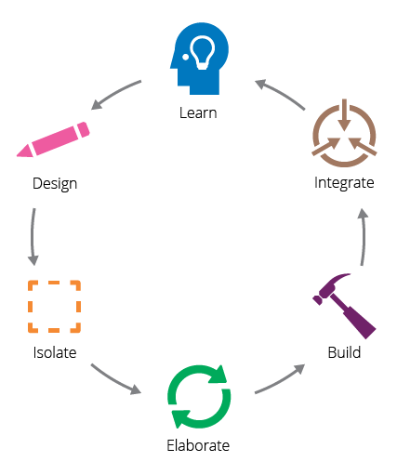

|  |  |
| --- | --- |
| Type | Comment |
| Design | A designer starts by designing a part of the experience, keeping in mind the overall context of the application and the current components available in the design language |
| Isolate | Isolating a component from its original design helps ensure that it is decoupled, while still being connected to the overall design. |
| Elaborate | The designer collaborates with a UI developer to isolate core UI elements so that they can elaborate on their structure, appearance, and behaviours. In a component architecture, components are independent and reusable across various contexts. |
| Build | Using the agreed specification, the UI developers build the Foundation Component as a UI component for the application. |
| Integrate | Foundation Components are published so that application developers can bring them into applications and assemble them into larger, more complex components. |
| Learn | New components are fed back into the design process so they can be reused and iterated on. |

## Web Frontend Architecture diagram

Angular Modules: Module can be contains three things /shared, /pages, /components

|  |
| --- |
| Injector  C:\Users\PL96959\Desktop\Gear_1.svg.png  Meta data  Events  Directives  Html/Templates  Components  Meta data  +  Property binding  Module 1  Module 2  Html/Templates  Components  CSS  Module 3  API  Backend  Services |

**Sample code for ng-module**

import { NgModule } from '@angular/core';

import { BrowserModule } from '@angular/platform-browser';

@NgModule({

imports: [ BrowserModule ],

declarations: [ AppComponent ],

exports: [ AppComponent ],

bootstrap: [ AppComponent ]

})

export class AppModule { }

* [declarations](https://angular.io/api/core/NgModule#declarations)—The [components](https://angular.io/guide/architecture-components), *directives*, and *pipes* that belong to this NgModule.
* [exports](https://angular.io/api/core/NgModule#exports)—The subset of declarations that should be visible and usable in the *component templates* of other NgModules.
* [imports](https://angular.io/api/core/NgModule#imports)—Other modules whose exported classes are needed by component templates declared in *this* NgModule.
* providers—Creators of [services](https://angular.io/guide/architecture-services) that this NgModule contributes to the global collection of services; they become accessible in all parts of the app. (You can also specify providers at the component level, which is often preferred.)
* [bootstrap](https://angular.io/api/core/NgModule#bootstrap)—The main application view, called the *root component*, which hosts all other app views. Only the *root NgModule* should set this [bootstrap](https://angular.io/api/core/NgModule#bootstrap) property.

## Lazy loading for Modules

|  |  |
| --- | --- |
| Page load | User action |
| Module 2  Module 1 | Module 3 |
| Shared Module 2 | Module 4 |
|  |  |

## Web Login

|  |
| --- |
| UserStore  Access token  +  Request  Web browser  Client site validation  +  Post data  +  Post data  Dashboard  +  Other pages  Login page  +  Client side validation  JWT Token  Encrypt password  REST API  REST API  REST API  REST API  API Gateway  Authorization API  User validation  +  Creating token  +  Post to UI |

Login implementation on front end will be with JWD (JSON web token)

Step 1 - User Login in an Angular Application : User authentication starts with a Login page

Step 2 - Creating a JWT-based user Session [backend]

Step 3 - Sending a JWT back to the client

Step 4 - Storing and using the JWT on the client side on session storage

Step 5 - Sending The JWT back to the server on each request

## Code review and quality checks

For angular type script should be checked and review by ts lint, install tslint by using installing the below commands on the local machine, code should be check and reviewed by ts lint compiler.

npm install tslint typescript –save-dev

*# or*

yarn add tslint typescript --dev

## Accessibility

To implement accessibility with angular use angular services “ngAria”, ngAria hooks into standard AngularJS directives and quietly injects accessibility support into your application at runtime.

Install ngAria

npm install --save angular-aria@X.Y.Z

<table role="presentation">

<thead>

<th>for table header</th>

</thead>

<tbody><td></td></tbody>

Site should be accessible by the keyboard user can navigate with mouse as well as keyboard.

Image tag should be define should contain alt and title tag

Header should be define in a proper order should start with h1 to h6.

Hyperlinks should be define properly with proper description.

Examples

<img src=”” alt=”information about image” title=”image title” />

<a href=”” title=”about the link”></a>

## Web Content Delivery Through Akamai CDN Network

Parivartan SSL Web Content is delivered over a dedicated portion of the Akamai network, segregated physically and logically from the rest of the Akamai’s systems. This dedicated network, the Akamai Secure Content Delivery Network, is composed of groups of servers deployed and physical requirements designed to comply with the Payment Card Industry Data Security Standards (PCI DSS). The Akamai edge servers deliver SSL content to end-users on behalf of Akamai's customers.

**Akamai usage for NSE Parivartan**

|  |  |
| --- | --- |
| Akamai Solution | Applicability for NSE Parivartan |
| Security Solutions | * Amongst numerous solutions under Security Solutions - Web Applications Security solutions are applicable for NSE   + They provide protection against DoS, DDoS, Sql Injection, Cross Site scripting etc. * Data Center Security, DNS Services, Customer Identity & Access Management, Malware and Phishing solutions, etc. are not applicable at this point |
| Web Performance Solutions | * Amongst numerous solutions under Web Performance Solutions – Accelerate Solutions that offers Intelligent automation and controls to maximize user experiences on web, iOS, and Android apps are applicable.   + Parivartan can use it for caching static content such as images, CSS, Java script files etc. * Serverless Solutions, API Gateway, IoT Solutions are not applicable at this point |
| Media Delivery Solutions | Not applicable for Parivartan as this is for large scale media/video content |
| Network Operator Solutions | Not applicable for Parivartan as this is for Network operators |

The figure below shows the request patterns via CDN network for Parivartan users coming through web channel.

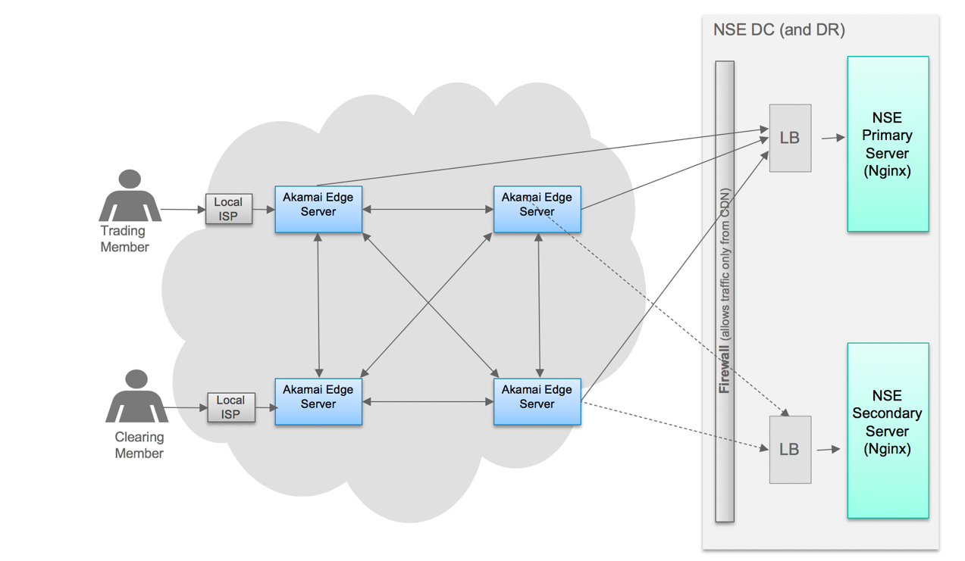

**NSE Akamai CDN Interaction Flow**

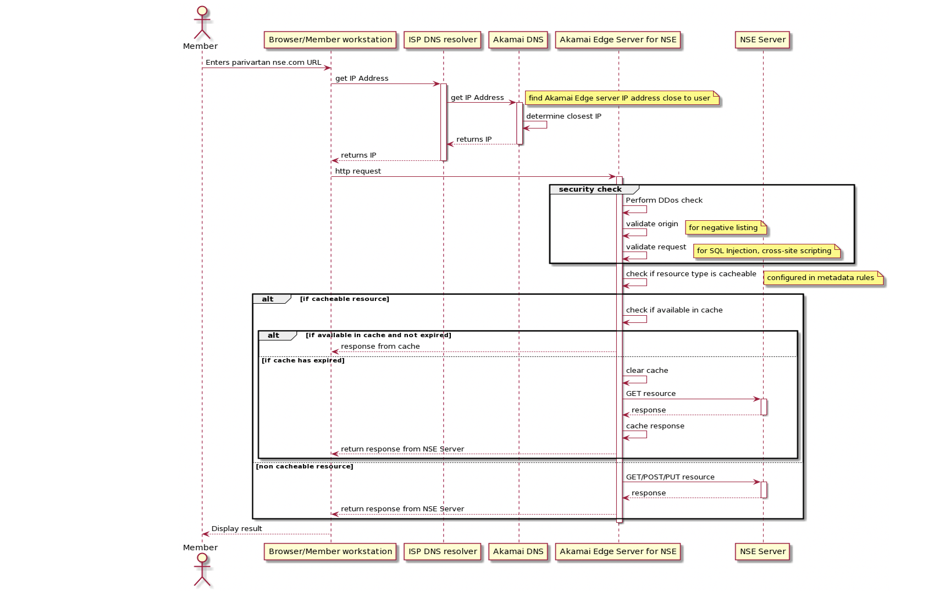

**Handling Content changes and Fault Tolerance**

Caching of static resources in Akamai is done using PULL model.

**Object Fresh Frequency** – can be set from as low as 1 seconds to once a week, or once a month, or longer.

For NSE Parivartan, an optimal Expiration/Fresh value can be set to few minutes as determined during design based on the frequency of changes and the actual resource to be cached.

High frequency refresh will not necessarily create more load on NSE Servers as Akamai Edge servers will distribute the cache amongst themselves and offload the NSE Servers from handling concurrent access from the users.

**Fault Tolerance in Object Retrieval**

Akamai Edge servers will retry if they experience an error retrieving an object from the origin. These retries can be customized to use an alternate origin or to choose a different path to the origin.

Hence for Parivartan, secondary server can be configured for the static resources to be cached in Akamai, so that if the primary is not responding or is slow, it can refresh from the secondary which could even be one of the DR.

## Mobile React Native Framework

React Native is a JavaScript Framework which is used to develop mobile applications for iOS and Android. It uses large amount of inbuilt components and APIs.

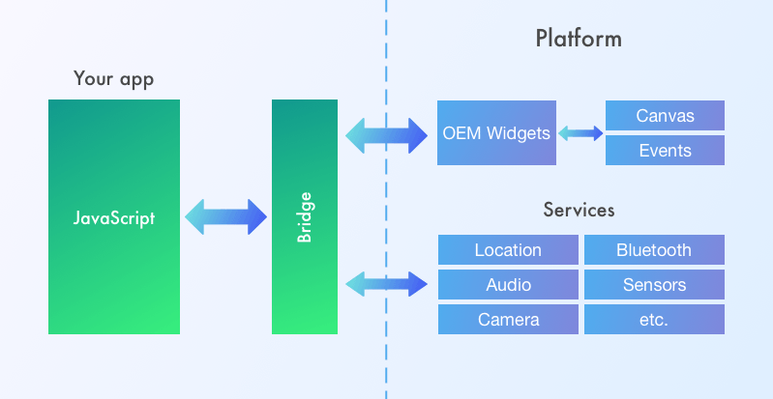

## React Native UI Core Components

* Basic Components
* User Interface
* List Views
* IOS Specific
* Android Specific
* Others

## Basic Components

|  |  |
| --- | --- |
| Component | Comment |
| View | The most fundamental component for building a UI, View is a container that supports layout with [flexbox](https://reactnative.dev/docs/flexbox), [style](https://reactnative.dev/docs/style), [some touch handling](https://reactnative.dev/docs/handling-touches), and [accessibility](https://reactnative.dev/docs/accessibility) controls. View maps directly to the native view equivalent on whatever platform React Native is running on, whether that is a UIView, <div>, android.view, etc. |
| Text | A component for displaying text. |
| Text Input | A component for inputting text into the app via a keyboard. |
| Scroll View | Provides a scrolling container that can host multiple components and views. |
| Style Sheet | Provides an abstraction layer similar to CSS style sheets. |
| Images | A component for displaying images. |

**User Interface**

|  |  |
| --- | --- |
| Component | Comment |
| Button | A basic button component for handling touches that should render nicely on any platform |
| Picker | Renders the native picker component on Android and iOS |
| Switch | Renders a Boolean input. |

**List Views**

|  |  |
| --- | --- |
| Component | Comment |
| Flat List | A component for rendering performant scrollable lists. |
| Section List | Same as Flat List, but it is used for section based lists. |

**iOS Specific**

|  |  |
| --- | --- |
| Component | Comment |
| Action Sheet IOS | API to display an iOS action sheet or share sheet |

# 

**Android Specific**

|  |  |
| --- | --- |
| Component | Comment |
| Back Handler | Detect hardware button presses for back navigation. |
| Drawer Layout Android | Renders a Drawer Layout on Android. |
| Permissions Android | Provide access to the permissions model introduced in Android M. |

**Others**

|  |  |
| --- | --- |
| Component | Comment |
| Activity Indicator | Displays a circular loading indicator. |
| Alert | Launches an alert dialog with the specified title and message |
| Animated | A library for creating fluid, powerful animations that are easy to build and maintain. |
| Dimensions | Provides an interface for getting device dimensions. |
| Keyboard Avoiding View | Provides a view that moves out of the way of the virtual keyboard automatically |
| Linking | Provides a general interface to interact with both incoming and outgoing app links. |
| Modal | Provides a simple way to present content above an enclosing view |
| Pixel Ratio | Provides access to the device pixel density |
| Refresh Control | This component is used inside a Scroll View to add pull to refresh functionality. |
| Status Bar | Component to control the app status bar. |

# Integration Architecture

## Considerations:

1. The digital transformation program consists of re-engineering of journeys belonging to the following wholly owned subsidiaries:

* NSE Trading
* NSE Clearing (NCCL)

1. NSE Clearing clears trades which can belong to other exchanged (such as BSE) and such trades are currently available via ICCL
2. Hence the integration architecture has to consider possibility that these will be in separate data centres in future with only secured access allowed between these two.
3. The proposed application intends to employ a micro services based architecture with an API layer enabling access via multiple channels.
4. The current integration landscape at NSE, covering the applications to be revamped under the scope involves many legacy systems. Almost all of these are either using DB links, file transfers of various types (some being secured) and direct TCP / IP server-client communications. A couple of interface are also with AQ JMS on Oracle WebLogic server.
5. Most of the TCP/IP interfaces have very high volumes (about 2-2.5 crores in capital market & F & O segments – two segments which has about 99% of the total volume)
6. We have a constraint that, disruptions to the existing core systems and other legacy systems are minimum, if not none, and any such change will require to get approved based on feasibility and priority of implementation by existing project teams maintaining these
7. Since these two subsidiaries will be part of different network, we will have separate instances of below applications:
   * API Gateway
   * Master Database
   * SMTP Server
   * Email Server
   * Open source tools - Kafka for messaging and Apache Camel for ESB layer.

## Overall Integration Architecture Approach

Parivartan will use different types of integrations for different integration needs as follows

|  |  |
| --- | --- |
| **Integration Type** | **Usage** |
| **API Integration using Apigee** | The new Parivartan Microservices will expose REST APIs to the front-end Web and Mobile applications via API Gateway Apigee. |
| **Asynchronous Publish/Sub using Kafka** | Kafka will be used in Parivartan for high throughput asynchronous messaging and Publish/subscribe scenarios. Wherever possible existing batch based processing will be converted to Event Driven processing within the scope of Parivartan. |
| **Enterprise Service Bus using Camel** | Integration between the new Microservices and the existing NSE core systems will be implemented using Camel. Camel will decouple new and the existing applications and perform protocol conversion between them. More details are provided below. |
| **Managed File Transfer using IBM Sterling** | IBM Sterling will be used to transfer files in secure way between applications where batch files are required due to existing systems ability and scheduled nature processing. It provides secure data exchange mechanism and ability to centrally monitor, audit and control the file transfers |

The following diagram depicts at a high level the integration approach. Apache Camel is used as a lightweight ESB along with adapters for different protocol translations to communicate with various backend systems.

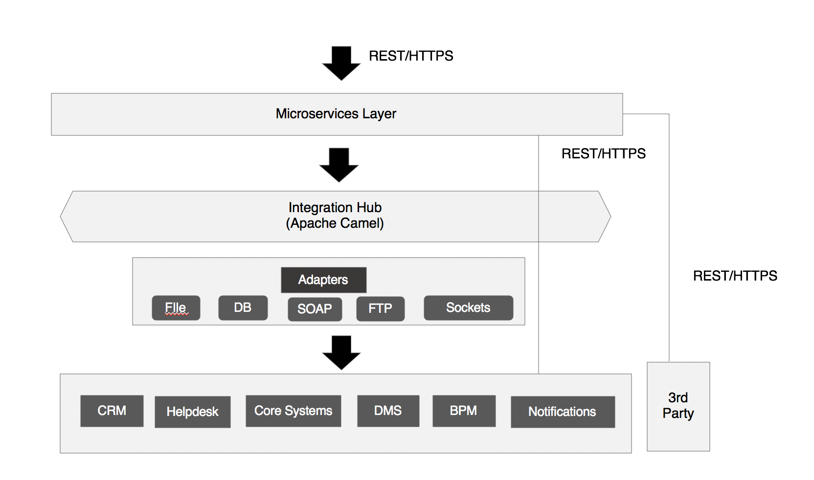

1. Integration Hub (Apache Camel):

* Apache Camel message router allow to consume from an input destination, evaluate predicate and choose the right destination.
* Apache camel transformer performs declarative transformation of the message according to declared input type and/or output type on a route definition which declares expected message type. Transformer Type:
  + Data Format Transformer – for transforming from one data format to another.
  + Endpoint Transformer – using Endpoint for protocol conversion.
  + Custom Transformer- using custom transformer class
* Protocol Translation – camel has multiple transformation features wherein it can be transformed from one protocol type to another one wherein it uses custom data transformation and type converters.

1. Integration Architecture proposition is to use:

* Using APIs, managed & controlled by an API manager for handling external requests with similar purpose as the UI / Access components developed.
* Fast event-driven message queuing interface to handle the high throughput interfaces
* Light-weight Enterprise Service Bus (ESB) for converting the interfaces to standard protocols & formats as needed by the new age digital platform that is being targeted by the reimagined journeys.

1. As it was seen that there are many master & some transactional data either used by multiple applications (such as security/ company data) or hoping across applications (such as first to NOTIS application an then to NCMS), a master/ common data store is envisaged for both Trading and Clearing Platforms.
2. The data transfer between Trading legacy application and new Clearing platform and vice versa is envisaged to happen via the Integration layer components (ESB or message queue) over secured protocols
3. Similarly integration between the two new platforms will also happen via secured protocols and preferably via integration layer
4. The communication with the COTS products are envisaged to happen the out of the box connectivity (over standard protocols) enabled by these applications.
5. The custom solution components will follow the architectural patterns and designs as explained in the technical architecture section.

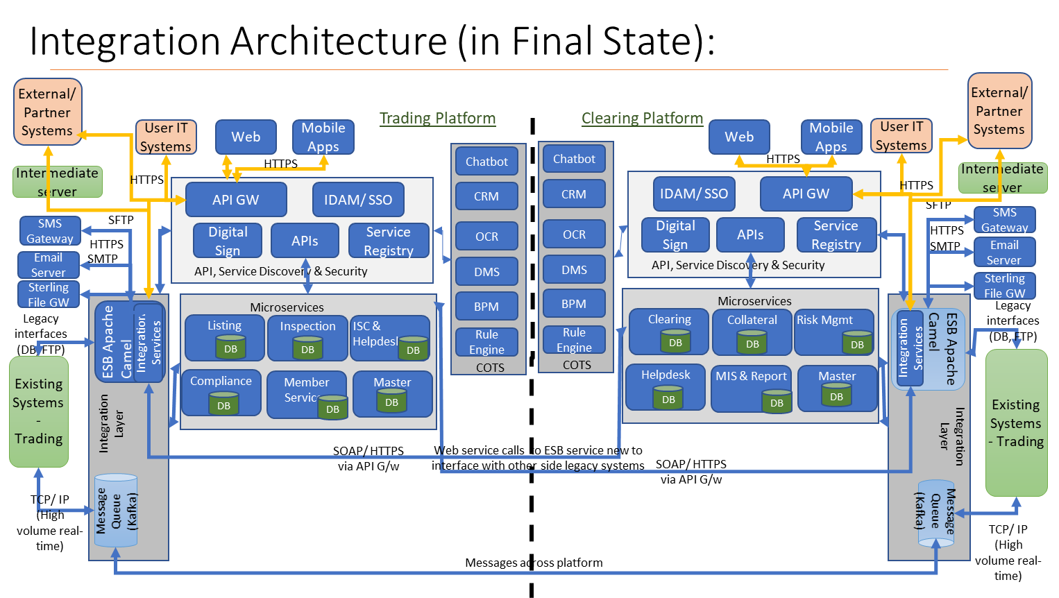

## Integration Design Principles and Guidelines

1. Interfaces should expose standard format/protocols to & from Parivartan.
2. Batch Interfaces should have restart, retry and start from pending batch elements. Batch scheduling/ size/ number of batch should be configurable.
3. Real time high volume interfaces: Should take care of data reliability/ integrity under exceptional scenarios by making use of product features and restart logic using sequence number.
4. Integration layer should take care of protocol conversion and messaging format requirement from core system to Parivartan and in the format required for 3rd party integrations.
5. Email and SMS service should be call through API layer and using Kafka messaging service for retry and queuing mechanism.
6. External interfaces should be checked for feasibility of using through API layer and if not possible then may continue with existing interface for e.g., interface with SEBI, NSDL/CDSL, IDBI and others
7. Use of Selective Data Replication using publish – subscribe replication approach. This helps in simplifying implementation, more resilient, and low latency.
8. Website documents should be available to be accessed through API call to Document Management system instead of cron job, upload of docs to given repository and other steps.
9. Point-to-Point interfaces in DBLink and SFTP should be changed to publish-subscribe or enterprise service bus (ESB) based communication.
10. Communication between Trading and Clearing Platform only through standard interface protocol or API based layer.
11. Use of Datawarehouse for View / Reporting purpose should be encouraged instead for data sharing among application purpose.
12. Check whether internal system communication (through DBLink or TCP) to change with Microservices interaction / API exchange patterns if it is possible to match with required latency.
13. Check implementation of digital signature with DMS so that multiple transactions to make doc digitally signed can be minimized.

## Parivartan Clearing & Settlement and Collateral To-Be Interface List:



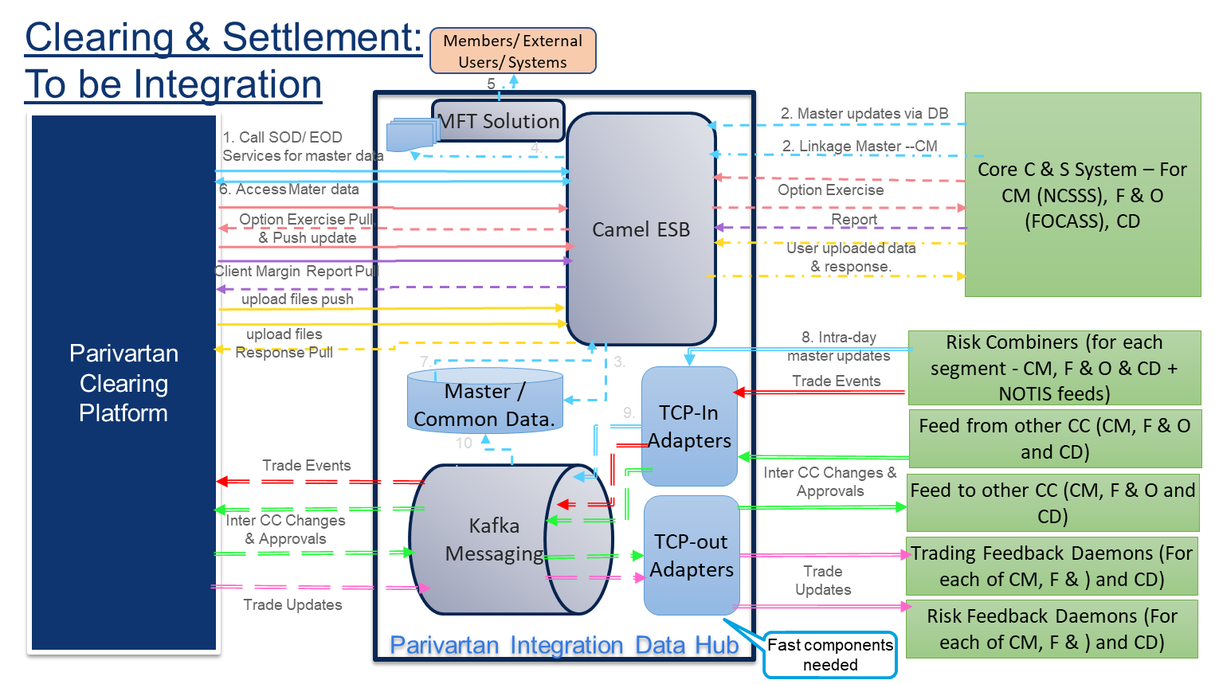

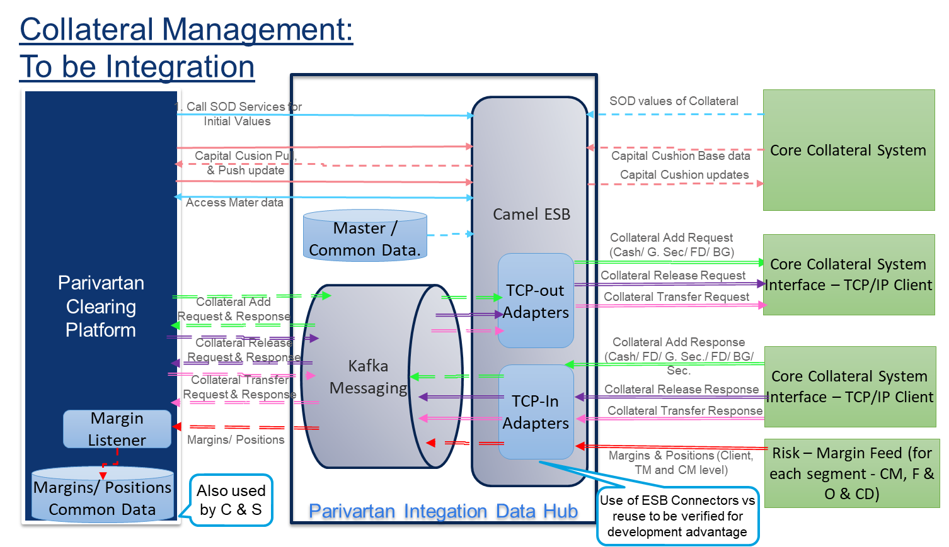

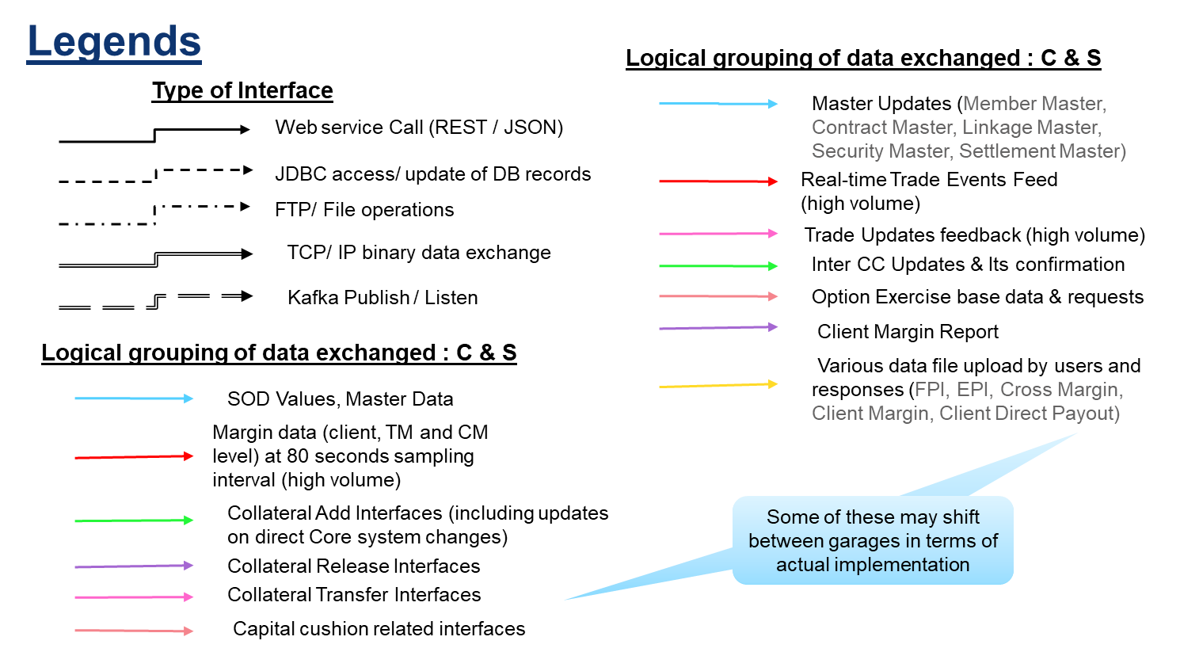

## Integration Scenarios

**Scenario 1: Real-time interfaces from Exchange Legacy System to Parivartan Clearing (e.g.: Clearing journey- trade events)**

1. Currently the trades (and client positions/ margins) are send to clearing interface systems (NCMS, NCIS etc.) via a TCP/IP sockets with a fixed binary message format using client-server technology., with the server and client components being written in C/C++
2. The proposed solution envisage to retain the provider side format and protocol and accept the same via Camel ESB, which will push the trade message received into Kafka.
3. The Camel ESB will reside in the Parivartan Exchange platform, to ensure minimum issues of security and performance.
4. Kafka is envisaged to be present in both the Trading and Clearing platform and will provide secure, reliable, scalable and high performance data transfer.
5. The Clearing side receiver component will listen to the topic on which the message is sent; will transform the message on receiving the trade and proceed with the processing intended as per functional requirements (need not always immediately persist)
6. The received component will also check the duplicates based on sequence number before processing
7. The interface, as required by the performance needs and considering constraints based on processing needs, may use appropriate scaling methods such as number of partitions of Kafka Topic (partition allocation can be based on the member identifier (say, separate topics & instances for clearing member groups) and caching methods.

Example: Trade / Positions from Risk Combiners to Parivartan Clearing

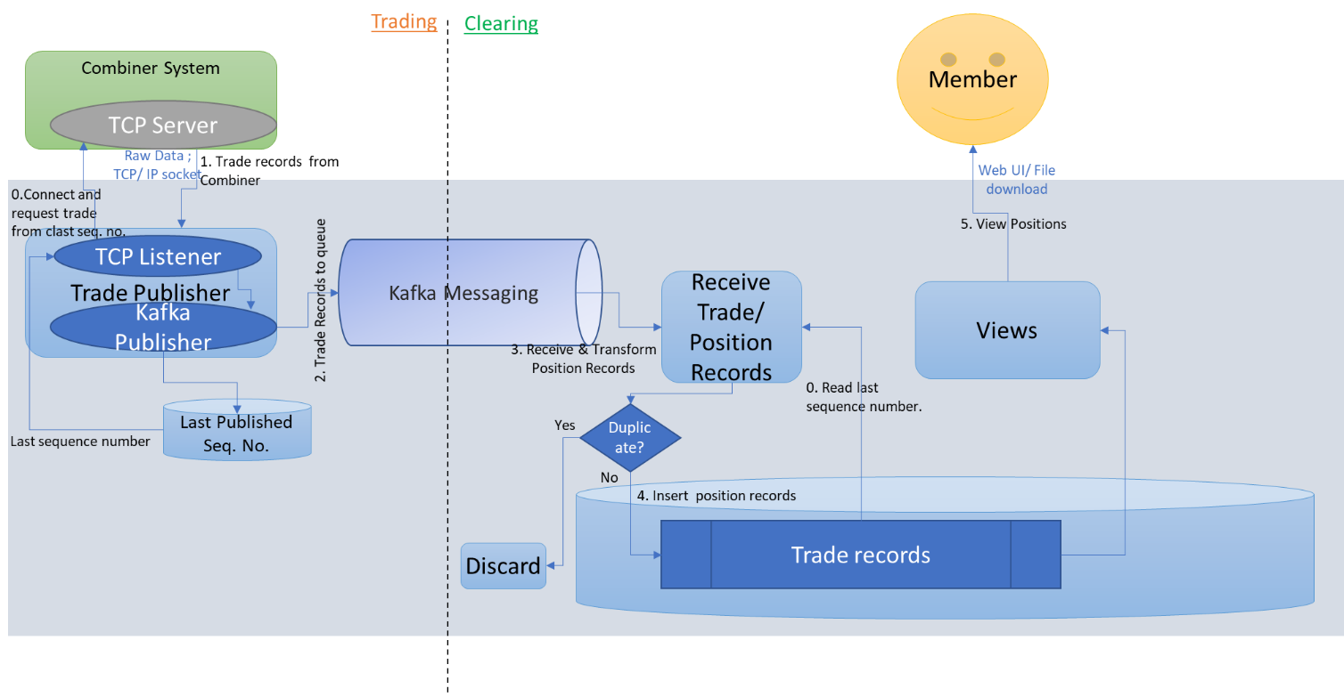

**Scenario 2: Real-time interfaces across from Parivartan Clearing to Exchange Legacy System**

1. Currently the trades (and client positions/ margins) are send to clearing interface systems (NCMS, NCIS etc.) via a TCP/IP sockets with a fixed binary message format using client-server technology, with the server and client components being written in C/C++
2. Currently the trades after updates (such as client core rectification, confirmation, allocation of INST trades), needs to be send back to both trading solution and clearing/ risk management solution.
3. Since the trades received may be
   * Traded on either NSE or in other exchanges
   * To be settled on either NCCL or in other clearing house
   * The above might be changed due to a CP code modification
4. Hence the update trade needs to be send to multiple destinations conditionally.
5. In this scenario the destination component currently is acting as a TCP client, with a restart logic based on sequence numbers
6. Hence, to retain the current interface at the other end, will need to have a TCP server component, which needs from a persistent store so as to service a possible restart at the other end.
7. As shown in the diagram, the trade after the update will be pushed into the message queue, read at the trading platform end, and persisted. The respective TCP servers will send the trade updates to the respective destinations (TCP clients).
8. This scenario also involves a notification use case – to notify the clearing member of the CP. This is envisaged to achieve via a notification service deployed on the enterprise service bus, which will utilize connectivity provided by ESB for Email, SOAP/HTTP(S) etc. The service may use the configurations read and parameters in the request to decide the destinations.
9. Alternatively, a notification tool/ product may be employed for this particular intention.

Example: Trade update from Parivartan Clearing to Trading & Risk:

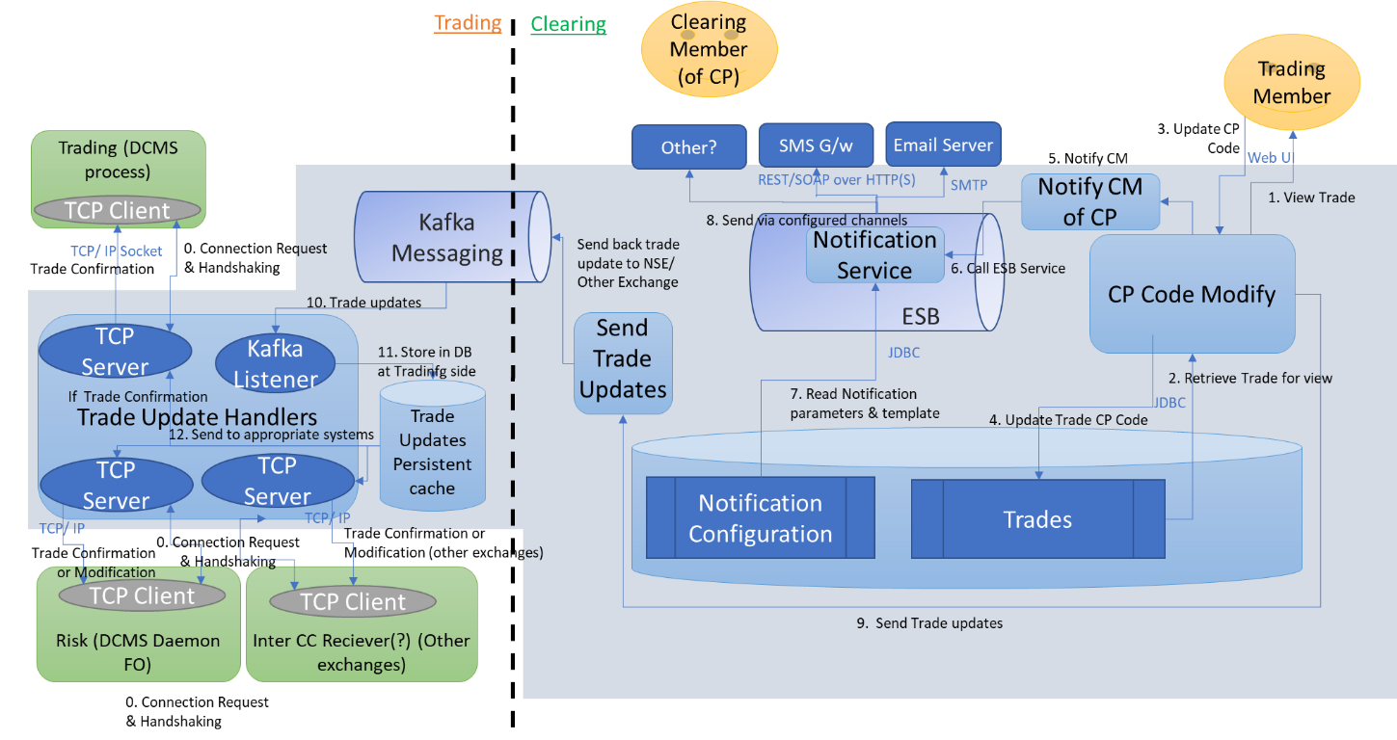

**Scenario 3: Legacy Interfaces – Within & Across Platforms**

and vis-à-vis For SFTP/ HTTPS interfaces may directly access other side

1. Analysis of current interfaces shows, apart from a few AQ JMS & HTTP interfaces and the TCP/IP interfaces stated below, others use DB links and FTP (or SFTP).
2. Some of these are pull interfaces, while others are push.
3. Some of these are across Trading & Clearing areas
4. The proposed platform envisage to employ a light weight Enterprise Service Bus to convert one side (new platform side) of the legacy interfaces to standard protocols & formats while retaining the other side format & protocol (unless there is an agreement and viability of upgrading the whole interface in time).
5. The ESB service will use either JDBC or FTP/ SFTP (or any other supported legacy interface) to connect to the legacy application / database. These services will be exposed as web services to the new platform.
6. In case of cross platform legacy interfaces, the ESB interface will be built on the ESB deployed on same side of the legacy application and accessed by the component on the other platform via secured channel.



Based on the current Integration architecture details, currently envisaged imagination of the existing applications, the following integration architecture is visualized.

## Integration Architecture (Detailed):

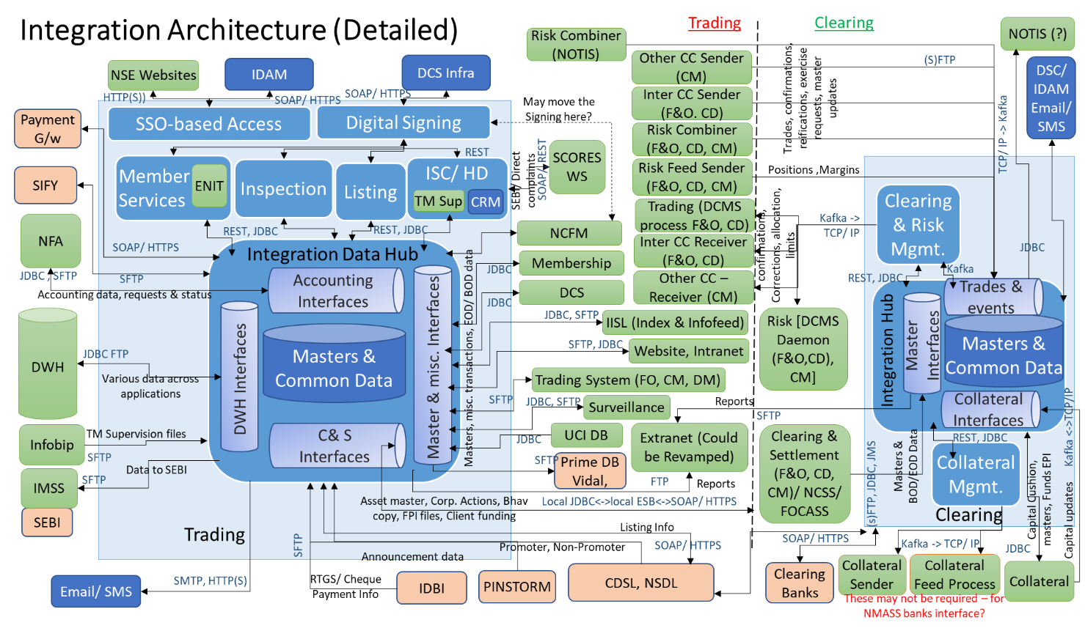

## Integration Patterns to Various Backend Systems

Referring to the logical architecture depicted above the following highlighted layers depict the integration components involved in the architecture

* + The microservices will be built to receive invocations from client applications through REST interfaces with endpoints proxies created on API Gateway.
  + The Gateway will perform client authentication and authorization to invoke a microservice
  + Each request to an API should include the client id of the client app invoking the API and also the logged in user id on the front end passed as HTTP Header parameters
  + All REST-ful invocations should enforce TLS encryption of communication tunnel so the entire payload in encrypted
  + The microservices will be integrating to Domain Datastores on Oracle
  + There will be a need to integrate to other systems like CRM, BPM, ECM, Document Management, NSE Core Systems, Third Party Services
  + For simple REST protocols based integrations microservices can directly invoke REST interfaces exposed by backend systems. E.g. BPM, BRM, CRM and other systems built on modern stack of products would all support REST ful APIs that microservices can invoke.
  + For systems that provide some more interface protocols like JMS, SOAP etc protocols adapters of Apache Camel may be used to implement the protocol translation. The various Springboot components supporting integration to DB, REST interfaces, Web Services have been depicted in the common framework components section of this document
  + 3rd Party integration will not involve Camel but direct REST ful invocation from microservices
  + For more complex interfaces with socket or custom protocol based integration, lightweight ESB like Apache Camel can be used for the integration.
  + Apache Camel is an integration engine, which can be used to facilitate interactions between a wide and varied array of technologies. These bridges between services and technologies are called routes. Routes are implemented on an engine (the CamelContext), and they communicate with so-called “exchange messages”.

## Apache Camel Adapters

|  |  |  |
| --- | --- | --- |
| **Protocol** | **Description** | **URI** |
| SFTP | **Both producer and consumer are supported**  This component provides access to remote file systems over the FTP and SFTP protocols. Absolute path is **not** supported. Camel translates absolute path to relative by trimming all leading slashes from directoryname.  Maven users will need to add the following dependency to their pom.xml for this component:  <dependency>  <groupId>org.apache.camel</groupId>  <artifactId>camel-ftp</artifactId>  <version>x.x.x</version>See the documentation of the Apache Commons  *<!-- use the same version as your Camel core version -->*  </dependency> | sftp:*//[username@]hostname[:port]/directoryname[?options]*  ftps:*//[username@]hostname[:port]/directoryname[?options]* |
| JDBC | **Only producer is supported**  The JDBC component enables you to access databases through JDBC, where SQL queries (SELECT) and operations (INSERT, UPDATE, etc) are sent in the message body. This component uses the standard JDBC API, unlike the [SQL Component](https://camel.apache.org/components/latest/sql-component.html) component, which uses spring-jdbc.  Maven users will need to add the following dependency to their pom.xml for this component:  <dependency>  <groupId>org.apache.camel</groupId>  <artifactId>camel-jdbc</artifactId>  <version>x.x.x</version>  *<!-- use the same version as your Camel core version -->*  </dependency>  This component can only be used to define producer endpoints, which means that you cannot use the JDBC component in a from() statement. | jdbc:dataSourceName[?options] |
| File | **Both producer and consumer are supported**  The File component provides access to file systems, allowing files to be processed by any other Camel Components or messages from other components to be saved to disk. | file:directoryName[?options]  file:*//directoryName[?options]* |

# Parivartan Security Architecture

The four principle areas of application security concerns are

1) Security at Edge using API Gateway policies,

2) Access Management implemented using a product and supported by fine grained access controls (e.g. at API operation access level) that can be maintained and queried in authorization schemas in a database;

3) Platform security addresses key regulatory concerns around audit requirements, session and entitlements management, access tokens (e.g. JWT tokens elaborated later), risk and fraud identification events;

4) Securing Data at rest and Data in transit

The following diagram depicts the various Parivartan security architecture concerns that should be addressed for a digital platform.

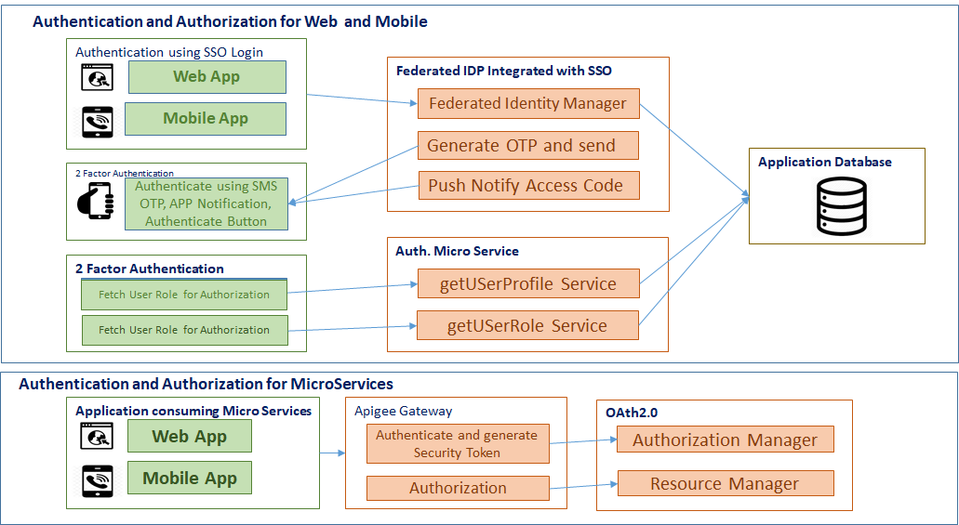

## Parivartan Apigee API Gateway Security

Application access controls and threat protection are key security mechanisms for protection of APIs used by external or internal developers. API management solutions help securely manage, and mediate API traffic, while growing the API program to meet increasing business demand.

The key Apigee Gateway policies to be used in Parivartan Program are listed below.

|  |  |
| --- | --- |
| Policy | Description |
| **Verify Access Token** | It provides OAuth security for API proxies, it verifies the API access token. None of the API will pass through that does not have an access token that can be verified. |
| **SpikeArrest Policy** | It protects from the sudden incoming traffic which is created by bad bots so that the backend won't be impacted in case of Dos, DDoS attacks and also it prevents improper use of the API by unauthorized users. It throttles the number of requests processed by an API proxy and sent to backend servers. |
| **Content-Based Security** | It protects from malicious API consumers. It provides a set of policies to mitigate the potential for your backend services to be compromised by attackers or by malformed request payloads. |
| **JSON threat protection** | It protects from JSON request payloads. It Minimizes the risk posed by content-level attacks by enabling you to specify limits on various JSON structures, such as arrays and strings. |
| **XML threat protection** | It detects XML payload attacks based on configured limits. It minimizes the XML vulnerabilities and attacks on your API. |
| **RegularExpressionProtectionpolicy (General Content Protection)** | It extracts information from URI Path, Query Param, Header, Form Param, Variable, XML payload, JSON payload and evaluates that content against with the expressions. If any specified regular expressions evaluate to true, the message is considered a threat and is rejected. |
| **Javascript Policy** | It is used to validate incoming request payload body as well as it is used for request and response transformations. |
| **Extract Variables Policy** | It extracts content from a request or response and set the value of a variable to that content. |
| **AssignMessage Policy** | Which is used to create new request and response message during the API proxy flow. |

## Channel Request Authorization Flow Via Apigee

Apigee provides the authorization token for application access. On successfully authenticated access token user can fetch details from backend server.

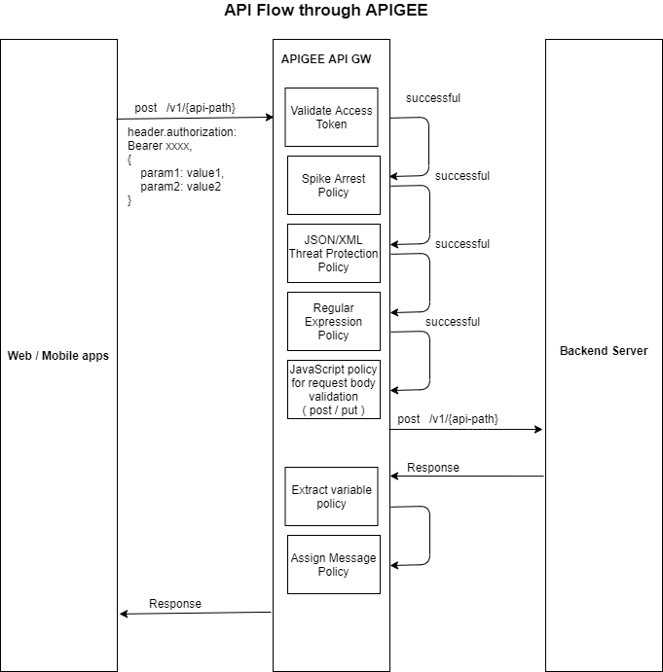

|  |  |
| --- | --- |
| **Step** | **Description** |
| 1 | Client app invokes API endpoint with access token and request payload, Apigee GW validates and transform the API request and response using following policies (Verify Access Key, Spike Arrest, JSON/XML threat protection, Regular Expression, JavaScript, Extract Variable and Assign Message policy) |
| 2 | Verify Access Token policy – It validates the access token; on success it forwards the request to next policy |
| 3 | Spike Arrest Policy – It protects from sudden traffic spikes that can be caused by an increase in usage, buggy clients, or malicious attacks. |
| 4 | JSON / XML Threat Protection Policy – It protects from content-based attacks, it validates the structure of JSON / XML request payloads |
| 5 | Regular Expression Policy – It protects from SQL injection, all Code injection etc., it extracts the information from query parameters, URI path, header, form parameters variables, json and XML path variables and evaluates that against expression. If any specifies expression evaluate to true, the message is considered a threat and is rejected. |
| 6 | JavaScript Policy – It is used to validate the request payload, or it also used for response transformation |
| 7 | Extract Variable Policy – It extracts content from a request or response and sets the value of a variable to that content |
| 8 | Assign Message policy – It creates new request or response messages during the API proxy flow. |
| 9 | Response sent back to the client app |

## Microservices Authorization

An authorization microservice will be built to lookup access privileges based on role passed as part of the request header along with user id. The role to access mapping will be maintained in a table.

**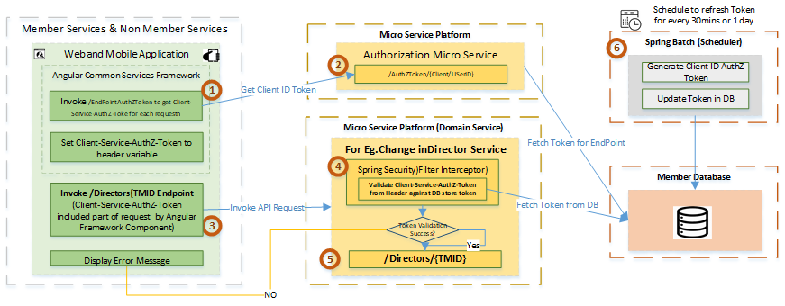**

Process Flow Steps:

1.     Above flow steps are applicable for MicroServices Authorization only for the clients to invoke Rest end Points by passing Client-Service-AuthZ Token

2.      For each client to invoke MicroServices REST End Point by using Client-Service-AuthZ-Token-, Angular Framework or Mobile App to develop common framework to invoke /AuthToken by passing user/Client ID to get Token for client to set this as part of HTTP Request Parameter.

3.      Authorization Service to host end point /AuthZToken with client/user ID to fetch token stored in database for the token mapped to endpoint and return token as response.  Before each service API invocation, latest token has to be retrieved by invoking /AuthZToken.

4.      Before making domain service end point call,  Ui has to invoke /AuthZToken end point and set this token as part of Client-Service-AuthZ-Token header parameter. Subsequent call to invoke domain related end point will contain Client-Service-AuthZ-Token header parameter.

5.      When request is sent to Micro Services, Spring Security Framework to intercept and extract token from header parameter to validate the token against token stored in Database for the corresponding end point mapping.

6.      Once Token validation is successful, actual domain endpoint will be allowed to access by spring security and subsequent end point business related operation can be performed normally. Otherwise error will be thrown to the end user for request not allowed to access resource.

7.      Before all above steps are performed, token will be generated and stored in database for all resource endpoint level or Micro Service Level mapping with Client AuthXZ Token. This token will be refreshed or renewed either hourly or daily or weekly basis and restore newly generated tokens for the end points or services. Database table to maintain mapping for User/client ID.  Access role and Client-Service-AuthZ-Token for validation purpose

## Access Control for UI

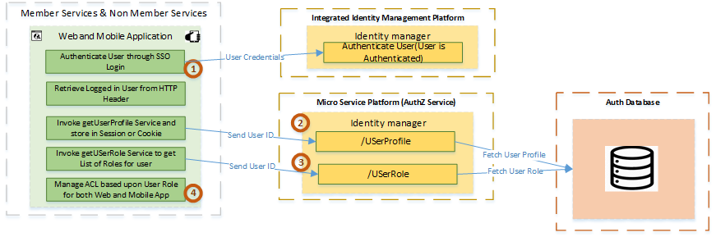

**Process Flow Steps:**

1.      Authorization Flow will be started once user is Authenticated through SSO, which sets Logged in User ID in HTTP Header

2.      Web or Mobile App to retrieve Logged in User ID from HTTP Header Parameter

3.      Invoke /UserProfile Service to get list of attributes belonging to user profile by passing User ID part of request parameter

4.      Invoke /USerRole Service to get list of user roles which is stored in database for that particular user

5.      Parivartan Applications to manage Access Control to control UI access based upon User role received from /UserRole End point

## Web and Mobile App oAuth Pattern - Grant Type: Password Grant

This scenario is for Parivartan Web Portal and Mobile app user. For external users, Parivartan Authentication microservice validates user credentials stored in DB while for internal NSE users it would be validated via existing Microsoft AD.

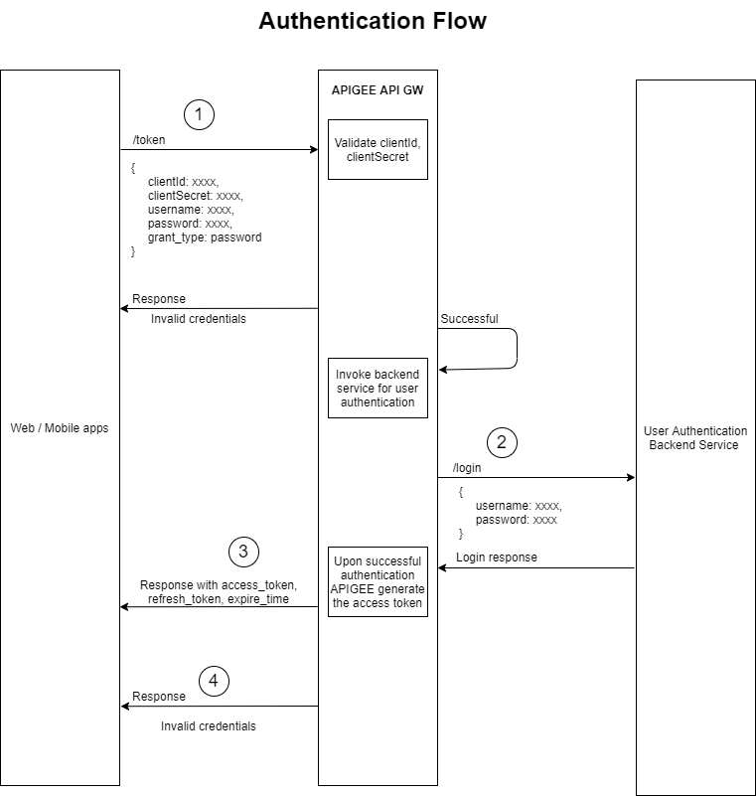

|  |  |
| --- | --- |
| **Step** | **Description** |
| 1 | Client app invokes token endpoint for authorization of access token., It passes client id, client secret, user id, password and grant type from user login screen |
| 2 | API Gateway validates client id and secret and invokes user authentication microservice |
| 3 | On successful login, the API Gateway returns access token, refresh token, and expiration time with access privileges to the client app |
| 4 | For all other cases it returns invalid credentials as response |

## OAuth Flow from Partner API Clients

The following diagram depicts the OAuth flow that all interactions from front end channel apps to backend APIs will go through for secured and authorized access to APIs and data. This pattern is for external partners invoking Parivartan APIs coming through the Internet. The Authorization server and Resource server are both Apigee in this scenario.

1. Scenario – Partners invoking APIs (B2B) – Grant Type: Client Credentials

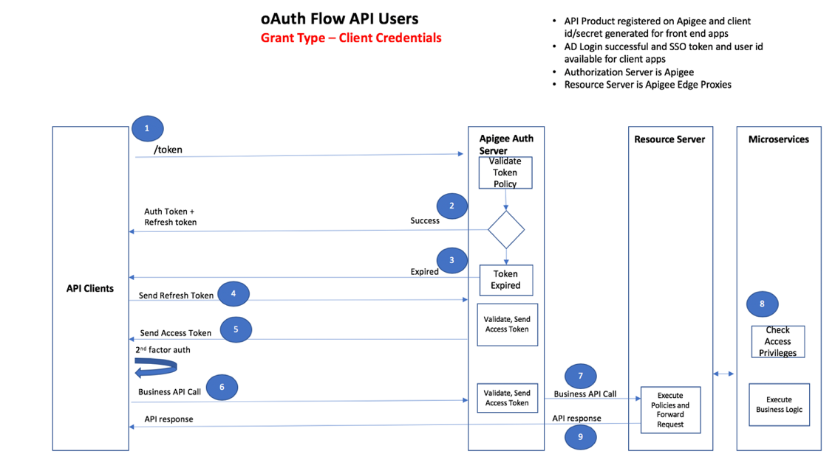

|  |  |
| --- | --- |
| **Step** | **Description** |
| 1 | Client app invokes token endpoint for getting auth token by passing client id and client secret |
| 2 | API Gateway validates client id and secret and returns success along with Auth and Refresh tokens |
| 3 | If the request in step 1 is a business API call with access token, Apigee checks for token expiry and can return expired error |
| 4 | For expired token scenario, client app sends a call to generate new access token by passing the refresh token |
| 5 | Apigee returns a new access token |
| 6 | Client app makes business API call passing access token as Bearer token in HTTP header |
| 7 | Apigee validates access token and grants access to resource server which applies policies and send request to microservices |
| 8 | Authorization check is done in microservices layer and business logic execute |
| 9 | Microservice send back response relayed back to client via Gateway |

## Addressing Vulnerabilities using Spring Security

Cross Site Request Forgery(CSRF) –  Spring Security provides built-in feature to enable CSRF protection using annotation @EnableWebSecurity

|  |
| --- |
| @EnableWebSecurity  public class WebSecurityConfig extends WebSecurityConfigurerAdapter {       @Override     protected void configure(HttpSecurity http) throws Exception {         http             .csrf()                 .csrfTokenRepository(CookieCsrfTokenRepository.withHttpOnlyFalse());     }  } |

Content Security Policy for XSS Protection- Spring Security provides in-built feature for XSS protection using annotation @EnableWebSecurity

|  |
| --- |
| @EnableWebSecurity  public class WebSecurityConfig extends WebSecurityConfigurerAdapter {       @Override     protected void configure(HttpSecurity http) throws Exception {         http.headers()             .contentSecurityPolicy("script-src 'self' <https://trustedscripts.example.com>; object-src <https://trustedplugins.example.com>; report-uri /csp-report-endpoint/");     }  } |

**Handle Other OWASP Vulnerabilities**

Leverage Spring Security Intercepting Filter to intercept incoming request to scan for other vulnerabilities using custom logic

## SSO Process Flow

The following diagram shows the authentication flow for web and mobile channel login for clearing and non-clearing members. The solution assumes the selection of an Identity and Access Management product (IDAM) supporting SSO and 2FA.

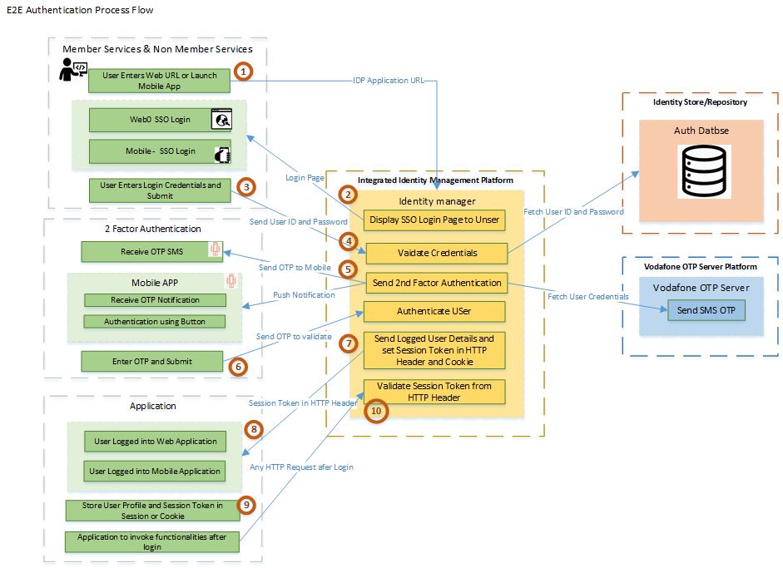

**Constraints:**

1. IDM product to be chosen needs to have SSO Feature otherwise needs to integrate with any third party SSO like OpenSSO etc.
2. IDM Product needs to support integration with existing Vodafone OTP Server/new OTP product. Or alternatively OTP can be generated using IDM feature or custom logic and OTP sent through Notification Service/ SMS End point.
3. This solution needs to be revised once IDM Product is finalized

**Process Flow Steps:**

1. User enters Application URL for Web Application or Launch Mobile App
2. Request will be intercepted through reverse proxy URL and SSO Login Page will be rendered by IDP Platform
3. User will enter Login Credentials and click Submit
4. Identity Manager will validate user credentials for valid user and throw invalid login error login page incase of invalid credentials
5. Once user ID is validated, OTP will be generated for user for 2nd Factor Authentication. Either OTP will be generated by Vodafone Server platform OTP Server or Send Push Notifications to Mobile App for user to attend
6. User will enter OTP in Web Page after receiving SMS to registered Mobile Phone or Access Code to Mobile App. User can also click Authenticate Button in Mobile App without OTP or Access Code
7. IDM to validate Access Code or OTP against generated source. No Access code or OTP validation required to validate in case of user clicked Authentication Button from Mobile App
8. Once Token or OTP is validated, IDM to send User Profile and Session Token in Response
9. Web Application or Mobile App to retrieve user details from HTTP Header parameter and store it in cookie or session. Usually IDM will append HTTP Header parameters for logged in user and this needs to be validated.
10. For any subsequent calls to the application functionality after user login, IDM will validate for Session Token from HTTP Header for validity and expiry of Token

## 2FA

OTP, Email and Push Notification would be used as means of second factor authentication for members and external users of Parivartan. The list of APIs supporting these features are all provided by Infobip and listed in the 3rd party services table in this document.

[NSE has implemented internal 2FA standards using CISCO Duo to provide an authenticator app based 2nd factor authorisation. For internal users, Parivartan will use the CISCO Duo solution at a later stage.]

## Password Rules:

Following are a set of password rules that can be applied for NSE which help increase security by encouraging end users to create reliable, secure passwords and then store and utilize them properly.

1. Enforce Password History policy

The Enforce Password History policy will set how often an old password can be reused. It should be implemented with a minimum of 10 previous passwords remembered. This policy will discourage users from reusing a previous password, thus preventing them from alternating between several common passwords.

1. Minimum Password Age policy

This policy determines how long users must keep a password before they can change it. The Minimum Password Age will prevent end user from dodging the password system by using a new password and then changing it back to their old one. To prevent this, the specific minimum age should be set from three to seven days.

1. Maximum Password Age policy

The Maximum Password Age policy determines how long users can keep a password before they are required to change it. This policy forces the user to change their passwords regularly.

To ensure a network’s security, the value for passwords should be set to 90 days for passwords and 180 days for passphrases.

1. Minimum Password Length policy

This policy determines the minimum number of characters needed to create a password. We can generally set the Minimum Password Length to at least eight characters since long passwords are harder to crack than short ones. For even greater security, minimum password length could be even set to 12 characters.

1. Passwords Must Meet Complexity Requirements policy

Following are the guidelines for the Passwords Complexity Requirements policy.

• Passwords can’t contain the username or parts of the user’s full name, such as their first name.

• Passwords must use at least three of the four available character types: lowercase letters, uppercase letters, numbers, and symbols.

1. Reset Password

The local administrator password should be reset every 180 days for greater security and the service account password should be reset at least once a year during maintenance time.

1. Use Strong Passphrases

Strong passphrases with a minimum of 15 characters will be used to protect domain administrator accounts. While passwords and passphrases serve the same purpose, passwords are usually short, hard to remember and easy to crack, while passphrases are easier to remember and type but much harder to crack due to length.

1. Password Audit policy

Password Audit policy will be enabled to allow Administrator to track all password changes. By monitoring the modifications that are made it is easier to track potential security problems. This helps to ensure user accountability and provides evidence in the event of a security breach.

9. E-Mail Notifications

E-mail notifications prior to password expiry will be enabled to remind end users when it’s time to change their passwords before they actually expire.

## Data Encryption:

Unencrypted data is known as [plaintext](https://searchsecurity.techtarget.com/definition/plaintext), and encrypted data is called ciphertext. The formulas used to encode and decode messages are called encryption algorithms, or [ciphers](https://searchsecurity.techtarget.com/definition/cipher). Data Encryption is used to deter malicious or negligent parties from accessing sensitive data.

There are two types of encryption.

**Asymmetric**: It is also known as public key encryption. there are two keys: one key is used for encryption, and a different key is used for decryption.

**Symmetric**: There is only one key, and all communicating parties use the same key for encryption and decryption.

Parivartan program will use **AES 256** encryption for securing data. Website served over HTTPS will use encryption protocol called Transport Layer Security (TLS). A website that implements HTTPS will have an [SSL certificate](https://www.cloudflare.com/learning/ssl/what-is-an-ssl-certificate/) installed on its origin server.

## Application Security Best Practice:

* Conditional Access
* IP Restrictions
* Auth Method
* Logging and alerting

1. **ENCRYPTION VIA HTTPS IMPLEMENTATION** - While HTTP is considered as a means to transfer information on the internet, HTTPS provides some important security aspects for businesses and their end users. HTTPS helps site more secure for users when they provide any sort of information such as PCI via encryption. Because attackers don’t have the encryption key, it prevents “man in the middle” attacks.
2. **SECURE SOCKET LAYER (SSL) CERTIFICATES** - Secure socket layer (SSL) is the protocol that HTTPS uses so that the installation of an SSL certificate on your site enables the use of HTTPS. Encryption ranges anywhere from 128-bit to the recommended 256-bit. In today’s stretched online world, the higher the encryption, the better.
3. **MULTIFACTOR AUTHENTICATION** (MFA) or 2FA WITH SINGLE SIGN-ON (SSO) - Multifactor authentication (MFA) or 2FA is beyond the basic requirement of website users to provide an additional form of authentication to log in along with their standard user name and password. This is normally accomplished through SMS message, voice message, or a one-time code generated via an application on a user’s mobile phone.MFA also can and should include more advanced website security methods, such as biometrics, GPS location, or a hardware token, but those can take more time and effort to implement. The addition of single sign-on (SSO) enables web users who need access to cloud applications, networks, and other business systems via the web rather than multiple sign-on steps as they access other connected systems.
4. **UPDATE PLATFORMS AND SCRIPTS** - Keep installed platforms and scripts up to date to eliminate security loopholes that allow malicious hackers to take control of the website.
5. **DILIGENCE, POLICIES, AND FIREWALLS FOR XSS ATTACK PREVENTION -** It’s imperative that any code you use on your website for functions or fields that allow input is as explicit as possible in order to prevent cross-site scripting (XSS) attacks. XSS attacks consist of attackers injecting malicious JavaScript code that infects web pages and makes use of coding vulnerabilities. While diligence in the coding process is the most important preventive measure, web application firewalls (WAFs) also play an important role in mitigating reflected XSS attacks. In addition, a robust Content Security Policy (CSP) allows specification of the domains that a browser should consider valid sources of executable scripts when on your page.
6. **IMPLEMENT PASSWORD** MANAGERS - More than just having password generators, businesses should implement password managers that can provide a wealth of important features, including:

* Password generator
* Local-only key encryption with AES-256
* Automatic cloud credential backup
* Master key only visible to administrator
* Compliance report generation
* Employee provisioning and deprovisioning
* Key self-destruct settings
* FISMA, FIPS, HIPAA, PCI, compliance; SOC-2 certification
* Security audit capabilities
* 128-bit SSL for server communication
* SHA-512 hashing

While all of these features may not be included in a single password manager solution, most are available in the more robust offerings.

1. **LOCK DOWN DIRECTORY AND FILE PERMISSIONS -** Locking down your directory and file permissions can be somewhat involved depending on the size of your business and whether or not you have a qualified systems administrator. While file server resource managers (FSRMs) are designed to enable administrators to perform these functions, there are automated tools available that simplify the process in large organizations.
2. **IMPLEMENT MOBILE DEVICE AND MOBILE APPLICATION MANAGEMENT -** Solutions to manage access to corporate applications and data where BYOD (“bring your own device”) policies are in place require mobile device management (MDM) and mobile application management (MAM) tools to control approved application installation lists, as well as approved Wi-Fi access points. IT can also require users to employ PINs to access their devices.
3. **IMPLEMENT BACKUP AND DISASTER RECOVERY MEASURES -** Perform frequent backups, keep a copy of recent backup data off premises, and test backups by restoring your system to make sure the process works. Best practice standards and adherence for website security and mobile applications is only the beginning of an enterprise cybersecurity strategy. It’s important to remember that effective website security is an ongoing and evolving process that requires diligence, as well as the use of integrated forward-thinking tools that protect data, users, and customers.

## Parivartan Data Security

1. **Auditing and Robust Logging -** Auditing and logging go hand-in-hand and therefore, audit logs will give all the information to help investigate suspicious activities and to conduct root-cause analysis if we experience a breach. Furthermore, we can apply audit logs compliance with regulations such as GDPR, PCI, HIPPA, and SOX. With the help of audit plugin we can log a lot of information like all incoming connections, all query executions, and even all accesses of individual tables. We can see who has accessed a database table at a given time, and who has inserted or deleted data. The audit plugin can log to a file or the syslog, so if we have existing workflows that rely on the syslog, we can tie straight into those.
2. **Practice Stringent User Account Management -** It is vital that we manage our database user accounts carefully. Parivartan follows all aspects of IT ecosystem and therefore, following key aspects of user account management to be taken into consideration.

* Allow root access only from local clients.
* Always use strong passwords.
* Have a separate database user account for each applications.
* Restrict the number of IP addresses that can access database server.

1. **Keep Database Software and OS Up-to-Date -** Parivartan follows stringent process of security best practices and therefore, we should keep our software up-to-date including legacy operating systems and several-versions-old database servers. This will help to protect our data from all the latest threats. This applies not only to database but to OS as well.
2. **Encrypt Sensitive Data in app, in Transit, and at Rest -** The first phase of encryption happens in the application before the data gets to the database. If the data is encrypted in the application, then a hacker who compromises database cannot see what the data is. Next is encryption of data in transit. We can always use SSL/TLS protocols to exchange data across different locations. That means the data is encrypted over the network as it moves from the client onto Parivartan database server via API. This is basically the same concept as using HTTPS in web browser. Parivartan will use EKM which Extensible Key Management software which performs encryption and key management tasks. In case of SQL database we can use Transparent Data Encryption (TDE) as it is the easiest to implement. No code changes are required and enabling encryption requires just a few commands from the SQL Server console.

# Data Architecture Considerations

Oracle will be used for Project Parivartan transactional data storage. Microservices in general will talk to Oracle DB for CRUD operations for all business transactions and domain model persistence. In some cases, it is useful to have NoSQL datastores to serve specific use cases in Digital architectures e.g. location based use cases – many digital front-end applications on mobile devices make use of user location data (with appropriate permissions) for performing various location context-based services. However, in the context of Parivartan program no such use cases has been identified, hence Oracle will be the only database used for the program scope.

**On- Prem Databases**

Oracle Database is on premise at Mumbai NSE Office where approximately 95 percentage of the transactional data is stored. Following are the Data security guidelines in general and in particular to oracle database to keep the same secure.

The areas in which we can configure security are as follows

|  |  |  |  |
| --- | --- | --- | --- |
| User accounts | User session information using application context | Database access on the row and column level using Virtual Private Database | Classify and protect data in different categories |
| Authentication Methods | Network data encryption | Privileges and Roles | Strong authentication |
| Auditing database activities | Application Security |  |  |

**Database User Authentication and Authorization**

* Restrictions on the way passwords will create.
* Verification of the identity of users or other entities that connect to the database
* [Performing Privilege Analysis dynamically to Find Privilege Use](https://docs.oracle.com/en/database/oracle/oracle-database/19/dbseg/performing-privilege-analysis-find-privilege-use.html#GUID-44CB644B-7B59-4B3B-B375-9F9B96F60186)
* Configuration of Centrally Managed Users with Microsoft Active Directory

**Managing Security for Oracle Database Users**

* Users accounts should be secured through strong password like minimum 10 character with digits ,special

Characters and should be changed on regular basis like 1 month

* A user account should have restrictions such as profiles, a default role, and tablespace restrictions
* A resource limit, which will define the amount of system resources, that are available for a user. Like User Session Level, Limits to Database Call Levels, Limits to CPU Time
* New User Account created should have Minimum Database Privileges

[**Authentication of Database Administrators**](https://docs.oracle.com/en/database/oracle/oracle-database/19/dbseg/configuring-authentication.html#GUID-DEC6EFFB-C0F2-4380-B6D4-798FDCD7CCBA)

* Strong Authentication, Centralized Management for Administrators
* [Configuration of Directory Authentication for Administrative Users](https://docs.oracle.com/en/database/oracle/oracle-database/19/dbseg/configuring-authentication.html#GUID-50423B70-962F-448E-A033-EF70C1BF48EC)
* Configuration of Secure Sockets Layer Authentication for Administrative Users
* [Authentication of Database Administrators using the Operating System](https://docs.oracle.com/en/database/oracle/oracle-database/19/dbseg/configuring-authentication.html#GUID-BFC8BAC3-485A-448C-9519-8D1DA985BCC9)

**Database Authentication of Users**

* Configuration of Oracle Database to use database authentication.

[**Network Authentication of Users**](https://docs.oracle.com/en/database/oracle/oracle-database/19/dbseg/configuring-authentication.html#GUID-F2004DF1-1122-4614-9D3D-2F8330855A93)

* [Authentication with Secure Sockets Layer](https://docs.oracle.com/en/database/oracle/oracle-database/19/dbseg/configuring-authentication.html#GUID-AF7D7861-59C9-4621-85C7-9B3F3BF33F58)

[**Privilege Analysis to Find Privilege Use**](https://docs.oracle.com/en/database/oracle/oracle-database/19/dbseg/performing-privilege-analysis-find-privilege-use.html#GUID-44CB644B-7B59-4B3B-B375-9F9B96F60186)

* [Creation and management of Privilege Analysis Policies](https://docs.oracle.com/en/database/oracle/oracle-database/19/dbseg/performing-privilege-analysis-find-privilege-use.html#GUID-442371F1-541D-4A1E-BCBF-180C0D88517D)

[**Configuration of Centrally Managed Users with Microsoft Active Directory**](https://docs.oracle.com/en/database/oracle/oracle-database/19/dbseg/integrating_mads_with_oracle_database.html#GUID-9739D541-FA9D-422A-95CA-799A4C6F488D)

* Centrally managed users provides a simpler integration with Microsoft Active Directory to allow centralized authentication and authorization of users.

[**Application Development Security**](https://docs.oracle.com/en/database/oracle/oracle-database/19/dbseg/part_2.html)

* Secure Passwords in Application Design
* Secure External Procedures
* [Secure LOBs with LOB Locator Signatures](https://docs.oracle.com/en/database/oracle/oracle-database/19/dbseg/managing-security-for-application-developers.html#GUID-8F585EBE-611D-4717-AD9F-CAC10A19B7E1)
* [Creation of Secure Application Roles to Control Access to Applications](https://docs.oracle.com/en/database/oracle/oracle-database/19/dbseg/managing-security-for-application-developers.html#GUID-AF4D0F7A-D74E-444E-8D00-66B9FEFE8CD2)
* [Protection of Database Objects by using Schemas](https://docs.oracle.com/en/database/oracle/oracle-database/19/dbseg/managing-security-for-application-developers.html#GUID-7B5B46D4-7547-421C-930E-A0C375B60F6D)
* Parameters for Enhanced Security of Database Communication

[**Controlling Access to Data**](https://docs.oracle.com/en/database/oracle/oracle-database/19/dbseg/part_3.html)

* Use of Application Contexts to Retrieve User Information
* Use of Oracle Virtual Private Database to Control Data Access
* Use of Transparent Sensitive Data Protection
* Encryption of Sensitive Credential Data in the Data Dictionary
* Manual Encryption of Data

**Monitoring Database Activity with Auditing**

* Configuration of Audit Policies
* Administration of the Audit Trail

**Oracle Data Redaction**

* Oracle Data Redaction enables us to redact (mask) column data using several redaction types. This functionality is ideally suited for dynamic production systems in which data constantly changes.

Highly sensitive data i.e. Database column like customer personal details, transaction detail will need masking of data.

**Oracle Database Security Solutions**

Third-party security solutions can help provide another layer of comprehensive insights Into Oracle Security. Mentioned below are some of the Third-party security solutions.

1. Database Performance Analyzer: Database Performance Analyzer employs anomaly detection protocols to alert when behaviour within the database is different than expected, which can sometimes be a sign of suspicious or unauthorized activity.
2. Security Event Manager : Security Event Manager combines SIM and SEM protocols to monitor both real-time network activity and historical data stored in log files, which can help prevent potential intrusions as they’re happening and identify long-term patterns of unauthorized or suspicious behaviour
3. Patch Manager: To support an effective patch management security strategy for databases, having a dedicated patching tool like Patch Manager can make it easier to perform third-party patch management across thousands of servers and workstations at the same time, so they remain updated and compliant.

## Data Governance

Data governance is a set of principles and practices that ensure high quality through the complete lifecycle of organization data. The key focus areas of data governance is availability, usability, consistency and [data integrity](https://en.wikipedia.org/wiki/Data_integrity) .It includes establishing processes to ensure effective data management throughout the organization like accountability for the adverse effects of poor data quality and ensuring that the data which the NSE has can be used in optimal manner across the program and its project. It provides all data management practices with the necessary foundation, strategy, and structure needed to ensure that all stakeholder manage data as an asset and transform it into meaningful information. Data governance should be one of the top strategic initiatives for organizations.

## Benefits of Data Governance

* Lower costs associated with other areas of [Data Management](http://www.dataversity.net/what-is-data-management/).
* More accurate and defined procedures for regulation and compliance activities.
* Greater transparency within any data-related activities.
* Help with instituting better training and educational practices around the management of data assets.
* Increase in value of an organization’s data.
* Ability to provide standardized data systems, data policies, data procedures, and data standards.
* Better resolution of past and current data issues.
* Improved monitoring and tracking mechanisms for Quality and other data-related activities.
* Overall enterprise revenue growth.

## Data Governance Roles

**Steering Committee**: Steering committee members' responsibilities will include setting the overall governance strategy with specific outcomes, championing the work of data stewards, and holding the governance organization accountable to timelines and outcomes

**Data Owner:** Data owners will be individuals responsible for ensuring that information within a specific data domain will be governed across systems and lines of business

**Data Steward:** Data stewards will be accountable for the day-to-day management of data. They are subject matter experts (SMEs) who understand and communicate the meaning and use of information, and they work with other data stewards across the organization as the governing body for most data decisions.

## Data Governance Implementation

* Identification of the owners or custodians of the different data assets across the organization and getting them involved in the governance program.
* Development of data governance policies and data standards along with rules that define how data is used by authorized personnel.
* Put in place a set of controls and audit procedures to ensure ongoing [compliance](https://searchdatamanagement.techtarget.com/definition/compliance) with internal policies and external regulations and guarantee that data is used in a consistent way across applications.
* Data mapping and classification
* Business glossary
* **Data catalog** whichcollect metadata from systems and use it to create an indexed inventory of available data assets that includes information on data lineage, search functions and collaboration tools.

## Data Governance Best Practices

* Set clear, measurable, and specific goals. We cannot control what we cannot measure.
* Define ownership. Without business ownership, a data governance framework will not succeed.
* Identify related roles and responsibilities. Data governance is a teamwork with deliverables from all parts of the business.
* Educate stakeholders. Wherever possible use business terms and translate the academic parts of the data governance discipline into meaningful content in the business context.
* Map infrastructure, architecture, and tools. Data governance framework must be a sensible part of enterprise architecture, the IT landscape and the tools needed.
* Development of standardized data definitions. It is essential to strike a balance between what needs to be centralized and where agility and localization works best.
* Identification of data domains. Start with the data domain with the best ratio between impact and effort for rising the data governance maturity.
* Identification of critical data elements. More Focus on the most critical data elements.
* Proper and unambiguous Definition of control measurements. Deploy these in business process, IT applications and/or reporting where it makes most sense.
* Building a business case. Identify advantages of rising data governance maturity related to growth, costs savings, risk and compliance.
* Leverage metrics. Focus on a limited set of data quality KPIs that can be related to general performance KPIs within the enterprise.
* Establishment of proper Communicate channels as communication is the most crucial part of the discipline.

## Parivartan History and Differential Data Import

Purpose: Copy Historical Data from Legacy /Existing Systems and load to NSE Parivartan Database. Before Loading the Data, data will be normalized to reduce data redundancy and improve data integrity and data quality. Consequently, data of two or more applications of the legacy system may be merged in a set of database tables in the NSE Parivartan Data. Historical Data Load will be one time activity.

Post successful ingestion of history data into Systems, change in historical data will be captured and differential/changed data will be loaded into the new system on regular basis.

**ETL**

At a high-level, data migration consists of the following activities:

Load to Target Systems

Data Normalization, Change Capture

Extraction from Legacy System

* Source systems ( Oracle Database and other application data) Analysis to identify existing data structure and what needs to be copied to New System Database
* Extraction technique to efficiently extract data from existing source system
* Transformation of data to remove redundant data , data cleaning and data normalization
* One time Bulk load of historical data to Target Database in New System ( Oracle Database)
* Change capture of data in legacy system and reflection of it in new system on regular basis.

## Oracle Database Partitioning

Purpose: NSE Parivartan Oracle Databases tables will be indexed tables and databases tables and indexes will be partitioned to achieve following objectives.

* Operations such as data loads, index creation and rebuilding, and backup/recovery will be done at the partition level. This will result in significantly reduced times for these operations
* The results of a query can be obtained by accessing a subset of partitions. This will improve query performance.
* Partitioning will significantly reduce the impact of scheduled downtime for maintenance operations.
* Partitioning will increases the availability of databases once critical tables and indexes will be divided into partitions to reduce the maintenance windows, recovery times, and impact of failures.
* Partitioned indexes improve manageability, availability, performance, and scalability.

Method of partitioning: Following are the methods of partitioning which will be used

* Range Partitioning
* List Partitioning
* Auto-List Partitioning
* Hash Partitioning
* Composite Partitioning
* Multi-Column Range Partitioning
* Interval Partitioning
* Reference Partitioning Partitions
* Virtual Column Based Partitioning
* Interval Reference Partitioning

## Redis As Cache

Remote Dictionary Server (Redis) which is an in-memory key-value data store will be used as cache for following purpose

* To implement a highly available in-memory cache to decrease data access latency
* Reduce load on the transactional database
* Flexibility In data structures to store various types of data
* Easy scalability for higher loads

Following types of data will be stored as cache using Redis

* The Trade will be stored in Redis
* The Trade Enquiry Service will query Redis
* In case of update in Trade Store, the Trade will be also be updated in the Redis

## Parivartan ETL Jobs strategy

**Reverse Data sync and continuous forward sync design**.

Once Parivartan system will be live, there will be period when new and old system and its corresponding oracle databases will coexist before the old system will be finally decommissioned. Users of any type (End user, internal user, Business users etc.) will use Parivartan system for some functionalities and old system for functionality, which will not be present in the Parivartan consequently both the new and old system oracle database will be updated on regular basis

Henceforth there will be bidirectional data flow so that both the system can be in synchronization. This can be achieved by ETL jobs. It is important to mention any data migration and Data processing activity at the primary data centre will start only when proper Disaster Recovery mechanism (explained in detail under the section **Oracle Database Disaster Recovery Strategy**)setup will be complete.

**Data Domain**

Data can be viewed from different perspective.

* There will be separate platform for Clearing and for Exchange. So data, which will be freshly acquired from front end, screens (for the user stories, which are re-imagined) and data, which will be migrated from Existing Database to NSE Parivartan database, will be categorised based on Clearing and Exchange data
* Data will also be categorised on type of data like Master Data, Transactional Data, Inflight Transactions, and Historical Data.
* Data will also be categorised at Individual Garage level like member compliance, Equity Listing and Debt fund raising etc.

**Integration with the Data warehouse**

It is assumed Parivartan database will be integrated with the existing data warehouse using the ETL jobs following are best practice of data warehouse integration.

* Proper Metadata management
* Have a centralized repository for logging
* Regular Monitoring the health of the ETL/ELT process and having alerts configured
* System should have ability to recover to previous states should the need arise

Based on Volume of data, transformation complexity, availability of data and design of the existing and new databased system combination of following tools will be used for ETL Purpose

1. Informatica
2. Oracle Golden Gate

## Data Backup and Archival Architectural Guidelines

* Data should be organized and structured
* Data should be accessible
* Data should be retrievable
* Data should be efficiently retained
* Should have multiple copies of the data
* Should have standardized data retention policy across the various data storage
* Database Table will be portioned on date range e.g. Monthly Partition
* Archive and retention policy at database table level based on date or size

## Data Processing Strategy.

* Overall Data Migration will be a Trickle Data Migration
* Source Database and Target Database Schema Design will not be same
* Volume of Data to be processes is currently unknown
* Only those data which are relevant to reimagined user stories will be migrated from existing system to Parivartan Database on incremental basis
* During a particular wave also data processing will be in multiple run
* Technically Historical Data is last 2 years data.
* Historical Data will be imported from existing to new system on user journey basis.
* Once historical data will imported to Parivartan Database changes in those data at existing system will be captured in Parivartan Database on regular basis.
* Inflight transaction will not be imported from existing to new system. Such transactions will be allowed to complete in existing database only
* During the Migration, for reimagined user stories, once inflight transaction status is changed to complete those transaction will be imported to Parivartan database
* Parivartan Transaction Database will not be used to generate business reports
* All the Business Reports will be generated from Central Data warehouse which will be downstream system for Parivartan

## Migration of Data from Existing Database to Parivartan Database

|  |  |
| --- | --- |
| Pros | Cons |
| Single Source of Truth | More Testing effort for Data Validation |
| No Data Loss. Complete History | More Infrastructure Requirement for Data processing and storage |

## Overall Data Processing Diagram

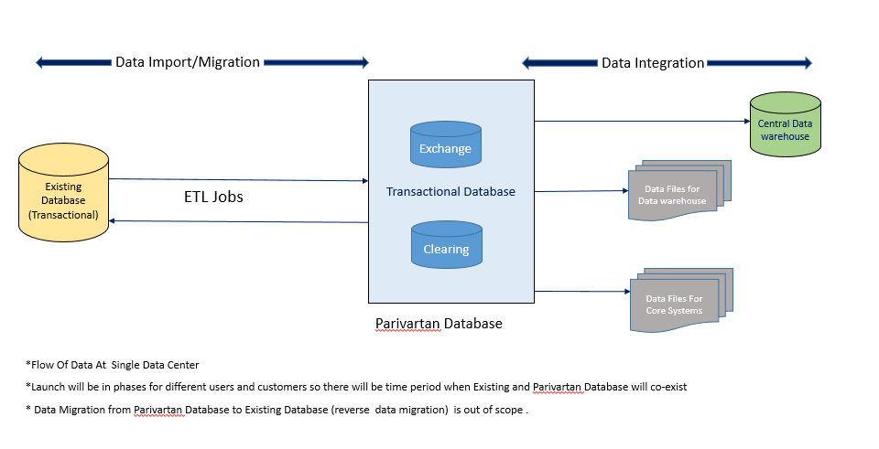

## Data Processing Definition

* Migration: Moving data from one data store to another data store
* Import: Copy data from one data source to another data store
* Historical Data: Data residing in current oracle database (D-2 years. D is current date)
* Replication: Copying of data between two database when two databases are identical in type and structure. I.e. Mirror image of each other
* Trickle Data Migration: Complete the migration process in phases. During implementation, the old systems and the new are run in parallel.

## Batch Jobs Scheduling and Maintenance

Data processing will be done through ETL tool and ETL jobs of both type batch jobs as well as continuous jobs will be scheduled using the scheduler of the ETL jobs, as it is more efficient way to create, monitor, maintain and schedule / reschedule data processing jobs.

**Batch Jobs Best Practices**

* Identification, finalization and creation of interdependent jobs. Jobs interdependency should be properly set
* Proper sequencing of the job
* In case of job failure jobs (especially database updating jobs and high data volume processing jobs) should start from the point of failure

Informatica will be used as the Parivartan ETL tool and Informatica workflow scheduler as the job scheduler.

## Database and Data Storage Backup and Disaster Recovery

Purpose: Main Data Centre (DC) and Near DR (Disaster Recovery) is at Mumbai India. Additionally Disaster Recovery (DR) is at Chennai India. For all business operations, Main Data Centre will be used. As part of disaster recovery and keeping production databases and datastorage up and running 24\*7 it is desired that all DC data should be available in DR and Near DR with minimal/no data latency.

Oracle Data Guard will be used for all type of Disaster Recovery for Oracle DB.

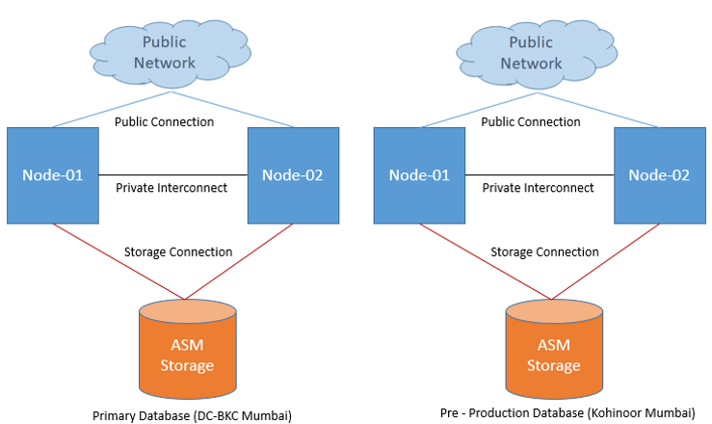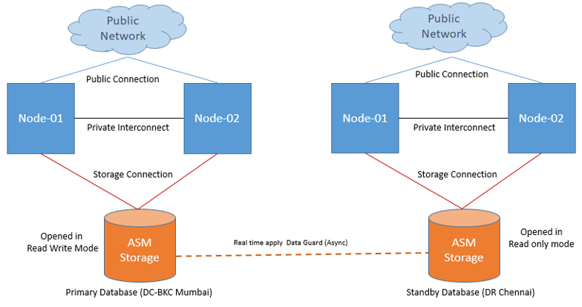

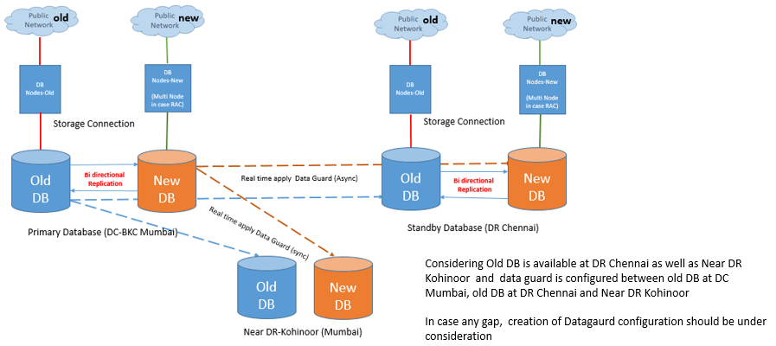

\*Old DB is Oracle Database currently being used ( Database ‘as is’)

\* New DB is Parivartan Oracle Database (Database ‘to be’)

\* Replication and Disaster recovery of old db is out of scope for Parivartan ,it is shown in above pic for better clarity of disaster recovery process

**Oracle Active Data Guard** is the replication solution optimized for data protection and disaster recovery for the Oracle Database. Active Data Guard prevents data loss and downtime by maintaining a synchronized physical replica of the production database. If the production database becomes unavailable for any reason, client connections can quickly fail over to the replica to immediately restore service.

Active Data Guard also eliminates idle redundancy by allowing read-only workloads to be offloaded to a copy of the production database. Active Data Guard is ideally suited for providing disaster recovery for databases with recovery time objectives that cannot tolerate the downtime that accompanies a restore from backup.

Standby database will be configured in **Maximum Availability Mode**. This protection mode provides the highest level of data protection that is possible without compromising the availability of a primary database. Transactions do not commit until all redo data needed to recover those transactions has been written to the online redo log and to at least one synchronized standby database. If the primary database cannot write its redo stream to at least one synchronized standby database, it operates as if it were in maximum performance mode to preserve primary database availability until it is again able to write its redo stream to a synchronized standby database.

**Limitation:** This mode ensures that no data loss will occur if the primary database fails, but only if a second fault does not prevent a complete set of redo data from being sent from the primary database to standby database.

**Note:** Network Bandwidth plays important role to maintain zero/minimum data loss hence considering

Zero latency network will be used to transfer redo from DC-BKC to DR-Chennai.

|  |  |
| --- | --- |
| **Objective** | **Description** |
| RPO (DB Layer) | **Zero (near zero)** RPO will be achieve through real time apply High Availability Mode Configuration with certain assumption and limitation    **Assumption :**  Zero latency network will be used to transferred redo from DC-BKC to DR-Chennai    **Limitation:**  This mode ensures that no data loss will occur if the primary database fails, but only if a second fault does not prevent a complete set of redo data from being sent from the primary database to standby database.  (In case first standby goes down and after few minutes primary will get crashed then there might be  chance of data loss) |
| RTO (DB Layer) | 15 to 20 Min RTO will be achieve using Active Data Guard Configuration  **Assumption :**  For graceful switchover to DR-Chennai   * Standby database is in sync and zero lag observed * No active application connections available at primary site * Batch jobs, backups and monitoring disabled and no active connections available at primary site   For activating standby site in case primary crash.   * Activating standby database is on decision base * DR- Chennai will be activated and data will be available until last received redo available and applied. |

|  |
| --- |
| **Assumption** |
| * Oracle database 19c will be used as RDBMS. * Compatibility will be approved by respective vendor support between Oracle database Version, OS version, VMware Version and Storage Version for Oracle RAC and ASM Configuration. * Production database will deployed at DC-BKC Mumbai. * DR databases will be deployed at DR-Chennai * In case near DR or Far sync site, It will be deployed at Kohinoor Mumbai * Development/Pre production databases will be deployed at Kohinoor Mumbai and there will not be DR site configured for Dev and Pre Prod database. * Zero latency network will be established between DC-Mumbai and Kohinoor Mumbai, between DC-Mumbai and DR-Chennai as well Between Kohinoor Mumbai to DR Chennai * Production Database will be mirrored to all DR sites using Oracle data guard High Availability Mode real time apply method. * Production database will be configured with Multi Node Real application cluster (RAC) to achieve high availability * Production and DR Databases will be configured with same capacity like compute, storage and maintained same cluster level * Production database and Pre Production database will be configured with similar setup (e.g.: Real Application cluster) to achieve best practices like performance test pre deployment of application modification, prior to implement dba changes like index creation, index rebuild, reorg. Table, patching, upgradation etc. * Data Replication between old and new database will be handled by ETL tool and configuration should be tested thoroughly at DC Mumbai as well at DR Chennai post switchover. * To differentiate and achieved realistic DC and DR Setup only one site will be functioning at a time and data will be sent to opposite site according to agreed method. * Post Switchover or failover data replication between Old and New DB will be treated separately as per the ETL tool used and supported functionality   (If required vendor discussion can be enabled to understand post switchover functionality.)   * There will be two DR sites 1) DR-Chennai (Full) and 2) Near DR – Kohinoor Mumbai (Only standby database with sync high availability mode) * Database Architecture Design will be approved by customer as well as database vendor * Considering Old DB is available at DR Chennai as well as Near DR Kohinoor and data guard is configured between old DB at DC Mumbai and old DB at DR Chennai and Near DR Kohinoor. In Case any gap creation of Datagaurd configuration should be under consideration |

## Kafka Disaster Recovery

**Purpose:** Our recommended approach to this is to deploy a local Kafka cluster in each datacenter with application instances in each datacenter interacting only with their local cluster and mirroring between clusters

This deployment pattern allows datacenters to act as independent entities and allows us to manage and tune inter-datacenter replication centrally. This allows each facility to stand alone and operate even if the inter-datacenter links are unavailable: when this occurs the mirroring falls behind until the link is restored at which time it catches up.

**Mirror Maker:** Kafka's mirroring feature makes it possible to maintain a replica of an existing Kafka cluster. The following diagram shows how to use the MirrorMaker tool to mirror a source Kafka cluster into a target (mirror) Kafka cluster

**Mirroring data between Data Centers for Recovery:** We refer to the process of replicating data between Kafka clusters "mirroring" to avoid confusion with the replication that happens amongst the nodes in a single cluster. Kafka comes with a tool for mirroring data between Kafka clusters. The tool consumes from a source cluster ( Our DC) and produces to a destination cluster( DR and Near DR). This kind of mirroring is to provide a replica in another datacenters for Disaster Recovery.

We can run many such mirroring processes to increase throughput and for fault-tolerance (if one process dies, the others will take overs the additional load).

Data will be read from topics in the source cluster and written to a topic with the same name in the destination cluster

The source and destination clusters are completely independent entities: they can have different numbers of partitions and the offsets will not be the same.

**An active-active cluster (multi-cluster deployments)**

The active-active model implies there are two or more clusters with bidirectional mirroring among them. Data is asynchronously mirrored in both directions among the clusters. Client applications are aware of several clusters and can be ready to switch to other cluster in case of a single cluster failure.

# Infrastructure Architecture Considerations

In Reimagination Journey of Modernizing Applications, NSE has chosen Tanzu Application Services for Virtual Machines (TAS for VMs) which is widely accepted and Industry proven solution for running and hosting microservices. This Product was earlier known as Pivotal Cloud Foundry and post VMware’s acquisition of Pivotal, it is being renamed as TAS for VMs under Tanzu umbrella of VMWare’s Digital Transformation Road Map.

VMware TAS for VMs continue to work on Cloud Foundry concept which is open source-based project. It is secure, scalable platform for running Java, and Node apps that automates the release and operation of your software

TAS for VMs let anyone deploy network apps or services and make them available to the world in a few minutes. When an app becomes popular, the cloud scales it to handle more traffic, replacing build-out and migration efforts that once took months with a few keystrokes. Cloud platforms enable you to focus exclusively on your apps and data without worrying about underlying infrastructure.

**High Level Architecture of TAS for VMs**

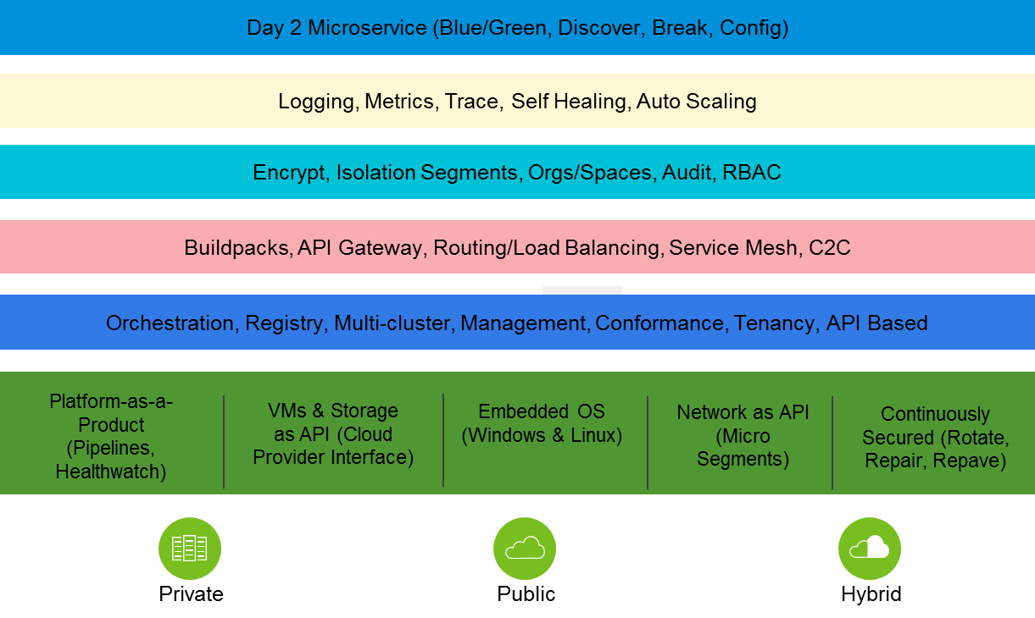

**Cf push –** developers experience of cf push from PCF remains same

**Best runtime for Spring and Spring Boot —** Spring’s microservice patterns—and Spring Boot’s executable jars—are ready-made for PAS.

**Turnkey microservices operations and security —** Spring Cloud Services brings microservices best practices to PAS. It includes Config Server, Service Registry, and Circuit Breaker Dashboard.

**Built for apps —** PAS has everything to need to run apps. Buildpacks manage runtime dependencies; metrics, logging, and scaling are done for you. Multitenancy, and blue/green deployment patterns are built-in. Extend apps with a rich service catalog.

**Container-ready —** PAS supports the OCI format for Docker images. Run platform-built and developer-built containers.

**Primary Considerations of Choosing TAS for VMs over other Platforms:**

|  |  |  |
| --- | --- | --- |
| SL No. | Criteria | Explanation |
| 1 | Open Source Based | TAS for VMs is an open sources based multi-cloud Platform for hosting applications |
| 2 | Approach to Containers | Preferred approach abstracts user from container image life cycles using buildpacks to create packages which run as containers internally. Prebuilt Docker images can also be pushed using a buildpack, mounted to Garden containers and run using runC. |
| 3 | Approach to Containers Orchestration | Diego Orchestration is specific to Cloud Foundry. Kubernetes deployment with BOSH (Kubo) was announced earlier and is expected in go Live in Sep 2020 |
| 4 | Preferred Application  Model | Polyglot language and framework support.  Spring Boot and Spring Cloud for cloud-native  microservices.  Some support for stateful apps. Runs 12-factor web apps really well, but it’s not limited to them. Bring .NET Framework apps, batch jobs, container images, stateful workloads, databases, and functions too! |
| 5 | Application Platform  Services Extensions | Standardized interface and contract with data stores and middleware using Service Broker. Standardized provisioning and management using the powerful BOSH toolchain, outside of  CF Elastic Runtime as VMs. PCF is bundled with first-party data services: MySQL, Redis and Cloud Cache. |
| 6 | Operating System  Support for Runtimes | Ubuntu-only, shipped as an integrated system. PCF license includes Ubuntu support. Windows Server support in BOSH and buildpacks |

High availability and scalability in a microservices architecture is accomplished by combining the capabilities of the platform and following best practices for high availability application design.

## Deployment Architecture

For hosting applications, NSE has decided to run 4 different environment which will run in four different foundations in different on-Prem and Cloud Environments

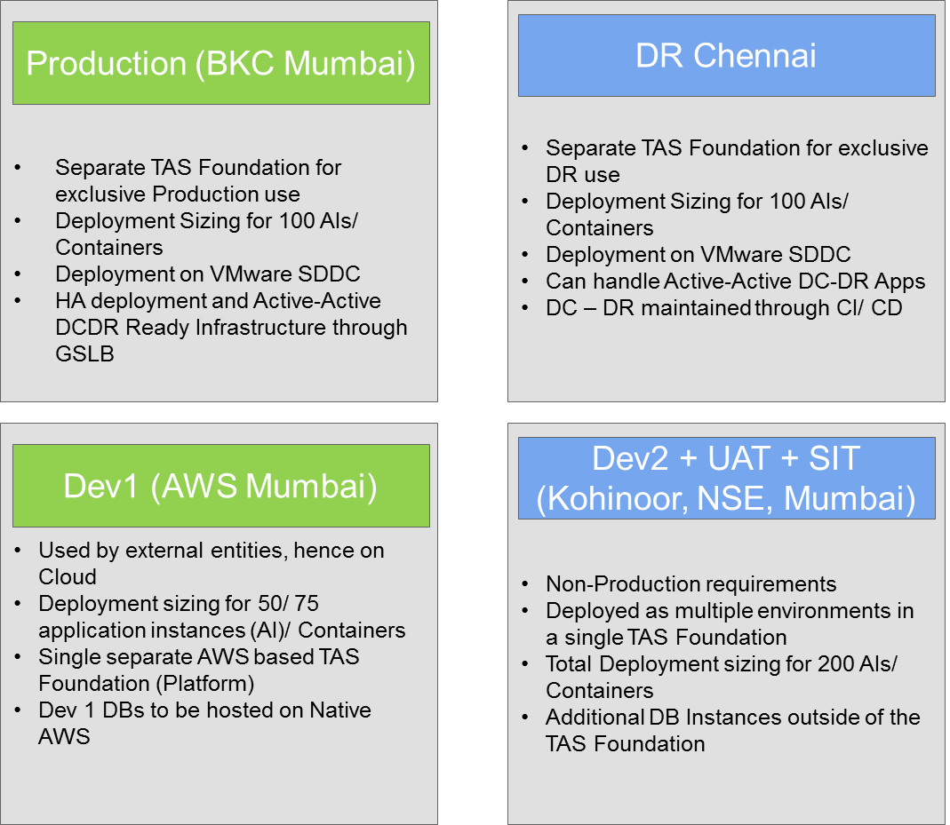

**High level Network view**



**Considerations**:

1. Total no. of foundations for **TAS for VM** is 4 [Kohinoor-SDDC (Dev2, SIT & UAT), BKC(Prod)  and Chennai SDDC (DR), AWS (Dev1) – Temporary , ]
   1. Kohinoor, BKC and Chennai SDDC has sizing for running 200 containers each and also infra Sizing of DR is same as that of Production environment
2. All the Three Foundations – Production, DR and Development 2 will be full-fledged installation of TAS along with other tiles of TKGI and other services like platform matrices, Healthwatch, harbor registry etc.
3. There will no foundation running on VMC on AWS
4. Temporary Environment consist of Native AWS & VMC On AWS:
   1. Platform Automation and TKGI is not considered
   2. **Sizing 1** - is for 10-15 Containers --- with Minimal foot Print of TAS VMs **without** RabbitMQ, SSO & SCS, Tanzu Platform Metrics, Tanzu Platform Healthwatch, Compliance Scanner, Harbour Registry
   3. **Sizing 2** - is for 200 Containers --- --- with Minimal foot Print of TAS VMs **with** RabbitMQ, SSO & SCS, Tanzu Platform Metrics, Tanzu Platform Healthwatch, Compliance Scanner, Harbour Registry
5. Storage Perspective – Internal Components of TAS will leverage storage Capacity from underlying hardware in the form of Ephemeral and Persistent
6. Day2 (Operations, Upgrade and Maintenance) perspective enough headroom will be available as Hosts will be sized maximum 70% threshold for Compute, Network and Storage
7. Sizing is considered with Single Availability zone as no. of microservices is not very huge
8. License: 100 Kubernetes Pods for all TKGI across all 3 foundations
9. 10 Service Instance Licenses across all foundations – out of which please confirm the consumption by Concourse, RaabitMQ and Redis as per current solution

**Overall Deployment Topology – DC View**

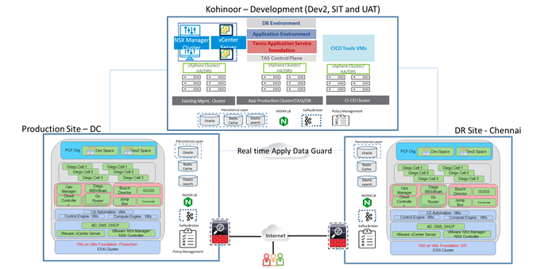

**Summary**:

* Deployment architecture will consists of 3 Sites consisting of 3 different foundations Development2, Production and DR
* All the three foundation will consists of 3 independent installations of TAS with bigger footprint including additional services of health watch, matrices, harbour and TKGI clusters
* Production, DR and Development sites will have Databases running individually and database replication will happen between production and DR databases
* Development Databases will run independently
* CI-CD tools will be installed in development environment and will be used for creating different pipelines to different targets

Below diagram consists of deployment architecure including temporary environment of AWS.

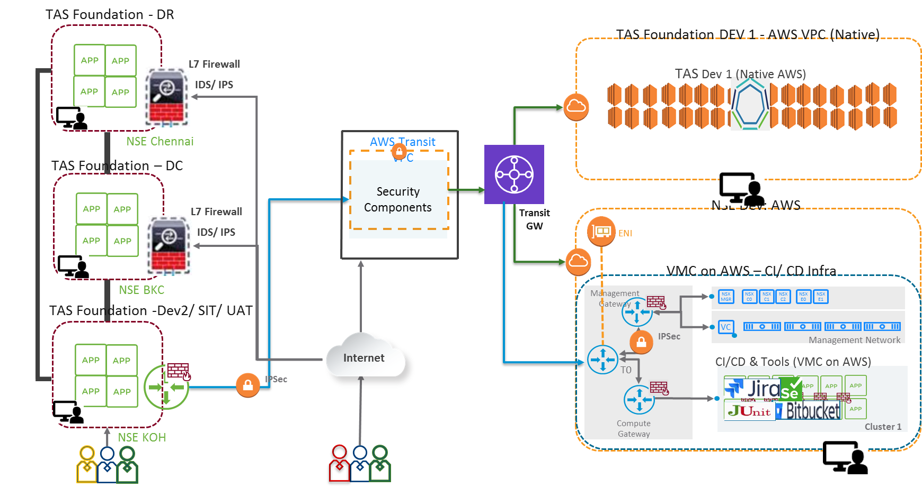

**Overall Deployment Architecture (including Temporary environment on AWS)**

## Production Site - BKC – Mumbai

BKC Production Site will be used for hosting all production Micros services. This site will consists of primarily three VMware vSphere Clusters:

* Existing Management Cluster : Existing Management cluster will be used for installation of vCenter Server Appliance HA, NSX Manager, NSX Load Balancer.
  + Augmentation of Existing cluster with 24Cores/198 GB RAM/2184 GB Storage
* App-Production Cluster : Application Production cluster will be used for installation of Tanzu Application Service (TAS) cluster installation including management components and microservices
* DB-Prod Cluster : DB Cluster will be used for hosting application level DB Requirements

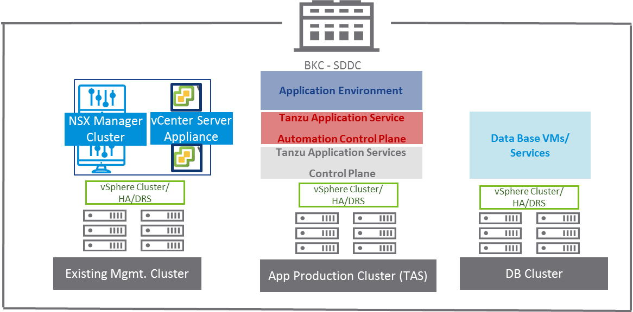

## Near DR Site - Kohinoor – Mumbai

Kohinoor Site will be used for hosting all Development, SIT and UAT environments of Micros services. This site will consists of primarily three VMware vSphere Clusters:

* Existing Management Cluster : Existing Management cluster will be used for installation of vCenter Server Appliance HA, NSX Manager, NSX Load Balancer.
  + Augmentation of Existing cluster with 24Cores/198 GB RAM/2184 GB Storage
* App-Production Cluster : Application Production cluster will be used for installation of Tanzu Application Service (TAS) cluster installation including management components and microservices
* CICD/DB Cluster : This cluster will be used for installation of CICD Tools and DBs Hosting

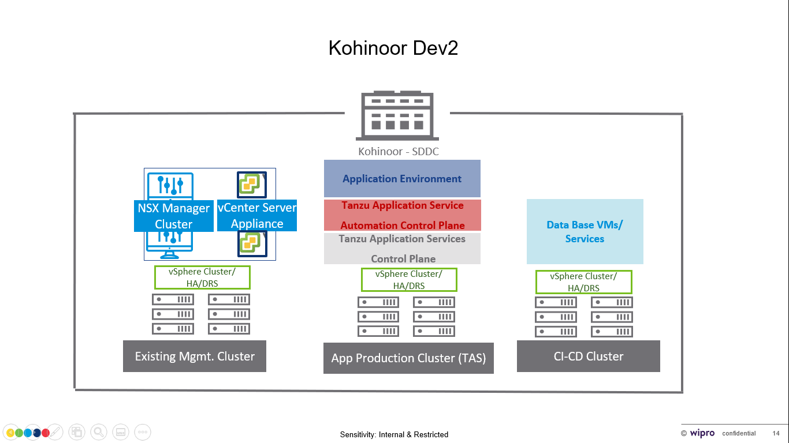

## DR Site – Chennai

Chennai DC will be the replica of Production Datacenter

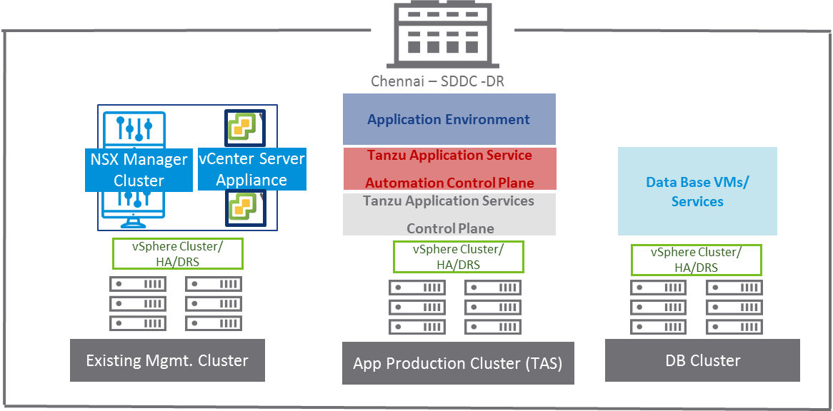

## Cloud – Native AWS ( APAC – Mumbai Region – Temporary environment)

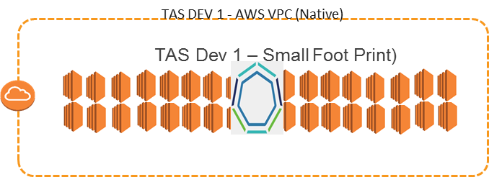

Native AWS will be used for installation of TAS on VMs for installing and configuring temporary environment for developers with small foot print for TAS

## Cloud – VMC on AWS

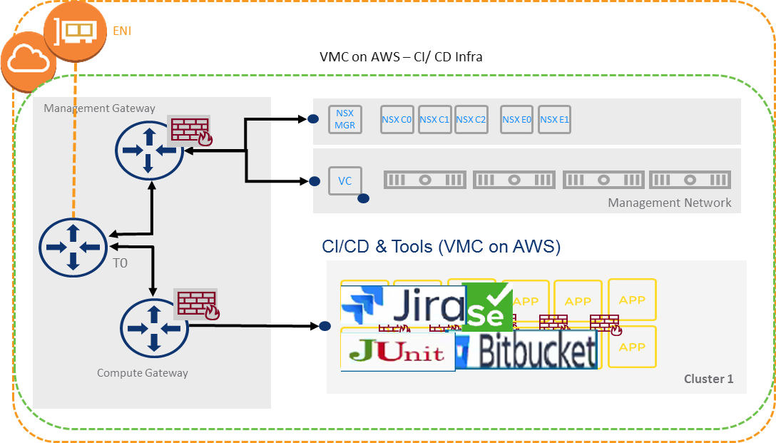

VMC on AWS will include all Devops Tools installed on Different virtual machines and same will be used by creating pipelines to different targets

* Jeera, Confulence, Bitbucket, Jenkins Master & Slave, SonarQube, Maven, NPMS, junit, liquibase, elastisearch, Jmeter, Jfrog, etc

## TAS for VMs Architecture

TAS for VMs is primarily divided into 3 Major components:

* IT Infra (consumed as IaaS Layer) :- This layer is primarily infrastructure layer which will provide infrastructure as a service for all the services and components of Tanzu application services
* Control Plane : - these are actual control planes which controls the entire pivotal engine and runs application as per desire of codes and buildpack configuration. This layer is responsible for managing and upgrading the entire platform
* Control plane automation: - this layer is responsible for automation entire control plane and helps to maintain Day-2 operations with minimum touch

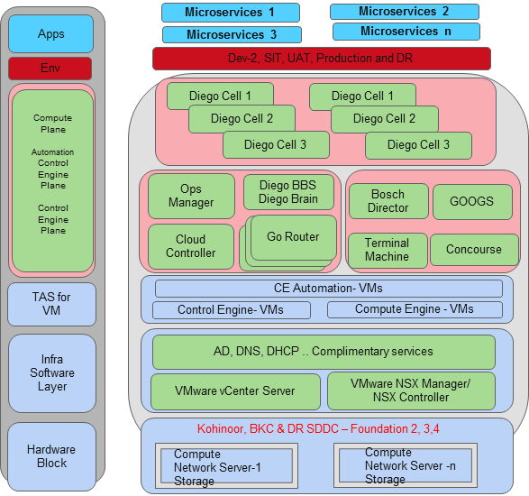

**TAS for VMs components** include a self-service application execution engine, an automation engine for application deployment and lifecycle management, and a scriptable command line interface (CLI), as well as integration with development tools to ease deployment processes. TAS for VMs has an open architecture that includes a buildpack mechanism for adding frameworks, an application services interface, and a cloud provider interface.

#### Router

The router routes incoming traffic to the appropriate component, either a Cloud Controller component or a hosted application running on a Diego Cell.

The router periodically queries the Diego Bulletin Board System (BBS) to determine which cells and containers each application currently runs on. Using this information, the router recomputes new routing tables based on the IP addresses of each cell virtual machine (VM) and the host-side port numbers for the cell’s containers.

#### Authentication

OAuth2 Server (UAA) and Login Server

The OAuth2 server (the [UAA](https://docs.pivotal.io/platform/application-service/2-9/concepts/architecture/uaa.html)) and Login Server work together to provide identity management.

#### App Lifecycle

Cloud Controller and Diego Brain

The [Cloud Controller](https://docs.pivotal.io/platform/application-service/2-9/concepts/architecture/cloud-controller.html) (CC) directs the deployment of applications. To push an app to TAS for VMs, you target the Cloud Controller. The Cloud Controller then directs the Diego Brain through the CC-Bridge components to coordinate individual [Diego cells](https://docs.pivotal.io/platform/application-service/2-9/concepts/architecture/index.html#diego-cell) to stage and run applications.

The Cloud Controller also maintain records of [orgs, spaces, user roles](https://docs.pivotal.io/platform/application-service/2-9/concepts/roles.html), services, and more.

#### nsync, BBS, and Cell Reps

To keep applications available, cloud deployments must constantly monitor their states and reconcile them with their expected states, starting and stopping processes as required

The nsync, BBS, and Cell Rep components work together along a chain to keep apps running. At one end is the user. At the other end are the instances of applications running on widely-distributed VMs, which may crash or become unavailable.

Here is how the components work together:

* **nsync** receives a message from the Cloud Controller when the user scales an app. It writes the number of instances into a DesiredLRP structure in the Diego BBS database.
* **BBS** uses its convergence process to monitor the DesiredLRP and ActualLRP values. It launches or kills application instances as appropriate to ensure the ActualLRP count matches the DesiredLRP count.
* **Cell Rep monitors** the containers and provides the ActualLRP value

#### App Storage and Execution

Blobstore

The blobstore is a repository for large binary files, which Github cannot easily manage because GitHub is designed for code. The blobstore contains the following:

* Application code packages
* Buildpacks
* Droplets

You can configure the blobstore as either an internal server or an external S3 or S3-compatible endpoint. For more information about the blobstore

#### Diego Cell

Application instances, application tasks, and staging tasks all run as [Garden](https://docs.pivotal.io/platform/application-service/2-9/concepts/architecture/garden.html) containers on the Diego Cell VMs. The Diego cell rep component manages the lifecycle of those containers and the processes running in them, reports their status to the Diego BBS, and emits their logs and metrics to [Loggregator](https://docs.pivotal.io/platform/application-service/2-9/concepts/architecture/index.html#metrics-logging).

#### Services

**Service Brokers**: Applications typically depend on [services](https://docs.pivotal.io/platform/services/) such as databases or third-party SaaS providers. When a developer provisions and binds a service to an application, the service broker for that service is responsible for providing the service instance.

#### Messaging

Internal HTTPS and BBS

TAS for VMs component VMs communicate with each other internally through HTTP and HTTPS protocols, sharing temporary messages and data stored in Diego’s [Bulletin Board System (BBS)](https://docs.pivotal.io/platform/application-service/2-9/concepts/diego/diego-architecture.html#bbs).

BOSH Director co-locates a [BOSH DNS](https://bosh.io/docs/dns/) server on every deployed VM. All VMs keep up-to-date DNS records for all the other VMs in the same foundation, enabling service discovery between VMs. BOSH DNS also provides client-side load-balancing by randomly selecting a healthy VM when multiple VMs are available.

Diego’s [Bulletin Board System](https://docs.pivotal.io/platform/application-service/2-9/concepts/diego/diego-architecture.html#bbs) (BBS) stores more frequently updated and disposable data such as cell and app status, unallocated work, and heartbeat messages, as well as longer-lived distributed locks. The BBS stores data in MySQL, using the [Go MySQL Driver](https://github.com/go-sql-driver/mysql).

The route-emitter component uses the NATS protocol to broadcast the latest routing tables to the routers.

#### Metrics and Logging

**Pivotal Cloud Foundry Metrics**

This Tool correlates events, logs and Metrics − PCF Metrics stores and graphically represents logs, metrics, and event data from applications running on Pivotal Cloud Foundry. Tool help quickly diagnose system failure and latency. Metrics, logs, and event data are aggregated and displayed via intuitive, interactive visualizations. − Accurately Identify Issues with Complete Data

**Pivotal Cloud Foundry Metrics displays the following:**

* Container Metrics: A visual graph of CPU, memory, and disk usage percentages
* Network Metrics: A visual graph of requests, HTTP errors, and response times
* Application Events: A visual graph of update, start, stop, crash, SSH, and staging failure events
* Logs: A list of application logs that can be searched, filtered, and downloaded for further interrogation
* Trace Explorer: A visual graph that traces requests between applications and their endpoints, along with the corresponding logs

#### Loggregator

Pivotal Cloud Foundry provides Loggregator as logging component in the solution. Below are the functionalities of Loggregator:

* Aggregates logs & metrics
* Platform metrics from PCF components
* System-level resource metrics from Platform VMs (BOSH Metrics)
* Application Logs & Available Metrics from service tiles
* PCF Metrics & Healthwatch: User friendly app clients to loggregator

The Loggregator (log aggregator) system streams application logs to developers.

#### PAS on vSphere with NSX-T

The following sections describe the reference architecture for PAS on vSphere with NSX-T deployments. They also provide requirements and recommendations for deploying PAS on vSphere with NSX-T, such as network, load balancing, and storage capacity requirements and recommendations.

**PAS on vSphere with NSX-T supports the following SDN features:**

* Virtualized, encapsulated networks and encapsulated broadcast domains
* VLAN exhaustion avoidance with the use of virtualized Logical Networks
* DNAT/SNAT services to create separate, non-routable network spaces for the PAS installation
* Load balancing services to pass traffic thru (at layer 4) to pools of platform routers (at layer 7)
* SSL termination at the load balancer at layer 7 with the option to forward on at layer 4 or 7 with unique certificates
* Virtual, distributed routing and firewalling services native to the hypervisor

The following reference architecture diagram describes the architecture for PAS on vSphere with NSX-T deployments.

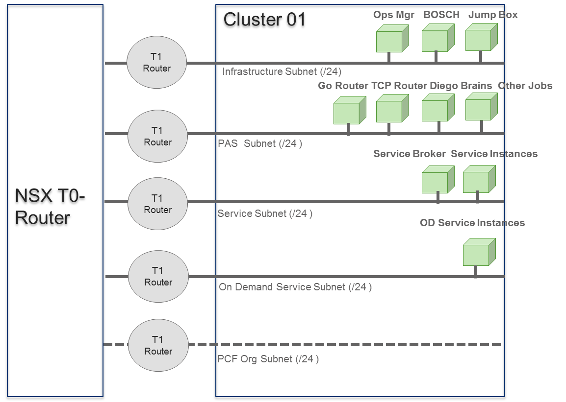

A NSX-T Tier-0 router is on the front end of the PAS deployment. This router is a central logical router into the PAS platform. One can configure static or dynamic routing using BGP from the routed IP backbone through the Tier-0 router with the gateway Edge.

Several Tier-1 routers, such as the router for the PAS and infrastructure subnets, connect to the Tier-0 router.

***Networking, Subnets, and IP Spacing***

The following are requirements and recommendations related to networks, subnets, and IP spacing for PAS on vSphere with NSX-T deployments:

* PAS requires statically-defined networks to host PAS component VMs.
* The client side of a NSX-T deployment uses a series of non-routable address blocks when using DNAT/SNAT at the Tier-0 interface.
* The reference architecture for PAS on vSphere with NSX-T deployments uses a pattern in which all networks are calculated on the /24 8-bit network boundary. The network octet is numerically sequential.
* NSX-T dynamically assigns PAS org networks and adds a Tier-1 router. These org networks are automatically instantiated based on a non-overlapping block of address space. One can configure the block of address space in the NCP Configuration section of the NSX-T tile in Ops Manager. The default is /24. This means that every org in PAS is assigned a new /24 network.

The following sections describe networking requirements and recommendations for PAS on vSphere with NSX-T deployments.

**Routable IPs**

The Tier-0 router must have routable external IP address space to advertise on the BGP network with its peers. Select a network range for the Tier-0 router with enough space so that the network can be separated into the following two jobs:

* Routing incoming & outgoing traffic.
* DNATs and SNATs, load balancer VIPs, and other PCF components.

**DNS**

PAS requires a system domain, app domain, and several wildcard domains.

**Load Balancing**

The following are load balancing requirements and recommendations for PAS on vSphere with NSX-T deployments:

* must configure NSX-T load balancers for the Gorouters.
* The domains for the PAS system and apps must resolve to the load balancer VIP.
* must assign either a private or a public IP address assigned to the domains for the PAS system and apps.
* Pivotal recommends that we configure Layer 4 NSX-V load balancers for the Gorouters. With Layer 4 load balancers, traffic passes through the load balancers and SSL is terminated at the Gorouters. This approach reduces overhead processing.
* Any TCP Gorouters and SSH Proxies within the platform also require NSX-T load balancers.
* Layer 4 and Layer 7 NSX-T load balancers are created automatically during app deployment.

#### Load Balancing

Any PAS installation needs a suitable load balancer to send incoming HTTP, HTTPS, SSH, and SSL traffic to its Gorouters and application containers. All installations approaching production-level use rely on external load balancing from hardware appliance vendors or other network-layer solutions.

The load balancer can also perform Layer 4 or Layer 7 load balancing functions. SSL can be terminated at the load balancer or used as a pass-through to the Gorouter.

Common deployments of load balancing in PAS are:

* HTTP/HTTPS traffic to and from Gorouters
* TCP traffic to and from TCP routers
* Traffic from the Diego Brain, when developers access app containers via SSH

To balance load across multiple PAS foundations, use an IaaS- or vendor-specific Global Traffic Manager or Global DNS load balancer.

#### Shared Storage

PAS requires disk storage for each component, for both persistent data and to allocate to ephemeral data. Size these disks in the Resource Config pane of the PAS tile.

The platform also requires one to configure file storage for large shared objects. These blobstores can be external or internal.

Shared storage is a requirement for PCF. One can allocate networked/Block storage to the host clusters following one of two common approaches: horizontal or vertical. The approach one follow reflects how the data centre arranges its storage and host blocks in its physical layout.

With the horizontal shared storage approach, grant all hosts access to all datastores and assign a subset to each PCF installation.

For example, with three datastores ds01 through ds03, grant all hosts access to all six datastores. Then provision the first PCF installation to use stores ds01 through ds03

## Routing Architecture

TAS for VMs Maintains Updated Routing Tables. The following process describes how a router obtains information about routes for an app running on TAS for VMs:

1.The Cloud Controller component sends app route information to Diego BBS. For HTTP routing, route information includes the host and path of an external URL

2.Diego BBS coordinates the back end IP address and port where each instance of the app runs. When queried by the route emitter, the BBS sends this information along with Cloud Controller’s app route information to the route emitter on the Diego cell where instances of the app are located.

3.If a route is HTTP, the route emitter on the Diego cells sends app route, IP, and port information to NATS, which then sends it to the Gorouter. If a route is TCP, the route emitter sends that information to the Routing API, which then sends it to the TCP router.

4.The Gorouter and TCP router use the route, IP, and port information from the route emitter to map incoming app requests to back end app instance locations.

**External Client Request Flow**

When TAS for VMs’s routing tables are updated, TAS for VMs can process requests from external clients to an app. The following process describes how an external client makes a request to an app running on TAS for VMs:

* The external client sends its request.
* Your DNS service sends the request to the HTTP or TCP load balancer based on the prefix of the DNS name in the client request, such as http in http.example.com.
* The load balancer sends the request to the load balancer’s corresponding router.
* The router sends the request to the app

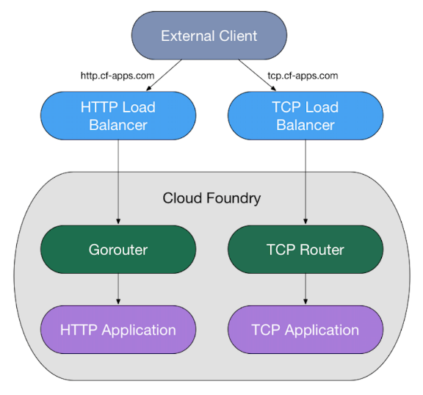

#### Design Considerations

IaaS Platform

All the following platforms are supported for running TAS for VMs platform

* [AWS](https://docs.pivotal.io/platform/2-9/customizing/aws.html)
* [Azure](https://docs.pivotal.io/platform/2-9/customizing/azure.html)
* [GCP](https://docs.pivotal.io/platform/2-9/customizing/gcp.html)
* [OpenStack](https://docs.pivotal.io/platform/2-9/customizing/openstack.html)
* [vSphere](https://docs.pivotal.io/platform/2-9/customizing/vsphere.html)

|  |  |  |
| --- | --- | --- |
| Sl No. | IaaS Platform | Foundation Details |
| 1 | vSphere | BKC, Kohinoor, Chennai |
| 2 | AWS | Dev1 - Temporary |

#### High Availability and Scalability

High availability is accomplished in TAS for VM first by scaling components VMs and locating them in multiple Availability Zones (AZ) so that their redundancy and distribution minimizes downtime during ongoing operation, product updates, and platform upgrades.

Scaling component VMs means changing the number of VM instances dedicated to running a functional component of the system. Scaling usually means increasing this number, while scaling down or scaling back means decreasing it.

The ability to scale component VMs is important for high availability. To scale component VMs, you must ensure that the surrounding infrastructure of your deployment supports VM scaling.

This section describes the infrastructure required to support scaling component VMs for high availability.

|  |  |  |  |
| --- | --- | --- | --- |
| **VMware Tanzu Application Service for VMs (TAS for VMs) Job** | **Recommended Instance Number for HA** | **Minimum Instance Number** | **Notes** |
| Diego Cell | ≥ 3 | 1 | The optimal balance between CPU and memory sizing and instance count depends on the performance characteristics of the apps that run on Diego Cells. Scaling vertically with larger Diego Cells makes for larger points of failure, and more apps go down when a Diego Cell fails. On the other hand, scaling horizontally decreases the speed at which the system re-balances apps. Re-balancing 100 Diego Cells takes longer and demands more processing overhead than re-balancing 20 Diego Cells. |
| Diego Brain | ≥ 2 | 1 | For high availability, use at least one per AZ, or at least two if only one AZ. |
| Diego BBS | ≥ 2 | 1 | For high availability in a multi-AZ deployment, use at least one instance per AZ. Scale Diego BBS to at least two instances for high availability in a single-AZ deployment. |
| MySQL Server | 3 | 1 | If you use an external database in your deployment, then you can set the MySQL Server instance count to 0. For instructions about scaling down an internal MySQL cluster, see [**Scaling Down Your MySQL Cluster**](https://docs.pivotal.io/platform/application-service/2-9/mysql/scaling-mysql.html#scale-down). |
| MySQL Proxy | 2 | 1 | If you use an external database in your deployment, then you can set the MySQL Proxy instance count to 0. |
| NATS Server | ≥ 2 | 1 | In a high-availability deployment, you might run a single NATS instance if your deployment lacks the resources to deploy two stable NATS servers. Components using NATS are resilient to message failures and the BOSH Resurrector recovers the NATS VM quickly if it becomes non-responsive. |
| Cloud Controller | ≥ 2 | 1 | Scale the Cloud Controller to accommodate the number of requests to the API and the number of apps in the system. |
| Clock Global | ≥ 2 | 1 | For a high-availability deployment, scale the Clock Global job to a value greater than 1 or to the number of AZs you have. |
| Router | ≥ 2 | 1 | Scale the Gorouter to accommodate the number of incoming requests. Additional instances increase available bandwidth. In general, this load is much less than the load on Diego Cells. |
| UAA | ≥ 2 | 1 |  |
| Doppler Server | ≥ 2 | 1 | Deploying additional Doppler servers splits traffic across them. For a high-availability deployment, VMware recommends at least two per AZ. |
| Loggregator Traffic Controller | ≥ 2 | 1 | Deploying additional Loggregator Traffic Controllers allows you to direct traffic to them in a round-robin manner. For a high-availability deployment, VMware recommends at least two per AZ. |
| Syslog Scheduler | ≥ 2 | 1 | The Syslog Scheduler is a scalable component. For high availability, use at least one instance per AZ, or at least two instances if only one AZ is present. |
| CredHub | ≥ 3 | 2 | CredHub is a scalable component. For high availability, use at least one instance per AZ, or at least three instances if only one AZ is present. |

#### Availability Zones

Deploying Cloud Foundry across three or more AZs and assigning multiple component instances to different AZ locations lets a deployment operate uninterrupted when entire AZs become unavailable.

NSE has 6 Availability Zones for its Cloud Foundry platform. Cloud Foundry maintains its availability as long as a majority of the AZs remain accessible. For example, a three-AZ deployment stays up when one entire AZ goes down, and a five-AZ deployment can withstand an outage of up to two AZs with no impact on uptime. When using more than 3 AZs, it’s recommended that the number of AZs is odd.

In current Scenario, we will be using only one Availability Zone for each foundation, as number of applications are limited and also separate Hardware, Cooling, Rack Spaces are needed to run additional Availability zones

|  |  |
| --- | --- |
| SL No. | No. Of availability Zones |
| 1 | Single in Each Foundation |

#### Security and Patching

Pivotal Cloud Foundry platform manages patching and hardening of platform components. In PAS all components patching is managed by platform. In case of PKS container patching needs to be taken care separately as platform will only patch platform components.

**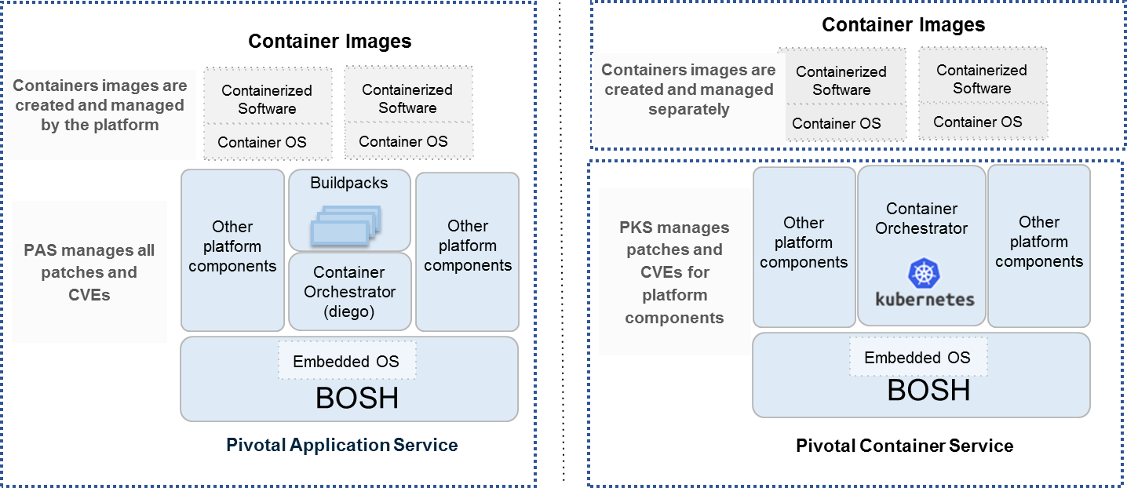**

In platform there is concept of Bosh stemcells which are pre-hardened as per security best practices. Below are the key functionalities of Stemcells:

* Provides a base OS image for installing software packages
* Version changes to the OS image
  + If a library is changed a new stemcell version is released
  + Provides traceability of what is running on a VM
  + Guarantees reproducibility
* Reusing base OS images across VMs of platform
  + Eliminate snowflakes in your system
  + Simplifies patching / upgrades / maintenance
  + Simplifies troubleshooting
* Reusing base OS images across different IaaS providers
  + BOSH software release only needs to be built once and they will work the same on all IaaS providers
* Stemcells are pre-hardened according to security best practises
  + Building on top of a stemcell means working on a more secure software
  + Pivotal works with OS vendors (Canonical & Microsoft) to make the stemcells are always uptodate & secure
* Filesystem Hardening
  + Locked down /tmp file system, and shared memory partitions
  + Linux file systems that are unused in CF have been disabled
  + Problematic directories (/var, /var/log, /var/log/audit, /home, /tmp) are in a separate partition with restricted access
* Minimization of attack surface
  + Removed Network Information Service and rsh tools
  + Disabled talk, telnet, tftp and many other servers
  + Disabled Network services like chargen, daytime, echo, discard and time
* Network Security
  + Modified the IPv4 network configuration to be safer
  + Disabled unneeded protocols like SCTP, DCCP, LDAP, RDS
  + /etc/hosts.allow and /etc/hosts.deny files exist and are empty
  + /etc/hosts.allow and /etc/hosts.deny files are protected from unauthorized write access